Data Review and Validation Report: 2023, Feb, PM10

Contents
Data 2
Data Reports and Supporting Materials Filepath 2
Instrument Health 2
QC Operations and Results, including Audits 2
Level 0 Verification 3
Flagging Due to Data Outside Range 3
Flagging Due To <75% Capture for Hour (n-minute data) 3
Flagging Due to Repeating (Identical) Values 3
Flagging Due to Extreme Change Between Consecutive Values 3
Unusually High Concentrations (Spikes) 3
Spike on 2/22-2/23/2023 4
Comparison with historical max values from AQS: 9
Logbook Verification 10
Outliers, Error Codes, Or Anomalies Verification 10
Verifying Average Flow Rate and Variability of Flow 10
Calibration Certificates/Intervals Verification 10
Verifying Performance Audits (NPAP/PEP/Independent) satisfactory results and loading copies to be available to the level 2 reviewer 10
Verifying agreement between the datalogger and instrument values (at least 3 of the highest values per parameter reviewed per month, after several months of verified/documented agreement on larger sets) 10
Verifying the critical, operational, and systematic review criteria for NAAQS data (data limits are built in to QREST), or the appropriate QAPP tables for other data 10
Attachment A: Continuous PM10 Validation Criteria (excerpted from QAPP) 10
Table 14-1. Operational Criteria (must be met for each hourly record): 10
Table 14-2. Operational Criteria 11
TABLE 14-3. Systematic Criteria 12
Attachment B: February 2023 Data Summary: 14

Year | Month | Min | Mean | % annual hours below monthly mean | Median | Max | DateTime of Max (local) | 2nd Max | Max - 2nd Max Difference | Std Dev | 25th Ntile | 75th Ntile
2023 | 2 | 1 | 17 | 75 | 13 | 216 | 02/22/2023 00:00 | 212 | 4 | 20 | 9 | 19

Data
Parameter(s): PM10, POC 3
Org ID | Site ID |  | Par Code | Par Name | Method Code
TRIBAL AGENCY | ID |  | 81102 | PM10 Total 0-10um STP | 079
Dates reviewed: 2/1/2023 00:00 through 2/28/2023 23:00

Data Reports and Supporting Materials Filepath
Scanned logbook pages and other materials at: QREST SUPPORTING DOCUMENTATION for this month and parameter. Backup copies in L1 site materials backup folder at C:\Users\melinda\Dropbox (NAU Unlimited)\Backups\PM10\81102_079.zip

Instrument Health
No error codes reported during this time period. All maintenance up to date. Next due: 04/01/23. See scanned logbook pages from January indicating next due date of 4/1/23. Parts are available at the air station.

QC Operations and Results, including Audits

The data reviewed was all within QAPP-documented performance and QC limits, and meets or exceeds the NAAQS regulatory QC requirements (see the requirements and checklist in Attachment A, excerpted from the QAPP and consistent with the validation tables in Appendix D of the QA Handbook vol. 2).

No external audits were performed during this time period.

Level 0 Verification
Level 0 automated checks are conducted on polled or imported data that flags values that do not meet site operator-set criteria. These flags are added to the parameter records and are sortable in the database’s table, and values that did not meet the criteria are color-coded in the chart. Values that are flagged are not necessarily invalid, but are reviewed thoroughly before final validation, as described further in this report.

Flagging Due to Data Outside Range
Alert Min | Alert Max
-50 | nn
No PM10 values were less than the minimum value of -nn microg/m3, and the values that exceeded the maximum of nn microg/m3 were all investigated and judged to be valid (see the discussion of high concentrations as investigated as part of the Level 1 data review).

Flagging Due To <75% Capture for Hour (n-minute data)
87 hourly records were comprised of less than 75% of 5 min records (see Summary Table in Attachment B). All records LOST occurred during the documented (see email saved in Supporting Documentation) power outages.

Flagging Due to Repeating (Identical) Values
Alert Stuck Count
3
No values were flagged as having identical values as two previous records.

Flagging Due to Extreme Change Between Consecutive Values
Alert Amt Change
nn
No values were flagged by this criterion. (All values that exhibited a change from the previous record greater than this limit (generally 50 microg/m)3 should be investigated).

Unusually High Concentrations (Spikes)
There was only one episode of high PM10 concentration during the month, as shown in Figure 1. The rationale for validity is described in this section.

Figure 1: Feb 2023
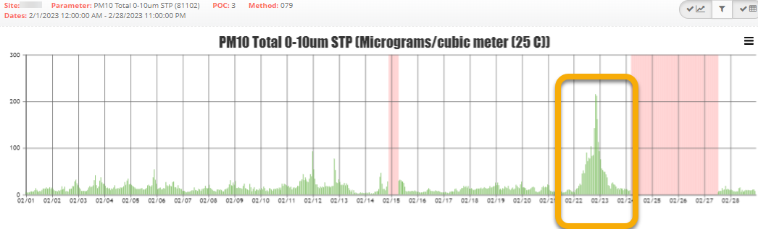

Spike on 2/22-2/23/2023

Five minute data (if available)
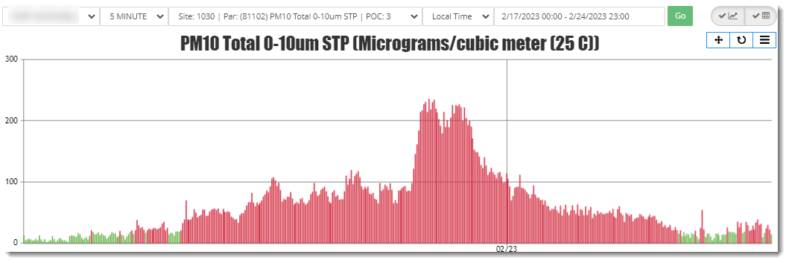

Comparison of within-site parameters:
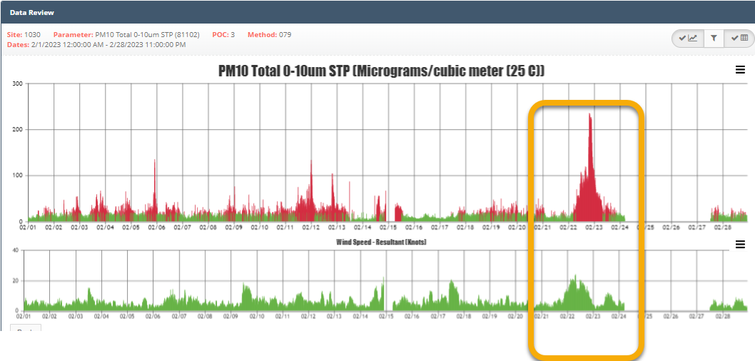

Based upon a comparison of wind speed and PM10, the spike in PM10 concentration to over 200 microg/m3 is valid as it occurred slightly after (lag of about ten minutes).

Wind rose during this interval
The predominant wind direction at this time was from the north, as obtained from Airnow Tech for that date (https://www.airnowtech.org/navigator/) and shown Figure 3.

Figure 3: Wind Rose for Jan. 16, 2020
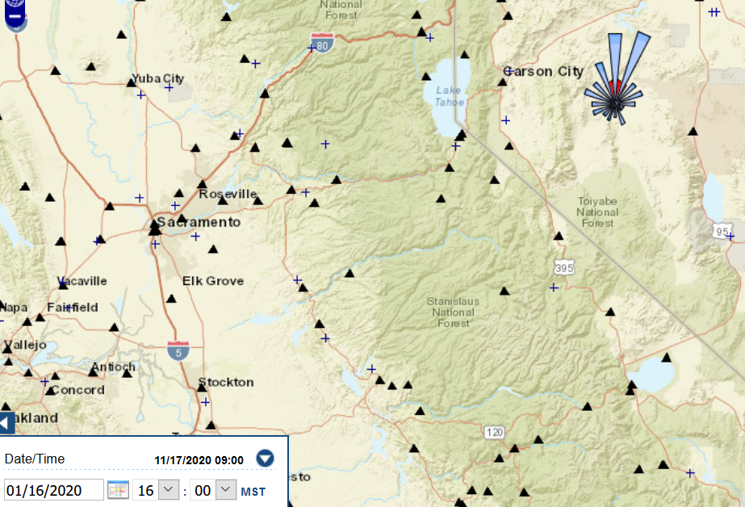

Downwind (companion site) identification:
At this time, the downwind site reporting PM10 is Spanish Springs AQS Code:320311007 , and data for this datetime show a peak of PM10 at that site, as shown in Figure 4.

Downwind site data during the same time interval:
Figure 4: Spanish Springs PM10
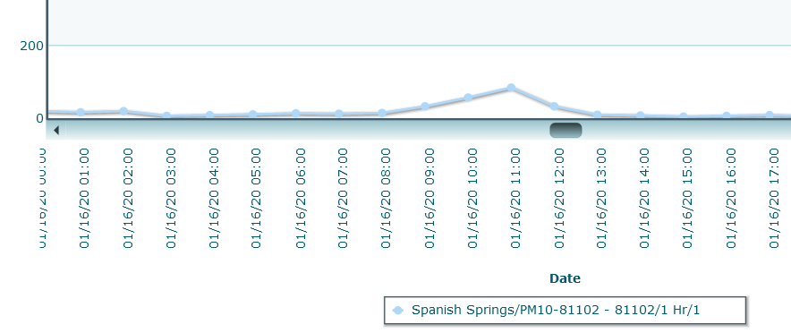
Figure 4 was created from Airnow tech data (https://www.airnowtech.org/data/ ) from the downwind site, Spanish Springs, with the specifications for this corroborating site shown in Figure 5.

Figure 5: Downwind Site for Jan. 16, 2020
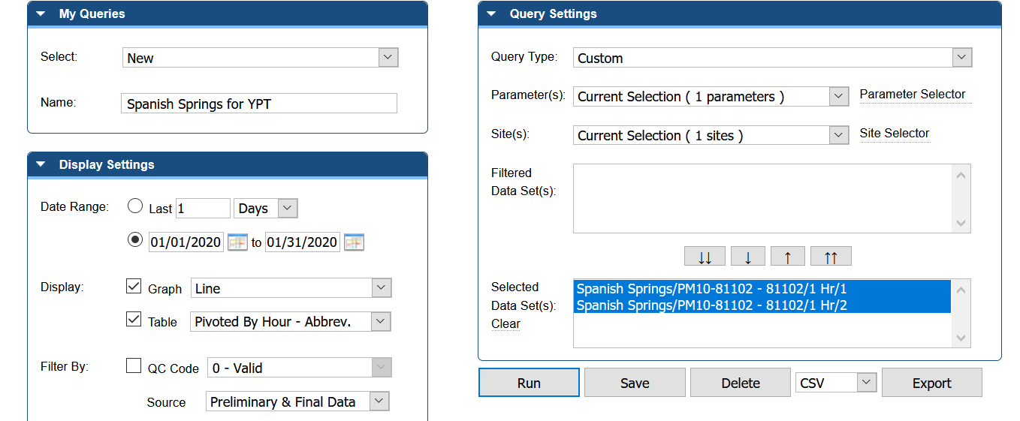

Figure 6 shows the second set of values exceeding the MAX limit of 75 microg/m3, flagged in red.
Figure 6: Spike on Jan. 29, 2020
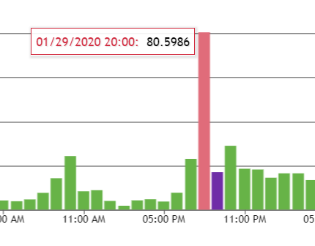
The prevailing wind on that datetime was also from the north, as shown in Figure 7.

Figure 7: Wind Rose for Jan. 29, 2020
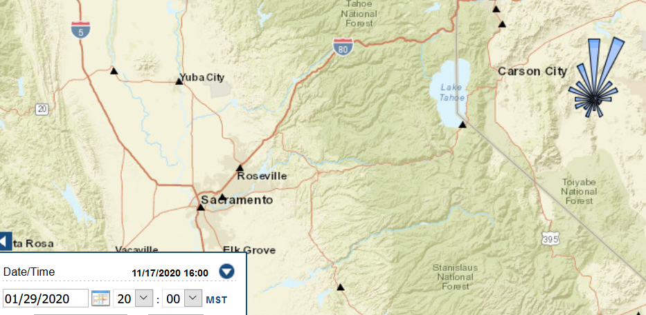

Comparison with historical max values from AQS:
Although this spike is not close to the 3-year historic max of 490 microg/m3 at this site (https://aqs.epa.gov/aqsweb/aqstmp/ofmeaqsprod2_2020-11-17_14.22.46_9653/2182579_STAT_CR.pdf) this increase is corroborated by downwind data at that time from Spanish Springs (increased concentration from less than 10 to approximately 17 microg/m3).:

Logbook Verification
No information was added to logbooks based on additional information obtained after site visits during this time.

Outliers, Error Codes, Or Anomalies Verification
There were no error codes or operator flags in the records for this time interval.

Verifying Average Flow Rate and Variability of Flow
Flow rate and variability of flow rate were within limits for this time period, as documented in the QAPP checklist in attachment 1.

Calibration Certificates/Intervals Verification
Calibrations are within specifications and are current for this time period (see Checklist in Attachment 1).

Verifying Performance Audits (NPAP/PEP/Independent) satisfactory results and loading copies to be available to the level 2 reviewer
One independent audit has been conducted, with the report attached.

Verifying agreement between the datalogger and instrument values (at least 3 of the highest values per parameter reviewed per month, after several months of verified/documented agreement on larger sets)
The values in the table below were compared and all agree:
Date and time: | Datalogger value: | Instrument value:

Verifying the critical, operational, and systematic review criteria for NAAQS data (data limits are built in to QREST), or the appropriate QAPP tables for other data

Attachment A: Continuous PM10 Validation Criteria (excerpted from QAPP)

Table 14-1. Operational Criteria (must be met for each hourly record):
 |  | Table 14-1: Critical Criteria
Requirement | Frequency |  | Acceptance Criteria | Identification | Information/Action
Average Flow Rate | every 24 hours of op |  | Average within < + 5.1% of design | No flags generated by system between 1/1/2020 and 7/1/2020 | EPA recommendation
One-point Flow Rate Verification | every 30 days each separated  by 14 days |  | < + 7.1% of transfer standard | Dates and relative percent difference from transfer standard  RPD=(analyzer-FRstandard)/FRstandard  Date: RPD:  ________ ___%  ________ ___%  ________ ___%  ________ ___%  ________ ___%  ________ ___% | 1 and 2) 40 CFR Part 58, App A, Sec. 3.3  3) Method 2.10 Table 3-1

Table 14-2. Operational Criteria
Criteria that are important for maintaining and evaluating the quality of the entire data collection system are included in this Operational Criteria Table. Violation of one or more of these requirements may be cause for invalidating a set of data. The decision should consider other quality control information that is available. The dataset for which one or more of these criteria are not met will be considered suspect unless other quality control information demonstrates that the data are valid. The reason for not meeting these criteria MUST be investigated, fixed, or justified.

 |  |  | Table 14-2: Operational Criteria
Requirement | Frequency | Acceptance Criteria |  | Identification | Information/Action
System Leak Check | During precalibration check | Auditory inspection with faceplate blocked |  | Date: | 1, 2 and 3) Method 2.11 Sec. 2.3.2
FR Multi-point  Verification/Calibration | every 365 days and once a  calendar year | 3 of 4 cal points within < + 10.1% of design |  | Date : | 1) 40 CFR Part 50 App J Sec. 8.0  2 and 3) Method 2.10 Sec. 2.2.4
Semi Annual Flow Rate Audit | Twice a calendar year and 5-  7 months apart | < + 10.1% of audit standard |  | Dates : | 1, 2) Part 58, App A, Sec. 3.3.3  3) Method 2.10 Sec. 7.1.5
Inlet/downtube Cleaning | every 90 days and 4 times a  calendar year | cleaned |  | Dates : | 1, 2 and 3) Method 2.10 Sec. 6.1.2
FR Multi-point Verification | 1/yr. | <± 2.1% |  | Date: RPD: | Part 50, App.L, Sec 9.2

TABLE 14-3. Systematic Criteria
Criteria which are important for the correct interpretation of the data but do not usually impact the validity of a sample or group of samples are included on the third table, the Systematic Issues Table. For example, the data quality objectives are included in this table. If the data quality objectives are not met, this does not invalidate any of the samples but it may impact the error rate associated with the attainment/non-attainment decision.

 |  | Table 14-3: Systematic Criteria
Requirement | Frequency |  | Acceptance Criteria | Identifcation | Information/Action
Siting | Every 365 days and 1/  calendar year |  | Meets siting criteria or waiver documented | No changes in site, no new roads, no new trees, no new activities | 1) 40 CFR Part 58 App E, Sections 2-5  2) Recommendation  3) 40 CFR Part 58 App E, Sections 2-5
Data Completeness | 24-hour  quarterly |  | > 75% | % | 1, 2 and 3) 40 CFR Part 50 App. K, Sec. 2.3b & c
 |  | Verification/Calibration Standards and Recertifications - All standards should have multi-point certifications against NIST Traceable standards
Flow Rate Transfer Std. | every 365 days and once a  calendar year |  | < + 2.1% of NIST-traceable Std. | Date: RPD: | 1) 40 CFR Part 50, App.J Sec. 7.3  2) Method 2.11 Sec. 1.1.3  3) 40 CFR Part 50, App.J Sec. 7.3
Field Thermometer | every 365 days and once a  calendar year |  | + 0.1degrees C resolution, + 0.1 degrees C accuracy | Date: | 1, 2 and 3) Method 2.10 Sec. 1.1.2
Field Barometer | every 365 days and once a  calendar year |  | + 1 mm Hg resolution, + 5 mm Hg accuracy | Date: | 1, 2 and 3) Method 2.10 Sec. 1.1.2
Clock/timer Verification | every 180 days and twice a  calendar year |  | 15 min/day | Date : | 1) 40 CFR Part 50, App.J Sec. 7.1.5  2) Recommendation  3) 40 CFR Part 50, App.J Sec. 7.1.5

Attachment B: February 2023 Data Summary:
Day- | Max | Min | Avg | STD | Cap
1 | 9.1 | 1.4 | 6.1 | 1.9 | 100
2 | 17.2 | 2.1 | 6.9 | 4.1 | 100
3 | 19.8 | 3.0 | 9.8 | 4.7 | 100
4 | 69.1 | 5.0 | 19.6 | 18.8 | 100
5 | 38.0 | 0.7 | 11.9 | 8.2 | 100
6 | 30.4 | 2.6 | 10.0 | 7.6 | 100
7 | 27.2 | 0.1 | 11.7 | 6.4 | 100
8 | 14.6 | 0.3 | 6.3 | 4.0 | 100
9 | 14.4 | 4.7 | 7.8 | 2.8 | 100
10 | 14.3 | 2.2 | 6.8 | 3.5 | 100
11 | 9.1 | 3.0 | 5.6 | 1.3 | 100
12 | 15.3 | 1.4 | 7.0 | 3.4 | 100
13 | 19.3 | 2.5 | 8.0 | 4.6 | 100
14 | 22.9 | 2.3 | 8.8 | 4.8 | 100
15 | 24.4 | 3.5 | 11.7 | 6.4 | 100
16 | 140.8 | 0.0 | 15.4 | 28.5 | 100
17 | 14.9 | -1.0 | 6.3 | 3.7 | 100
18 | 15.6 | 2.7 | 7.5 | 3.2 | 100
19 | 17.2 | 4.6 | 9.2 | 3.1 | 100
20 | 26.2 | 5.9 | 11.7 | 5.5 | 100
21 | 21.4 | 3.1 | 10.0 | 4.1 | 100
22 | 23.5 | 5.0 | 9.9 | 4.2 | 100
23 | 42.3 | 4.8 | 11.5 | 8.4 | 100
24 | 28.7 | 0.0 | 9.6 | 6.2 | 100
25 | 13.4 | 3.2 | 7.5 | 2.8 | 100
26 | 12.9 | 1.6 | 7.9 | 3.0 | 100
27 | 37.3 | 4.5 | 11.7 | 8.3 | 100
28 | 22.0 | 3.3 | 10.7 | 4.6 | 100
29 | 80.6 | 2.0 | 12.5 | 16.4 | 100
30 | 34.1 | 4.6 | 13.8 | 7.1 | 100
31 | 31.1 | 0.0 | 9.8 | 7.0 | 100

