QUALITY ASSURANCE PROGRAM PLAN

for the

Lead (pb) ambient
air monitoring Network

Final

Prepared by:
Arizona Department of Environmental Quality
Air Quality Division
1110 W. Washington Street
Phoenix, AZ 85007

December 2012

A.1 TITLE and APPROVAL PAGE

Title: Quality Assurance Program Plan for the Arizona Department of Environmental Quality Lead (Pb) Ambient Air Monitoring Network
ADEQ has prepared this Quality Assurance Program Plan (QAPP) following the EPA Requirements for Quality Assurance Project Plans (EPA QA/R-5) dated March 2001, the EPA Guidance for Quality Assurance Project Plans (EPA QA/G-5) dated December 2002, the EPA Region 9 Requirements for Quality Assurance Program Plan (R9QA/03.2) dated March 2012, and the ADEQ Quality Management Plan dated August 2010.

This QAPP is hereby recommended for approval and commits the Department to follow the elements described within.

Arizona Department of Environmental Quality

Eric C. Massey, Director, Air Quality Division

Signature: Date:

Theresa Rigney, Manager, Air Assessment Section

Signature: Date:

Mark Carrel, Manager, Air Monitoring Unit

Signature: Date:

John Olasin, Manager, Data Management & Quality Assurance Unit

Signature: Date:

Bryan Paris, Manager, Special Application Unit

Signature: Date:

Ceresa Stewart, QA/QC Lead, Data Management & Quality Assurance

Signature: Date:

Sherri Zendri, Acting Laboratory & Quality Assurance Manager, ADEQ

Signature: Date:

EPA Region 9

Eugenia McNaughton, Quality Assurance Manager, EPA Region 9

Signature: Date:

A.2 Table of Contents

A.3 DISTRIBUTION LIST 10
SECTION A. PROGRAM MANAGEMENT 11
A.4 PROGRAM ORGANIZATION 11
A.5 PROBLEM DEFINITION/BACKGROUND 18
A.6 PROGRAM DESCRIPTION 19
A.7 QUALITY OBJECTIVES and CRITERIA 20
A.8 SPECIAL TRAINING/CERTIFICATIONS 25
A.9 DOCUMENTATION AND RECORDS 26
SECTION B. DATA GENERATION and ACQUISITION 30
B.1 SAMPLING PROCESS (NETWORK) DESIGN 30
B.2 SAMPLING METHODS 38
B.3 SAMPLE HANDLING AND CUSTODY 41
B.4 ANALYTICAL METHODS 42
B.5 QUALITY CONTROL 44
B.6 INSTRUMENT TESTING, INSPECTION, AND MAINTENANCE 45
B.7 INSTRUMENT CALIBRATION AND FREQUENCY 49
B.8 INSPECTION/ACCEPTANCE REQUIREMENTS FOR SUPPLIES AND CONSUMABLES 58
B.9 NON-DIRECT MEASUREMENTS (Data from other Sources) 60
B.10 DATA MANAGEMENT 62
SECTION C. ASSESSMENT AND OVERSIGHT 77
C.1 ASSESSMENTS and RESPONSE ACTIONS 77
C.2 REPORTS to MANAGEMENT 85
SECTION D. DATA VALIDATION AND USABILITY 89
D.1 DATA REVIEW, VALIDATION, and VERIFICATION REQUIREMENTS 89
D.2 VERIFICATION and VALIDATION METHODS 94
D.3 RECONCILIATION and USER REQUIREMENTS 100
LIST OF FIGURES

Figure A.1 Pb Air Monitoring Program Organizational Chart 15
Figure A.2 ADEQ Air Quality Division Organizational Chart 16
Figure A.3. The Ambient Air Quality Monitoring QA Program 21
Figure B.1 Photographs of the Globe Highway Site 32
Figure B.2 Photographs of the Miami Golf Course Site 34
Figure B.3 Photographs of the JLG Supersite 36
Figure B.4 Continuous Data Collection System Hardware Architecture 64
Figure B.5 ERG’s Data Management and Sample Flow Diagram 69
Figure C.1. ADEQ Internal Audit Finding Form 80
Figure C.2 ADEQ Audit Response Form 81
Figure D.1 AAAD DCS Secondary Quality Assurance Screen 96

LIST OF TABLES

Table A.1 ADEQ Air Quality Division (AQD) Pb Program Personnel 14
Table A.2 Pima County Wastewater Reclamation Laboratory Personnel 17
Table A.3. Summary of ADEQ Documents and Records 27
Table A.4 Summary of PCWRL Documents and Records 29
Table B.1 Site and Metadata Information for the Globe Highway Site 31
Table B.2 Site and Metadata Information for the Miami Golf Course Site 33
Table B.3 Site and Metadata Information for the JLG Supersite 35
Table B.4 Lead (Pb) Air Monitoring Plan per Site 39
Table B.5 Analytical Methods for Pb Samples 43
Table B.6 High-Volume TSP Sampler Specifications 45
Table B.7 Inspection of Field Items for TSP Sample Collection 47
Table B.8 Inspection of Field Items for Pb PM₁₀ Sample Collection 47
Table B.9 Preventative Maintenance of Field Items 48
Table B.10 Standard Materials and/or Apparatus for TSP Sampler Calibration and Verification 50
Table B.11 Standard Materials and/or Apparatus for PM₁₀ Low-Volume Sampler Calibration and Verification 51
Table B.12 Acceptance Criteria for Operating HIGH VOL+ TSP Lead (Pb) Samplers in Actual Condition 52
Table B.13 Acceptance Criteria for Operating Partisol 2000 FRM Samplers in Local Conditions 54
Table B.14 Summary of Quality Control Procedures for the PCWRL 55
Table B.15 Summary of Quality Control Procedures for the ERG 57
Table B.16 Critical Field Supplies and Consumables 59
Table B.17 Summary of Data Records Stored at ADEQ 75
Table C.1. Summary of Assessments Planned by External Agencies 84
Table C.2. Summary of Internal Assessments Planned by ADEQ 84
Table D.1 Data Validation Code Types 92
Table D.2 ADEQ Quality Assurance Levels for Filter-based and Continuous Measurements 93
Table D.3 ADEQ Pb High-Volume (TSP) Validation Template 103

LIST OF ATTACHMENTS

Attachment ID | Attachment Name
A | Rationale for the Hayden Globe Highway Station Siting
B | Rationale for the Miami Golf Course Station Siting
C | EPA Air Monitoring Schedule (2013)
D | ADEQ AAS AMU-002 SOP Operating the TISCH HI-VOL Sampler
E | ADEQ AAS QA-013 SOP Auditing the TISCH HI-VOL Sampler
F | ADEQ AAS AFL-001 SOP Unexposed Glass Microfibre Filter Loading
G | ADEQ AAS AFL-002 SOP Unloading and Cutting Exposed Glass Microfibre Filters
H | ADEQ AAS FCC-003 SOP Lead (Pb) Filter Data Review and Reporting
I | ADEQ AAS ADM-003 SOP Corrective Action Process
J | ADEQ Quality Management Plan
K | PCWRL Quality Manual
L | PCWRL EQL-0510-191 SOP
M | PCWRL Lead Audit Strip SOP
N | ERG QAPP 2012
O | ERG SOP for Determination of Lead (Pb) in PM10
P | RTI SOP for Preparation of Lead Filter Audit Strips from NIST SRM and Glass Fiber Filters
Q | Region 9 SOP for Heated Nitric Acid Hot Block Digestion and ICP/MS Analysis for Lead (Pb) on TSP High-Volume Filters
R | Region 9 SOP for Lead (Pb) NPAP Audit Strips

LIST OF ACRONYMS AND ABBREVIATIONS

AAAD | Air Assessment Ambient Database
AAS | Air Assessment Section
AC | actual conditions (aka, local conditions)
ADEQ | Arizona Department of Environmental Quality
ADHS | Arizona Department of Health Services
ADQ | audit of data quality
AMU | Air Monitoring Unit
AMTIC | Ambient Monitoring Technical Information Center
ANSI | American National Standards Institute
APTI | Air Pollution Training Institute
AQD | Air Quality Division
AQS | Air Quality System
ASARCO | American Smelting and Refining COmpany
CA | corrective action
CAA | Clean Air Act
CAP | corrective action process/program
CAFDF | custody and field data form
CBSA | core-based statistical area
CFM | cubic feet per minute
CFR | Code of Federal Regulations
CL | confidence limit
COC | chain-of-custody
CRAO | Compliance and Regulatory Affairs Office (Pima County)
CV | coefficient of variation
DAS | data acquisition system
DCS | data collection system
DL | detection limit
DMT | Data Management Team
DM&QA | Data Management & Quality Assurance (Unit)
DQA | data quality assessment
DQO | data quality objectives
EDO | environmental data operation
EDXRF | energy-dispersive X-ray fluorescence
EPA | Environmental Protection Agency
EQL | estimated quantitation limit
ERG | Eastern Research Group, Inc
EU | Evaluation Unit
FEM | federal equivalent method
FR | Federal Register
FMMI | Freeport McMoRan, Inc
FRM | federal reference method
GIS | geographical information systems
GLP | good laboratory practice
h | hour
HAGH | Globe Highway (a monitoring site)
IAF | internal audit finding
ICPMS/ICP-MS | inductively coupled plasma mass spectrometry
IGA | intergovernmental agreement
ISO | International Organization for Standardization
IT | information technology
IUPAC | International Union of Pure and Applied Chemistry
JLG | John L. Guyton Supersite (aka, PXSS, Phoenix Supersite – a monitoring site)
LAN | local area network
LC | local conditions (aka, actual conditions)
LCD | liquid crystal display
LIMS | laboratory information management system
L/min | liters per minute
m³ | cubic meter
max./min. | maximum/minimum (thermometer)
MDL | method detection limit
mm | millimeters
mmHg | millimeters of mercury
MIGC | Miami Golf Course (a monitoring site)
min | minute
mL | milliliter
mo | month
MO | monitoring organization
MQO | measurement quality objective
MSA | metropolitan statistical area
MSR | management systems review
µg/m³ | micrograms per cubic meter
NAAQS | national ambient air quality standard
NAREL | National Air and Radiation Environmental Laboratory
NATTS | National Air Toxics Trends Stations
NBS | National Bureau of Standards (currently NIST)
NCore | National Core (monitoring network)
NIST | National Institute of Standards and Technology
nm | nanometer
NPAP | (EPA) National Performance Audit Program
NPEP | (EPA) National Performance Evaluation Program
OAQPS | (EPA) Office of Air Quality Planning and Standards
OAR | (EPA) Office of Air and Radiation
ORD | (EPA) Office of Research and Development
ORIA | (EPA) Office of Radiation and Indoor Air
P&A | precision & accuracy
P&B | precision & bias
Pb | Lead, a NAAQS criteria pollutant
PCWRL | Pima County Wastewater Reclamation Laboratory (unofficial acronym)
PE | performance evaluation
PEP | Performance Evaluation Program (PM_{2.5}/PM₁₀/Pb)
PM | Project manager or particulate matter (depends on context)
PM10 | particulate matter, aerometric diameter ≤ 10 micrometers
PM10 - 2.5 | particulate matter, aerometric diameter 10 – 2.5 micrometer
PM2.5 | particulate matter, aerometric diameter ≤ 2.5 micrometers
PO | project officer
PQAO | primary QA organization
PQL | practical quantitation limit
PT | proficiency test
PXSS | Phoenix Supersite (aka, PXSS, JLG Supersite - a monitoring site)
Qavg | average flow rate
QA | quality assurance
QA/QC | quality assurance/quality control
QAHBV2 | Quality Assurance Handbook for Air Pollution Measurement Systems: Volume II: Ambient Air Quality Monitoring Program (QAHBV2) (ed. 2008 or current)
QAM | quality assurance manager
QAPP | Quality Assurance Program or Project Plan
QC | quality control
QAL | quality assurance lead or leader
QMP | quality management plan
RPD | relative percent difference
RO | reporting organization
RTI | Research Triangle Institute (North Carolina)
RTP | Research Triangle Park (North Carolina)
RWRD | Regional Wastewater Reclamation Department (Pima County)
R&P | Rupprecht and Patashnick Co. (no longer in existence – currently Thermo)
SIP | state implementation plan
SLAMS | State and local air monitoring station
SLB | site logbook
SOP | standard operating procedure
S/T/L | State, tribal, and local
TSA | technical systems audit
TSP | total suspended particulate (any size limit)
T&RH | temperature & relative humidity
USEPA | United States Environmental Protection Agency
XRF | X-ray fluorescence
°C | degree Celsius or centigrade

A.3 DISTRIBUTION LIST

For the Arizona Department of Environmental Quality – Air Quality Division

Theresa Rigney, Assessment Section Manager

Michael Sundblom, Evaluation Unit Manager

Mark Carrel, Air Monitoring Unit (AMU) Manager

Ralph Lucero, Senior Technician, AMU

Greg Kendal, Lead Pb Operator, AMU

Kanika Simmons, Acting Supervisor, Air Filter Laboratory

John Olasin, Manager, Data Management & Quality Assurance (DM&QA) Unit

Ceresa Stewart, Lead QA/QC, DM&QA

Andy Clifton, QA Auditor, DM&QA

Heather Colson, Lead Pb Data Reviewer, DM&QA

Jon Midgley, Lead Air Toxics Data Reviewer, DM&QA

Vacant, Lead Data Collection System Administrator, DM&QA

SECTION A. PROGRAM MANAGEMENT

A.4 PROGRAM ORGANIZATION

This Quality Assurance Program Plan (QAPP) describes ADEQ’s Lead (Pb) Monitoring Network which collects source-oriented and non-source-oriented measurements of airborne Pb particles. The purpose of this QAPP is to document the results of the technical planning process, to describe the associated environmental data operation (EDO) and its quality objectives to be achieved, and to identify key project personnel in one clear, concise, and complete document. The QAPP communicates to all parties the specifications used to implement and maintain the operation of the Pb network. Topics covered in the QAPP include: the sampling and analysis plan, air monitoring instrument operation and associated quality control requirements, data and measurement quality objectives, the types of assessments and reports to management planned, and how data collected will be managed.

This QAPP will be updated periodically to reflect changes that have occurred to the Pb air monitoring network. Although a network’s regulatory purpose and data objectives do not change on a frequent basis, logistical changes can impact the operation of a specific air monitoring network from year to year. For a variety reasons, changes can occur to: the method type and/or manufacturer/make/model of the air monitor selected for use at an air monitoring station, the siting of an air monitor and its geographical location, the sample collection and shipment schedules, and numerous other operational or managerial processes. To ascertain the most current information regarding the Pb network and its sites, other documents such as the annual Air Monitoring Network Plan, associated Pb standard operating procedures (SOP) and instrument field sheets should be referenced. Each version of the Pb QAPP will document the purpose for such changes as a way of providing valuable historical information regarding the Pb air monitoring network to future employees.

ADEQ is responsible for collecting air filter samples, arranging for sample analysis with independent laboratories, performing data review and validation on sample results, and uploading the Pb concentration data to the U.S. EPA’s national database, the Air Quality System (AQS). To effectively and efficiently produce Pb data of high quality that meets the intended needs of data users as prescribed by the EPA, field, laboratory, and data management procedures must follow quality assurance/quality control (QA/QC) requirements established by the EPA and potentially other agencies or organizations including ADEQ. This QAPP and its associated SOPs cover the required QA/QC practices for each aspect of the Pb program. SOPs will be carefully followed and QA/QC principles and practices will be stringently applied throughout this EDO. In-house assessments of air monitoring programs are required by EPA and are conducted by ADEQ personnel. Assessments, or audits, will be conducted to assure that field, laboratory, and data management practices are following EPA or ADEQ-specific requirements. Contact information for key program personnel is provided in this document in the event questions arise or additional information is needed regarding elements of the Pb air monitoring network.

ADEQ will cooperate with all analytical laboratories regarding pertinent information concerning the collection, preservation, shipment, analysis, and reporting of Pb sample results. The Pb program differs from other ADEQ criteria pollutant air monitoring programs in that the Pb filter samples collected by ADEQ must be analyzed using a wet chemistry technique. ADEQ will use the services of two independent analytical laboratories for the Pb network, the Pima County Regional Wastewater Reclamation Department (RWRD), Compliance and Regulatory Affairs Office (CRAO) Laboratory, hereafter referred to as the Pima County Wastewater Reclamation Laboratory (PCWRL) in this document, and the Eastern Research Group (ERG), i.e., contract laboratories. The laboratories are performing work for ADEQ either under a service agreement, Intergovernmental Agreement (IGA), or EPA-sponsored contract and each is responsible for managing their own QA/QC programs as required by their Quality Manual and following their internal standard operating procedures (SOPs) which are referenced in this QAPP and provided as attachments.

Unless circumstances suggest ADEQ should perform an audit of the independent laboratories, the plan is to assess the laboratories indirectly by way of other agencies’ audit reports, audits of data quality, etc. The PCWRL is periodically audited by the Arizona Department of Health Services (ADHS) and the ADEQ QA Team will review these audit reports as they become available. The ERG was selected as the analytical laboratory for the non-source oriented Pb sample because they currently perform analysis on the PM₁₀ filter collected for the National Air Toxics Trend Stations (NATTS) program. ADEQ will work with EPA OAQPS and Region 9 to ensure ERG’s documentation and laboratory practices are fully evaluated; however, ADEQ does not plan to perform a TSA on ERG at this time, but to rely upon TSAs conducted by, or on behalf of, the EPA. The EPA Region 9 analytical laboratory will perform quarterly analyses of the collocated QA/QC Pb Performance Evaluation Program (PEP) samples collected by ADEQ. The Region 9 laboratory will perform analyses on the PEP sample collected annually by EPA. As with ERG, ADEQ does not plan on performing a TSA on the Region 9 laboratory, but to rely upon TSAs conducted by, or on behalf of, the EPA. Again, the SOPs for the analytical laboratories are provided as attachments to this QAPP.

The ADEQ Air Assessment Section (AAS) is responsible for the Pb air monitoring network. All AAS personnel worked together as a team in launching this new network. Personnel from several Units within the AAS are involved with the network. Key responsibilities for each Unit are:

- Within the Evaluation Unit (EU), an air modeler was responsible for identifying potential sites where the highest airborne Pb concentrations are expected using meteorological data collected by the source(s). A senior environmental engineer was responsible for finding physical locations that met EPA criteria and final sites were approved by EPA Region 9 program representatives.

- Within the Air Monitoring Unit (AMU), the manager and several personnel were responsible for selecting, testing, and installing the new high-volume total suspended particulate (TSP) Pb samplers at each source-oriented site. Technicians tested the new TSP samplers in-house before deploying to the air monitoring sites. Once installed at the sties, the technicians evaluated the new samplers’ performance in the field, performed trouble shooting on flow issues occurring at higher elevations, and developed the standard operating procedure (SOP) for properly operating the samplers and collecting air filter samples. The program’s lead technician/operator is responsible for the Pb TSP filter sample collection. For the non-source-oriented site, ADEQ was able to continue operating a low-volume PM₁₀ sampler that was already in-place. A lead technician/operator is assigned to the collection of the PM₁₀ Pb filter sample and the sampler’s operation.

- Within the Air Filter Laboratory (AFL), the lab supervisor was responsible for developing the process and supporting SOPs to be used for preparing unexposed filters for sampling, sub-sampling (cutting filter samples into strips for analysis), shipping sub-samples to the PCWRL, and archiving the remaining samples in case they are needed for future reference. The lab supervisor, or designee, also prepares and manages the shipment of the quarterly Pb PEP QA sample to the Region 9 laboratory and submits the PEP sample information to the RTI database. A senior laboratory analyst is responsible for support (backup) sample handling services when needed.

- Within the Data Management & Quality Assurance (DM&QA) Unit, the selection of sites and the modeling results were reviewed by the Unit manager and toxics data reviewer who also prepares the agency’s network plans. The lead Pb data reviewer is responsible for monthly data validation, reporting the Pb data to the EPA’s Air Quality System (AQS), and developing SOP(s) for the validation and reporting procedures. The QA Auditor is responsible for performance evaluation (PE) audits on the samplers, the associated SOP, and coordinating the EPA PEP audits. The QA/QC Lead is responsible for maintaining the official, approved Quality Assurance Program Plan and serving as a backup field auditor. Both the QA Auditor and the QA/QC Lead are responsible for additional QA assessments, such as technical system audits and audits of data quality. The QA/QC Lead established the Pb Team and will be responsible for coordinating meetings as needed. DM&QA personnel also correspond with PCWRL personnel and review the laboratory reports as part of the data review and QA process.

- The AAS Manager is responsible for securing program funding, serving as a liaison to EPA Region 9, and providing leadership and guidance to all Unit personnel involved with the Pb network.

Table A.1 shows ADEQ personnel involved with the Pb air monitoring program and their responsibilities. Figures A.1 and A.2 provide organizational charts of the ADEQ Air Quality Division (AQD) personnel involved with the Pb program. As shown on the chart, the QA Team is housed in the DM&QA Unit and is independent from the Air Monitoring Unit which generates the Pb filter samples.

Table A.1 ADEQ Air Quality Division (AQD) Pb Program Personnel
Lead (Pb) Ambient Air Monitoring Program
Name and Title | Role | Responsibilities | Contact Information
Theresa Rigney,  Environmental Program Manager | Air Assessment Section Manager | Program manager and liaison to Region 9 program lead | 602-771-2274  tr3@azdeq.gov
Mark Carrel,  Environmental Program Supervisor | Air Monitoring Unit Manager | Air Monitoring Unit operations and deliverables | 602-771-2359  mwc@azdeq.gov
Randy Redman,  Environmental Engineer | Site Coordinator | Site establishment and liaison to site owners | 602-771-2278  rrr@azdeq.gov
Ralph Lucero,  Environmental Program Specialist | Senior, Monitoring Technician | Air monitoring instrument support | 602-771-2390  rvl@azdeq.gov
Greg Kendall,  Environmental Health Specialist, II | Lead, Pb-TSP Site Operator | QA Level 1 reviews, sample collection, instrument verifications and calibrations, troubleshooting | 602-771-2258  gwk@azdeq.gov
Terry Taflinger,  Environmental Program Specialist | Lead, Pb-PM₁₀ Site Operator and Service Report Reviewer | Reviews all AMU field service reports for completeness and correctness | 602-771-2392  tkt@azdeq.gov
Kanika Simmons (Acting),  Environmental Program Specialist | Laboratory Supervisor | Pb filter handling, sub-sampling, shipping, receiving, and archiving | 602-771-2241  ks5@azdeq.gov
Kanika Simmons,  Environmental Health Specialist, II | Laboratory Support | Alternate for filter lab operations | 602-771-2241  ks5@azdeq.gov
John Olasin,  Environmental Program Supervisor | DM&QA Manager | Data Management and Reporting, QA/QC logistics and deliverables | 602-771-2345  jro@azdeq.gov
Vacant,  Environmental Program Specialist Lead | Data Collection System Administrator | Continuous data collection, DCS operations, QA Level 2 reviews
Heather Colson,  Environmental Health Specialist, II | Lead, Pb Data Reviewer | QA Level 3 Pb data reviewer and AQS data entry | 602-771-4488  hc2@azdeq.gov
Jon Midgley,  Environmental Program Specialist | Toxics Data Reviewer & Network Plan Coordinator | Pb data review support & network plan development and review | 602-771-2356  jm9@azdeq.gov
Ceresa Stewart,  Environmental Program Specialist | Lead, QA/QC | QA Team, QAPP, QA oversight; technical system audits (TSA) | 602-771-2297  cs5@azdeq.gov
Andy Clifton,  Environmental Health Specialist, II | QA Auditor | QA Team, air monitoring instrument audits and TSA support | 602-711-4382  agc@azdeq.gov
Feng Mao,  Environmental Program Specialist | Air Modeler | Prepare air models in support of identifying air monitoring sites | 602-711-4529  mf8@azdeq.gov
Kami Budhu,  Program and Project Specialist I | Administrative Assistant | Procurement of goods and services | 602-711-2370  kb2@azdeq.gov

Figure A.1 Pb Air Monitoring Program Organizational Chart

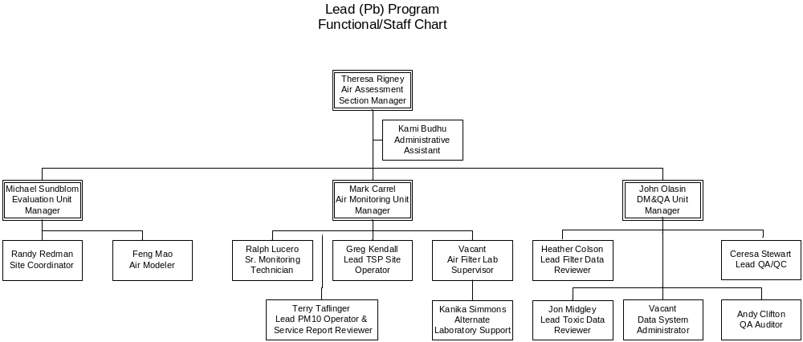

Figure A.2 ADEQ Air Quality Division Organizational Chart

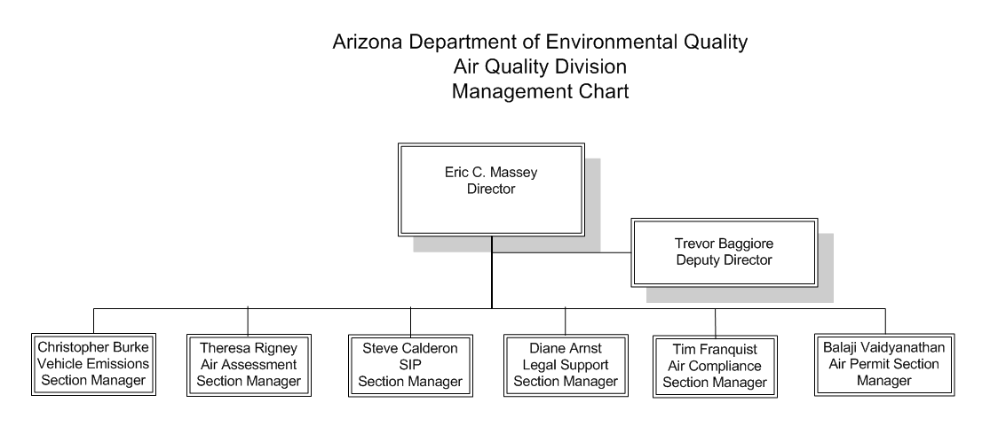

PCWRL is responsible for providing analytical laboratory services as stipulated in the IGA. Responsibilities include: analyzing Pb air filter samplers according to approved method EQL-0510-191, archival of solubilized filter samples for a period of 30 days minimum and reporting analytical results in a timely manner to ADEQ.

Table A.2 shows key personnel with PCWRL.

Table A.2 Pima County Wastewater Reclamation Laboratory Personnel
Program Title: Pb Ambient Air Monitoring Program

Name and Title | Role | Responsibilities | Contact Information
Barbara Escobar,  Laboratory Director | Executive Project Director and Interagency Liaison | Program Oversight & Contract Liaison | Barbara.Escobar@wwm.pima.gov  (520) 724-6052
Nancy Powell,  Quality Assurance Officer | Quality Assurance Officer | Quality Management Plan, QA Oversight | Nancy.Powell@wwm.pima.gov  (520) 724-6183
Belinda Gamboa-Felix,  Environmental Data Project Supervisor | Data Management and Analytical Reports | Report and data deliverables | Belinda.Gamboa-Felix@wwm.pima.gov  (520) 724-6007
Richard Aros,  Chemical Specialist | Inorganic Chemical Lab Supervisor | Analytical laboratory logistics and deliverables  Pb Prep Sample coordination | Richard.Aros@wwm.pima.gov  (520) 724-6065
Melissa Bomar,  Laboratory Chemist | Lead Analyst | Sample preparation and analysis | Bomar.Melissa@wwm.pima.gov  (520) 443-6062

EPA Region 9 is responsible for the following activities in support of this program:
- Reviewing, providing assistance with, and approving this QAPP.
- Responding to requests for technical and policy information and interpretations.
- Evaluating quality system performance through technical systems audits, performance evaluations, and network reviews as appropriate.
- Making available to ADEQ the technical and quality assurance information developed by EPA, and making the ADEQ aware of any unmet quality assurance needs in a timely manner.

A.5 PROBLEM DEFINITION/BACKGROUND

On November 12, 2008, the Final Rule for lowering the National Ambient Air Quality Standards (NAAQS) for ambient airborne concentrations of Pb from 1.5µg/m³ to 0.15µg/m³ for both primary and secondary standards was published in the Federal Register (see 73 FR 67052). The revised NAAQS became effective on January 12, 2009. Stationary sources are thought to be the major emitter of airborne Pb particles, but mobile sources contribute as well. Monitoring and quality assurance requirements for Pb are found in 40 CFR Parts 53 and 58. There are no anticipated end dates for the air monitoring of Pb particulates under either standard. Lead is one of six criteria pollutants regulated by the EPA under the NAAQS.

The primary standard was revised to better public health, especially in “sensitive” populations which include asthmatics, children, and the elderly. An array of adverse health effects can be attributed to Pb exposure including neurocognitive and neurobehavioral effects in children. Initially, Pb monitoring was required near sources that emit more than one ton of Pb per year. EPA later revised the Pb monitoring requirements to include monitoring near sources that emit more than 0.5 tons of Pb per year.

To comply with the current primary NAAQS, ADEQ will operate two source-oriented sites east of the Phoenix metropolitan area near the towns of Hayden and Miami. The sites are near copper smelting facilities operated by the American Smelting and Refining COmpany (ASARCO), Inc. and Freeport McMoRan, Inc., respectively. Tables and figures showing maps and metadata for these sites can be found in Section B. The mining and smelting operations release Pb particulate into the atmosphere. The rationale for siting stations in their current location can be found in Attachments A and B.

ADEQ started monitoring for ambient Pb in these two areas at the beginning of the 4th quarter 2010. The EPA required Pb monitoring at the beginning of 2010, but ADEQ funding limitations delayed the purchase of the new instrumentation until the summer of 2010. In addition to ADEQ’s Pb sampling near Hayden, additional EDOs under the direction of EPA Region 9 are ongoing in a portion of the area which is designated as a Superfund site.

In addition to the required monitors near sources of Pb, EPA‘s revised lead (Pb) ambient air monitoring requirements also require Pb monitors to be placed in large urban areas. Pb monitors are required at NCore sites that are located within Core Based Statistical Areas (CBSAs) with a population of 500,000 people or more. To meet this requirement, ADEQ will ascertain Pb concentrations in the Phoenix metropolitan area at ADEQ’s NCore site: the JLG Supersite, also known as (aka), Phoenix Supersite. The Pb concentrations generated from the JLG Supersite will come from the speciated PM₁₀ filter sample used for metals’ analyses for the National Air Toxics Trends Stations (NATTS) program. Therefore, the collection of Pb samples at the JLG Supersite will satisfy monitoring requirements for the Pb NAAQS and the NATTS programs.

It is worth noting that a PM₁₀ filter sample has been collected at JLG since January 2005 and analyzed using an inductively coupled plasma with mass spectrometry (ICPMS) analytical method specified by the NATTS program. However, the analytical method employed by the contract laboratory at the time was not necessarily approved by the EPA’s Office of Research and Development (ORD) as currently required for the detection of airborne Pb concentrations that are used in comparison to the NAAQS. The ERG’s ICPMS analytical method was approved in June 2012 and this designation was posted in the Federal Register (see 77 FR 32632) as per EPA regulations 40 CFR Part 53. Although the earlier analytical method(s) is essentially the same, using Pb data obtained from JLG prior to June 2012 may not be advisable depending on how the data will be used. If such data become of interests for purposes other than NATTS-related information, EPA should be consulted regarding suitability of use.

The ADEQ serves as the Primary Quality Assurance Organization (PQAO) for any primary and secondary NAAQS Pb air monitoring data collected throughout the State of Arizona with the exception of Maricopa and Pima Counties. Maricopa and Pima Counties are each designated as a PQAO by EPA Region 9, and they are responsible for all aspects of their Pb air monitoring network.

A.6 PROGRAM DESCRIPTION

The principal objective of the Pb network is to measure the concentration of Pb in ambient air at two different types of monitoring sites: source-oriented and non-source-oriented.

For source-oriented Pb monitoring, ambient air samples will be collected onto 8” X 10” fibrous glass filters using high-volume TSP samplers as required by EPA. Samples will be collected on the EPA 1/6 day national air monitoring schedule which is found at: http://www.epa.gov/ttn/amtic/calendar.html. See Attachment C for the 2013 schedule. Collocated samples will be collected on every 1/6 sample run day and one of the non-required collocated samples per quarter will be used for the EPA Pb PEP program. The PCWRL will analyze samples using the EPA approved method “EQL-0510-191; Determination of Lead Concentration in TSP by Inductively Coupled Plasma Mass Spectrometry (ICP-MS) with Heated Ultrasonic Nitric and Hydrochloric Acid Filter Extraction”.

For non-source-oriented Pb monitoring, ADEQ will use a low-volume sampler to collect a PM₁₀ filter sample at JLG Supersite, ADEQ’s NCore site. Samples will be collected onto a polytetrafluoroethelyne (aka, Telfon®) filter on the EPA 1/6 day national air monitoring schedule. Collocated samples are not required at JLG and ADEQ does not currently plan to collect them. The ERG will analyze samples using the EPA approved method “EQL-0512-202, Determination of Lead in PM₁₀ by Inductively Coupled Plasma Mass Spectrometry (ICP-MS) with Hot Block Dilute Acid and Hydrogen Peroxide Filter Extraction”.

Meteorological measurements will also be collected at the Pb sites in support of the Pb program. Data generated from these instruments may provide useful information regarding the source or origin of Pb in ambient air. Monitoring methods and objectives for meteorological monitoring will be addressed in a separate QAPP.

A.7 QUALITY OBJECTIVES and CRITERIA

Quality objectives and associated criteria establish the foundation upon which air monitoring data collection operations are conducted. For air monitoring organizations to consistently and confidently produce and report data of a known quality that also compare to each other, a number of decisions regarding how the data will be collected and evaluated must be made prior to launching major air monitoring programs. Statistical goals and a host of operational criteria are established for field, laboratory, and data validation operations. Over time as air monitoring instruments become more sophisticated and regulatory limits for pollutants potentially decrease, these goals and criteria are reviewed and adjusted as needed by air quality professionals from EPA and the monitoring organizations to ensure high quality data are produced for use by decision makers.

Two types of quality objectives are commonly developed and applied to ambient air monitoring programs: data quality objectives (DQOs) and measurement quality objectives (MQOs). These objectives are defined below; but in general, they establish and provide a means to control the error in data at or below a level determined to be acceptable, or tolerable, to the decision maker (customer) who uses the data to make decisions regarding the publics’ health and welfare. If data were to contain a level of error that exceeds what is tolerable, the decisions made could either invoke compliance actions that were not necessary or fail to invoke appropriate compliance actions to protect publics’ health and welfare; neither produces a desirable outcome. The basic idea is that if we follow established MQOs, the data are expected to meet any established DQOs. But, to truly know if DQOs are being achieved, an assessment must be performed where the data produced are evaluated against the DQOs. More information on assessments is provided in Section C. However, it is important to note that this comparison of data to the DQOs is the final step in completing the quality system cycle for an ambient air monitoring operation. DQOs are evaluated and amended over time as needed to reflect realistic goals. Figure A.3 shows the quality assurance life cycle’s stages that are applied to ambient air monitoring programs to help ensure data produced meet their objectives.

Figure A.3. The Ambient Air Quality Monitoring QA Program
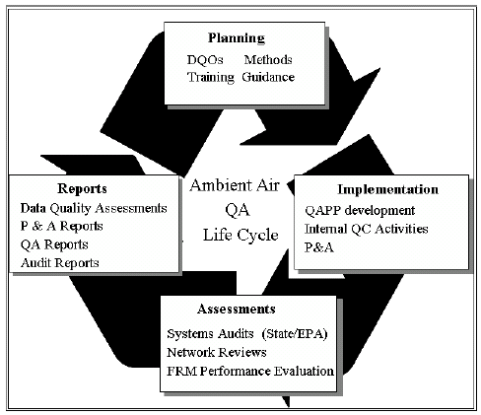
Source: The EPA Quality Assurance Handbook for Air Pollution Measurement Systems: Volume II: Ambient Air Quality Monitoring Program (2008 version)

It is worth noting that the Pb regulations found in 40 CFR Part 50 Appendix B and G were not updated prior to the 2008 changes to the NAAQS. However, the EPA Office of Air Quality Planning and Standards (OAQPS) held a number of conference calls and provided a number of technical notes regarding changes to the Pb monitoring program which are reflected in this QAPP. The technical notes and additional information can be referenced on the EPA’s Technology Transfer Network’s Ambient Monitoring Technology Information Center’s (AMTIC) Lead Monitoring website. The technical note on “Quality Assurance Issues” contains information on the DQO and MQO goals.

In addition, at the time this QAPP was written, an update to the “Pb High Volume (TSP) Validation Template” provided in the Quality Assurance Handbook for Air Pollution Measurement Systems: Volume II: Ambient Air Quality Monitoring Program (QAHBV2) 2008 version was in development but had not been released. Upon establishing an operating history with the new TSP samplers, we compared our observations gained from operating the TSP samplers to the new MQOs and the existing data validation template found in the QAHBV2. Based on the experience gained from operating the TSP samplers at the source-oriented stations, ADEQ customized a validation template to reflect the acceptable range of criteria to be used for sample validation. ADEQ’s validation template is provided in this QAPP. ADEQ personnel feel confident that following best practices and the approved operating criteria will ensure any error from field operations will remain within tolerable levels and that the data we generate is of high quality.

In addition, all laboratories seeking to perform analytical services for the Pb samples must have to have their procedure/method approved by EPA to ensure tolerable levels of error from laboratory practices are not exceeded.

Data Quality Objectives

The DQOs are defined as the qualitative and quantitative statements derived from the DQO planning process that clarify the purpose of the study, define the most appropriate type of information (data) to collect, determine the most appropriate conditions from which to collect that information, and specify the tolerable levels of potential decision errors. DQOs are based on the data requirements of the user, or decision maker, who needs to feel confident that the data used to make environmental decisions are of adequate quality. DQOs assess the adequacy of data (new or existing) in relation to the intended use. ADEQ has developed the following objectives for the Pb program.

The EPA publishes DQOs for air monitoring programs collecting data used for comparison to the NAAQS as well as other types of air monitoring programs. EPA used the DQO process to determine the appropriate precision and bias MQOs for the Pb program, but at the time this QAPP was written, no broad DQO statements were written for the Pb program similar to other programs such as the NATTS. Therefore, the ADEQ developed the following objectives for the data collected from the Pb monitoring network. The objectives are to:

- Determine total suspended particulate (TSP) or PM10 concentrations of airborne Pb for comparison to the NAAQS
- Ascertain the impact regulated sources have on air quality in their vicinity
- Provide an estimate of the reasonableness of source-oriented sites selected based on air shed models and to adjust site locations if needed
- Determine the level of ambient airborne Pb occurring in the Phoenix Metropolitan area
- Support the development and implementation of a SIP (if required)
- Produce high quality data for decision makers (data users) such as public health officials assessing the potential ill health effects associated with Pb

Measurement Quality Objectives

MQOs are designed to evaluate and control various phases of the measurement process to ensure that total measurement uncertainty is within the range prescribed by the DQOs. ADEQ will adhere to the MQOs developed by the EPA. EPA intends to assess the following goals on three years of data at the PQAO level of aggregation.

The EPA’s MQOs for the Pb program (source-oriented/TSP samplers) are:

- Precision goal is ≤ 20% coefficient of variation (CV) for a 90% confidence limit. The measure of precision will be determined from the Pb concentration of the collocated TSP filter samples and will only include Pb concentration data > 0.02 µg/m³.

- Overall absolute bias upper bound goal is ≤ 15% at the 95% confidence limit. The measure of absolute bias will be determined by the field-portion of the Pb PEP audit program for the TSP samplers. The EPA, or their contractor, will collect a filter sample on a regularly scheduled collection day using an EPA-selected TSP sampler that will be temporarily collocated at one of the source-oriented sites. It is worth noting that as per the EPA issued “Technical Note – Pb Monitoring Implementation Strategy Quality Assurance Issues”, “this process does not suggest that the Pb-PEP sampler or lab technique is superior to those used by the monitoring organization; it simply allows for a better comparison of differences should they exist.”

The tests above help determine measurement uncertainty that could be introduced into the sample collection process beginning with the unexposed filter setup through analysis at the laboratory. To date, the EPA has not established a Pb PEP requirement for the collection of Pb samples using the low-volume PM₁₀ samplers as ADEQ is performing at the NCore site. Intercomparision tests for Pb sample collection using this method will be implemented as required if added in the future.

In addition to the EPA’s MQO’s, ADEQ plans to evaluate additional information from data routinely collected in the Pb program to further evaluate how well other quality control checks perform over time. ADEQ plans to use the statistics provided by the AMP 255 Report to determine how well we meet the following metrics. The use of this information is voluntary and for in-house goals only.

ADEQ’s supplemental MQOs for the Pb program (source-oriented/TSP samplers) are:

- For flow rate verifications, an annual absolute bias goal of ≤ 7% based on all TSP flow rate verifications that pass flow rate acceptance criteria. If a sampler fails a verification check, the flow rate value for that check will not be averaged into the annual bias statistic.
- For the quarterly Pb audit strips, a bias goal of ± ≤ 10% will be targeted.

These goals will be evaluated periodically by EPA and ADEQ. It is anticipated that EPA will assess the nation-wide MQO goals on three years of data at the PQAO level of aggregation. ADEQ plans to assess these goals both annually by way of the data certification process, and on a three year basis, by way of the EPA’s report. ADEQ’s in-house goals will be monitored on an annual basis. As QA/QC data are collected and evaluated over the course of the Pb program, MQOs may be revised or updated based on the initial results.

Data Quality Indicators

To help assess how Pb data compare to the established DQOs and/or MQOs, data quality indicators (DQI) are used. DQIs provide additional information used for evaluating the quality of data. The EPA provides a software program that produces the AMP 255 Report which is a report on some of the DQIs. In addition, EPA posts an annual DQI report on AMTIC which ADEQ will begin utilizing more frequently to assess how well the Pb program is meeting certain DQIs. This report is located at: EPA - TTN - AMTIC Quality Indicator Assessment Reports. ADEQ will enter the information provided from flow rate verifications, the Pb PEP program’s collocated sample results, and performance evaluation audits into the program which calculates statistical results for precision and bias. Some DQIs must be assessed manually by technical personnel.

DQIs for the Pb program are:

  - Representativeness – is a measure of the degree to which data accurately and precisely represent a characteristic of a population, parameter variations at a sampling point, a process condition, or an environmental condition. Representativeness is controlled largely by the site location.
  - Precision – is the measure of mutual agreement among individual measurements of the same property usually under prescribed similar conditions. This is the random component of error. Precision is estimated by various statistical techniques using some derivation of the standard deviation (based upon monitoring calibration and verifications). Precision is determined using collocated sampling results and routine verifications.
  - Bias – is the systematic or persistent distortion of a measurement process which causes error in one direction. Bias will be determined by estimating the positive and negative deviation for the true value as a percentage of the true value. There are different ways to assess bias. Bias can be determined by an assessment of the comparability between routine flow rate verifications and routine PE audits. The Pb PEP program can also provide a measure of bias.
  - Detectability – is the determination of the low range critical value of a characteristic that a method specific procedure can reliably discern. The method sensitivity for the analysis of Pb samples using ICPMS is adequate for determining Pb at concentrations equal to, or less than, 5% of the NAAQS (0.15 µg/m³). The type of air sampler and filter media selected to collect Pb samples can affect comparability. The Pb TSP samplers collect particulate matter with aerometric diameter of up to 50 micrometers and the PM10 sampler collects particulate matter with aerometric diameter of up to 10 micrometers.
  - Comparability (reporting units and analysis) – Pb concentrations will be reported in micrograms/meter cubed (µg/m3) as required by EPA for air monitoring organizations. Monitoring measurement uncertainty also ensures data are comparable with other agencies.
  - Completeness – a measure of the amount of valid data obtained from the measurement system compared to the amount that was expected to be obtained under correct, normal conditions. The minimum data completeness requirement set by EPA is 75% for a rolling three-month period. ADEQ is targeting 85% completeness for a rolling three-month period.

A variety or errors can result in a sample being missed or an analytical result not being available. These include:

- Sampling error such as instrument failure or malfunction
- Collection error such as damaging a filter during retrieval
- Shipping error such as a shipment being lost
- Laboratory error such as a filter being damaged prior to analysis
- Quality assurance/quality control error such as PE audit failures and analytical laboratory criteria not being met

All monitoring instruments will be operated within the acceptance criteria defined by ADEQ, which meet or exceed the minimum EPA requirements. Operating criteria for the TSP samplers are found in Section B on Table B.12. In addition, some of this information is shown on the “ADEQ Pb High-Volume (TSP) Validation Template” found in Section D. This template is used for the validation of data.

Additional information concerning ADEQ’s air monitoring plan per site can be found under Sampling Methods on Table B.4 and under Analytical Methods on Table B.5. If any instrument fails its verification, calibration, or performance evaluation (PE) audit, AMU will take the appropriate actions to correct instrument performance as quickly as possible to prevent missing scheduled sample collection days.

A.8 SPECIAL TRAINING/CERTIFICATIONS

The TISCH HIGH-VOL+ TSP air samplers purchased by ADEQ for source-oriented Pb monitoring had not been operated by AQD prior to 2010. In previous years, early versions of high-volume TSP samplers were used for particulate air monitoring. However, use of those samplers was discontinued years ago due to more sophisticated low-volume samplers becoming the required method for particulate matter sampling and the requirement to sample for airborne Pb being lifted after sufficiently low levels of Pb were detected in Arizona for a suitable period of time.

ADEQ conducts on-the-job training as the primary means of training personnel. In general, AMU’s plan is for new personnel to work with experienced personnel for a period of about one to three months. Before working independently, new personnel must exhibit, to a technician with more seniority in AMU, the knowledge, skill, and ability needed to successfully operate an air monitoring instrument(s). Personnel have adequate time to review instrument manuals, monitoring literature, and EPA regulations. Technical personnel have access to the ADEQ QMP, QAPPs, and SOPs as well as other guidance such as the manufacturer’s operating manuals. Management will provide sufficient time for personnel to read and understand these documents. AQD strives to provide professional development to employees whenever possible. Training includes courses, workshops, conferences, or trade shows. In addition, employees participate in webinars provided by EPA and complete self-instructional courses available through EPA’s Air Pollution Training Institute (APTI). Each employee’s professional development is reviewed annually by the unit manager.

A.9 DOCUMENTATION AND RECORDS

Personnel within the AAS use our shared network for storing documents electronically in addition to maintaining hard copies of program-related documents. The network drive is backed up daily by ADEQ Information Technology. Documents are stored for a minimum of five years.

The modeling reports developed by the Evaluations Unit for source-oriented site selection are provided in Attachments A and B and electronic copies are found in each sites respective folder at: J:\AQD\AQD\ASSESS\MONITORING UNIT\SITE_LOG\ADEQ Active Sites.

AMU service documents, otherwise known as field sheets, related to the operation of air monitoring sites and instruments are generated and stored in hardcopy site files and/or electronically in each site’s folder at: J:\AQD\AQD\ASSESS\MONITORING UNIT\SITE_LOG\ADEQ Active Sites. Field sheets include: site logs, instrument logs, communication logs, instrument verification and calibration sheets, site and instrument change forms, and field service reports. The hardcopy reports are reviewed and approved by the AMU Manager and/or the field service report reviewer then routed to the QA/QC Lead for review and dissemination to the Pb data reviewers for use during data review and validation. DM&QA uses these documents for Level 3 data validation.

The AFL manages the ADEQ Lead_{TSP} Air Sampling Record, i.e., a form associated with each sample that combines chain-of-custody (COC) and field data information. An original and two copies are produced with each form using no-carbon-required sheets. The original accompanies the sample when it is sent to the analytical laboratory. A copy is maintained by the AMU operator and by AFL along with the shipment records.

In addition, the QA Auditor submits the PE audit field sheets to the QA/QC Lead for review and dissemination to the Pb data reviewer(s). The QA Team will submit any technical system audit (TSA) reports to the DM&QA Unit Manager for approval. Once approved, the report will be sent to the AAS Manager and the AMU Manager for review.

Section D contains more detailed information regarding how data will be managed from the Pb network. The source-oriented Pb concentration data and its associated quality control data will be archived by ADEQ in the Air Assessment Ambient Database (AAAD) for future reference by the agency and other interested parties. Data will be uploaded to the EPA AQS database as required by EPA. Non-source-oriented Pb concentration data and its associated quality control data will be stored in AAAD, but the uploading to AQS may be a shared task with ERG. Also, it is possible that the process for uploading this non-source-oriented data may change over time. Table A.3 shows a summary of documents stored by ADEQ and their locations.

Table A.3. Summary of ADEQ Documents and Records
Type of Record | Medium | Data Storage Location(s) | Responsibility
AQS Reports | Electronic | J:\AQD\AQD\ASSESS\DATA MANAGEMENT AND QA UNIT\DM\Programs\NAAQS\Lead | DM&QA
Calibration and verification records | Hardcopy and electronic | DM&QA Site File or  J:\AQD\AQD\ASSESS\MONITORING UNIT\SITE_LOG\ADEQ Active Sites  and DM&QA Site File | AMU and DM&QA
Certificates for all instruments and standards | Hardcopy and Electronic | DM&QA Site File, AMU instrument files  J:\AQD\AQD\ASSESS\MONITORING UNIT\SITE_LOG\ADEQ Active Sites and | AMU and DM&QA
Corrective Action Reports | Hardcopy and Electronic | DM&QA Site Files or  J:\AQD\AQD\ASSESS\DATA MANAGEMENT AND QA UNIT\Quality Assurance\Corrective Actions | QA Team
Custody and field data forms | Hardcopy and Electronic | AMU COC Files or  J:\AQD\AQD\ASSESS\DATA MANAGEMENT AND QA UNIT\DM\Programs\NAAQS\Lead | AMU, DM&QA, and PCWRL
Data Review/Validation forms and notes | Electronic | J:\AQD\AQD\ASSESS\DATA MANAGEMENT AND QA UNIT\DM\Programs\NAAQS\Lead | DM&QA
Downloaded files from samplers with QC data | Electronic | J:\AQD\AQD\ASSESS\MONITORING UNIT\Airlab\Field Instruments\Field Instrument Data (Palm Data)\Lead Sites | AMU
Lab validated data sets sent from the laboratory to ADEQ including metadata | Electronic | J:\AQD\AQD\ASSESS\DATA MANAGEMENT AND QA UNIT\DM\Programs\NAAQS\Lead | DM&QA
Maintenance and service records | Hardcopy | AMU Instrument File and DM&QA Site File | AMU and DM&QA
Pb QAPP | Hardcopy and electronic | Hardcopies provided to AMU and DM&QA staff  and  J:\AQD\AQD\ASSESS\QUALITY ASSURANCE DOCUMENTS\QAPPs & SOPs\QAPPs | QA Team
Quality Assurance Audit Records  (includes all audit reports, e.g., PE audit, TSA, ADQ, etc.) | Hardcopy and electronic | DM&QA Site Files  and  J:\AQD\AQD\ASSESS\MONITORING UNIT\SITE_LOG\ADEQ Active Sites | DM&QA
Raw Data | Electronic | J:\AQD\AQD\ASSESS\DATA MANAGEMENT AND QA UNIT\DM\Programs\NAAQS\Lead | DM&QA and PCWRL
Sample Preparation notes | Hardcopy and Electronic | Notes stored at PCWRL and available upon request by ADEQ | PCWRL
Shipping and receiving records | Hardcopy | AMU Shipping File | AMU/AFL
Site and instrument logbooks | Hardcopy | Site logbooks (SLB) remain at site until closure unless storage space is not available – then retired SLBs will be stored at AMU; and  a copy of SLB entries is stored in DM&QA site folders.  Instrument logbook travels with sampler until retired – then in AMU | AMU and DM&QA
Site Information | Hardcopy and Electronic | Network Plan  J:\AQD\AQD\ASSESS\DATA MANAGEMENT AND QA UNIT\DM\Docs\AQD\Reports  And  J:\AQD\AQD\ASSESS\MONITORING UNIT\SITE_LOG | AMU and DM&QA
Site Photographs | Hardcopy and Electronic | Network Plan  J:\AQD\AQD\ASSESS\DATA MANAGEMENT AND QA UNIT\DM\Docs\AQD\Reports  And  J:\AQD\AQD\ASSESS\MONITORING UNIT\SITE_LOG | AMU and DM&QA
SOPs | Hardcopy and Electronic | Hardcopies provided to AMU and DM&QA staff  and  J:\AQD\AQD\ASSESS\QUALITY ASSURANCE DOCUMENTS\QAPPs & SOPs\SOPs\ADEQ Final SOPs | QA Team
Training records | Hardcopy | Unit Manager’s Staff Files and  J:\AQD\AQD\ASSESS\QUALITY ASSURANCE DOCUMENTS\TRAINING_RECORDS\Internal (Employee) | AAS
Validation documents and notes | Electronic | J:\AQD\AQD\ASSESS\DATA MANAGEMENT AND QA UNIT\DM\Programs\NAAQS\Lead  and  J:\AQD\AQD\ASSESS\DATA MANAGEMENT AND QA UNIT\DM\Docs\AQD\Reports\Quarterly Data Review | DM&QA

The PCWRL, ADEQ’s selected laboratory for the source-oriented samples, maintains all laboratory records separately from ADEQ’s AAS. The type of records maintained, the location they are stored, and the person responsible for maintaining these records are listed with the table below. Table A.3 shows the documents and records that are generated in conjunction with the Pb program. Table A.4 shows the PCWRL documents and records generated for the Pb program.

Table A.4 Summary of PCWRL Documents and Records
Type of Record | Medium | Data Storage Location(s) | Responsibility
Audit Records | Hardcopy and electronic | Arizona Department of Health Services | ADHS Lab Licensure
Calibration and verification records | Electronic | PCRWRD CRAO Lab  ICPMS computer for each run - backed up on CD and/or network. | Lab  Richard Aros
Certificates for all instruments and standards | Hardcopy and Electronic | PCRWRD CRAO Lab  Attached to each standard in Element | Lab -  Richard Aros, electronic copies
Control Charts | Electronic | PCRWRD CRAO Lab  Hardcopy in Supervisor’s Office  Hard copy only by Importing data into qc program and printing graphs.  Audit Strips: Z:\Dir Div\CRAO\Lab Svcs\_Shared Data\Lab\Inorganic Unit\Inorganic Unit  Available in Element under QA Admin-Control Charts | Lab – Nancy Powell, hard copies  Richard Aros, electronic copies
Corrective Action Reports | Electronic | PCRWRD CRAO Lab  X:\CRAO\Lab Svcs\_Shared Data\Lab\Corrective Action\Inorganic\EQL TSP air filters | Lab – Nancy Powell
Chains of Custody | Hardcopy & Electronic | PCRWRD CRAO  Files, Electronic PDF’d with Final Report | Lab – Belinda Gamboa
Data Review/Validation forms and notes | Hardcopy and electronic | PCRWRD CRAO Lab  Hardcopies in Supervisor’s Office, Electronic Element Approvals | Lab - Richard Aros & Nancy Powell
Digestion Log | Hardcopy and Electronic | Notes stored at PCRWRD CRAO Lab  and available upon request by ADEQ  Z:\Dir Div\CRAO\Lab Svcs\Shared Data\Lab\Inorganic Unit\Inorganic Unit\Digestion Logs\Pb Air Filters | Lab – Melissa Bomar
Instrument logbooks | Hardcopy | PCRWRD CRAO Lab benchtop | Lab – Melissa Bomar
Maintenance and service records | Hardcopy | PCRWRD CRAO Lab in Instrument Logbooks | Lab - Melissa Bomar & Belinda Gamboa
Raw Data | Electronic | PCRWRD CRAO Lab Instrument based computers  ICPMS computer and backed up on CD and/or on network | Lab – Richard Aros
SOPs | Hardcopy and Electronic | PCRWRD CRAO Lab Files  Y:\Lab Svcs\_Shared Data\Lab\SOPs | Lab  QA/QC Unit
Training records | Hardcopy and Electronic | PCRWRD CRAO Lab Files  X:\CRAO\Lab Svcs\_Shared Data\Lab\training-files | Lab – Nancy Powell
Final Reports | Hardcopy and Electronic | PCRWRD CRAO Files  X:\CRAO\Lab Svcs\_Shared Data\Lab\training-files | Lab – Belinda Gamboa-Felix

SECTION B. DATA GENERATION and ACQUISITION

B.1 SAMPLING PROCESS (NETWORK) DESIGN

Site Selection and Information

See Attachments A and B for source-oriented siting rationales. The siting of Pb samplers meets 40 CFR Part 58 Appendix E.

Source-Oriented Monitoring Sites

As stated in Section A, site selection was based on the location where the highest level of airborne Pb concentration is expected to occur, the potential for population exposures, and the feasibility of operating samplers. To determine locations that represent the highest concentrations of airborne Pb, dispersion modeling and existing environmental data were used. This information was compared to the location of the population and the ability to obtain power, avoid obstacles that obstruct air movement, provide sufficient security to ensure sample custody and integrity, and safe accessibility for personnel. A review of all factors combined with consultation from the Region 9 contact, yielded the following locations:

- Globe Highway (near ASARCO)
- Miami Golf Course (near Freeport-McMoRan)

NCore (Non-Source-Oriented) Monitoring Site

Site selection was based upon the NCore requirements and the need for sampling to occur in CBSAs where the population is greater than 500,000 people.

- JLG Supersite (in Phoenix)

See Tables B.1, B.2, and B.3 for site and metadata information and Figures B.1, B.2, and B.3 for photographs concerning the above sites. Although ADEQ has no plans to change the type of samplers collecting Pb filter samples at either the non-source-oriented or the source-oriented sites, a change is possible. Furthermore, air monitoring sites tend to be dynamic over time. It is possible that a site could move or that additional air monitoring instruments could be added to measure other pollutants. To view the most current information for a site’s configuration and the air monitoring instruments being operated by ADEQ, see ADEQ’s Annual Network Plan which is posted on ADEQ’s website at http://www.azdeq.gov/environ/air/assessment/links.html.

Table B.1 Site and Metadata Information for the Globe Highway Site
Globe Highway
Site Purpose: NAAQS compliance network and a source permit requirement.

This site is the location of the collocated TSP Pb monitors in Hayden, AZ. ASARCO mine also maintains a sulfur dioxide analyzer at the site. The site is located on the southwest end of a small canyon and is located approximately 1 km to the east/southeast of the ASARCO smelting facility. Due to its proximity to the end of the canyon, the site may be influenced by both broad and local meteorological conditions.

Site Information
AQS ID | None | ADEQ ID | 16593
Address | SR 77 Winkelman, AZ 85292
County | Gila | Groundcover | Gravel
CBSA | Payson | Latitude | 33.002
Surrounding Area | Desert/Residential | Longitude | -110.765
Distance to road | 5 m – W | Elevation | 602 m
Traffic count | n/a | Site Established Date | 01/01/1975

Pb Monitoring Information
Monitor | Pb TSP | Wind | Temp/RH
Network | SLAMS | MET | MET
Objective | Source | Population | Population
Spatial Scale | Middle | Middle | Middle
Monitor Start Date | 10/01/2010 | 04/15/2011 | 04/15/2011
Instrument | Tisch TE-8550-BL TSP | RM Young 5103 Anemometer | Vaisala HMP155 Probe
Instrument Start Date | 10/01/2010 | 04/15/2011 | 04/15/2011
Instrument Location | Platform | Tower | Tower
Analysis method | ICP-MS with Heated Ultrasonic Nitric and Hydrochloric Acid Filter Extraction (TSP) | None | None
Method code | 191 | 40 | --
Sampling schedule | 1 in 6 | Continuous | Continuous
Sampling duration | 24 hour | Hourly | Hourly
Sampling season | All year | All year | All year
Probe height from ground | 2.5 m | 10 m | 2 m
Probe distance from structure | -- | -- | 1 m
Distance from obstructions | 3.7 m | -- | 32 m
Distance from trees | 1.5 m | -- | 36 m
Unrestricted airflow degrees | 330° | 360° | 360°
Distance between collocated monitors | 1.8 m | -- | --
In climate-controlled shelter? | N | N | N
Flow-rate verification frequency | Every 12 days | -- | --
Monitor audit frequency | Quarterly | Annual | Annual
PEP audit monitor? | Y | -- | --
Data submitted to AQS? | Y | N | N
Data submitted to AirNOW? | N | N | N

Figure B.1 Photographs of the Globe Highway Site

Site Photos
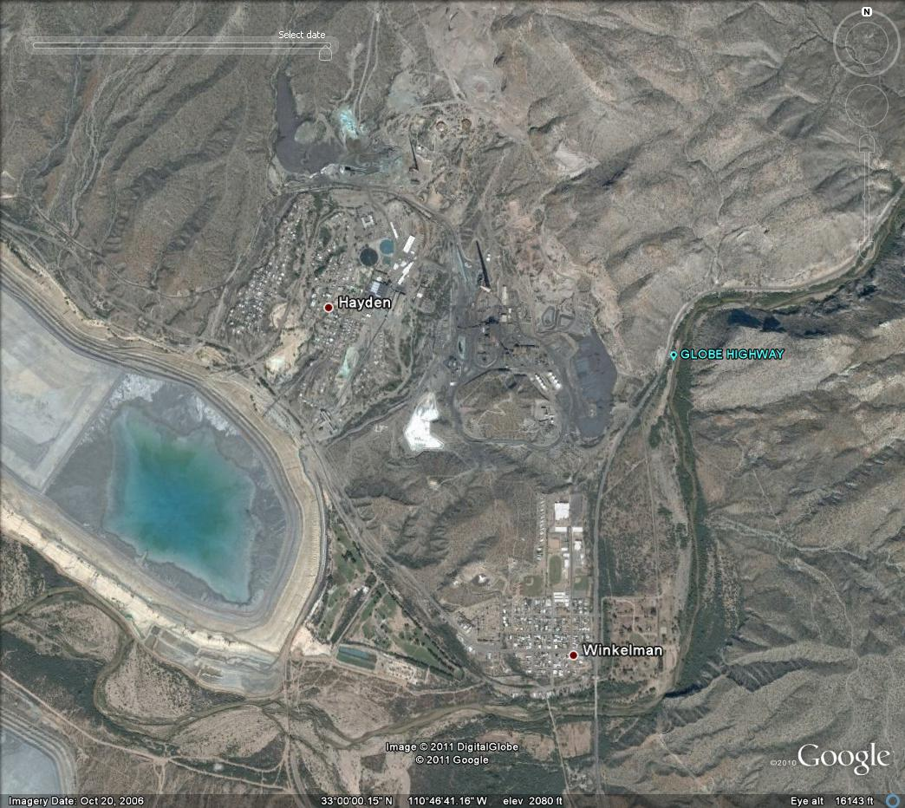  Aerial view of Globe Highway | 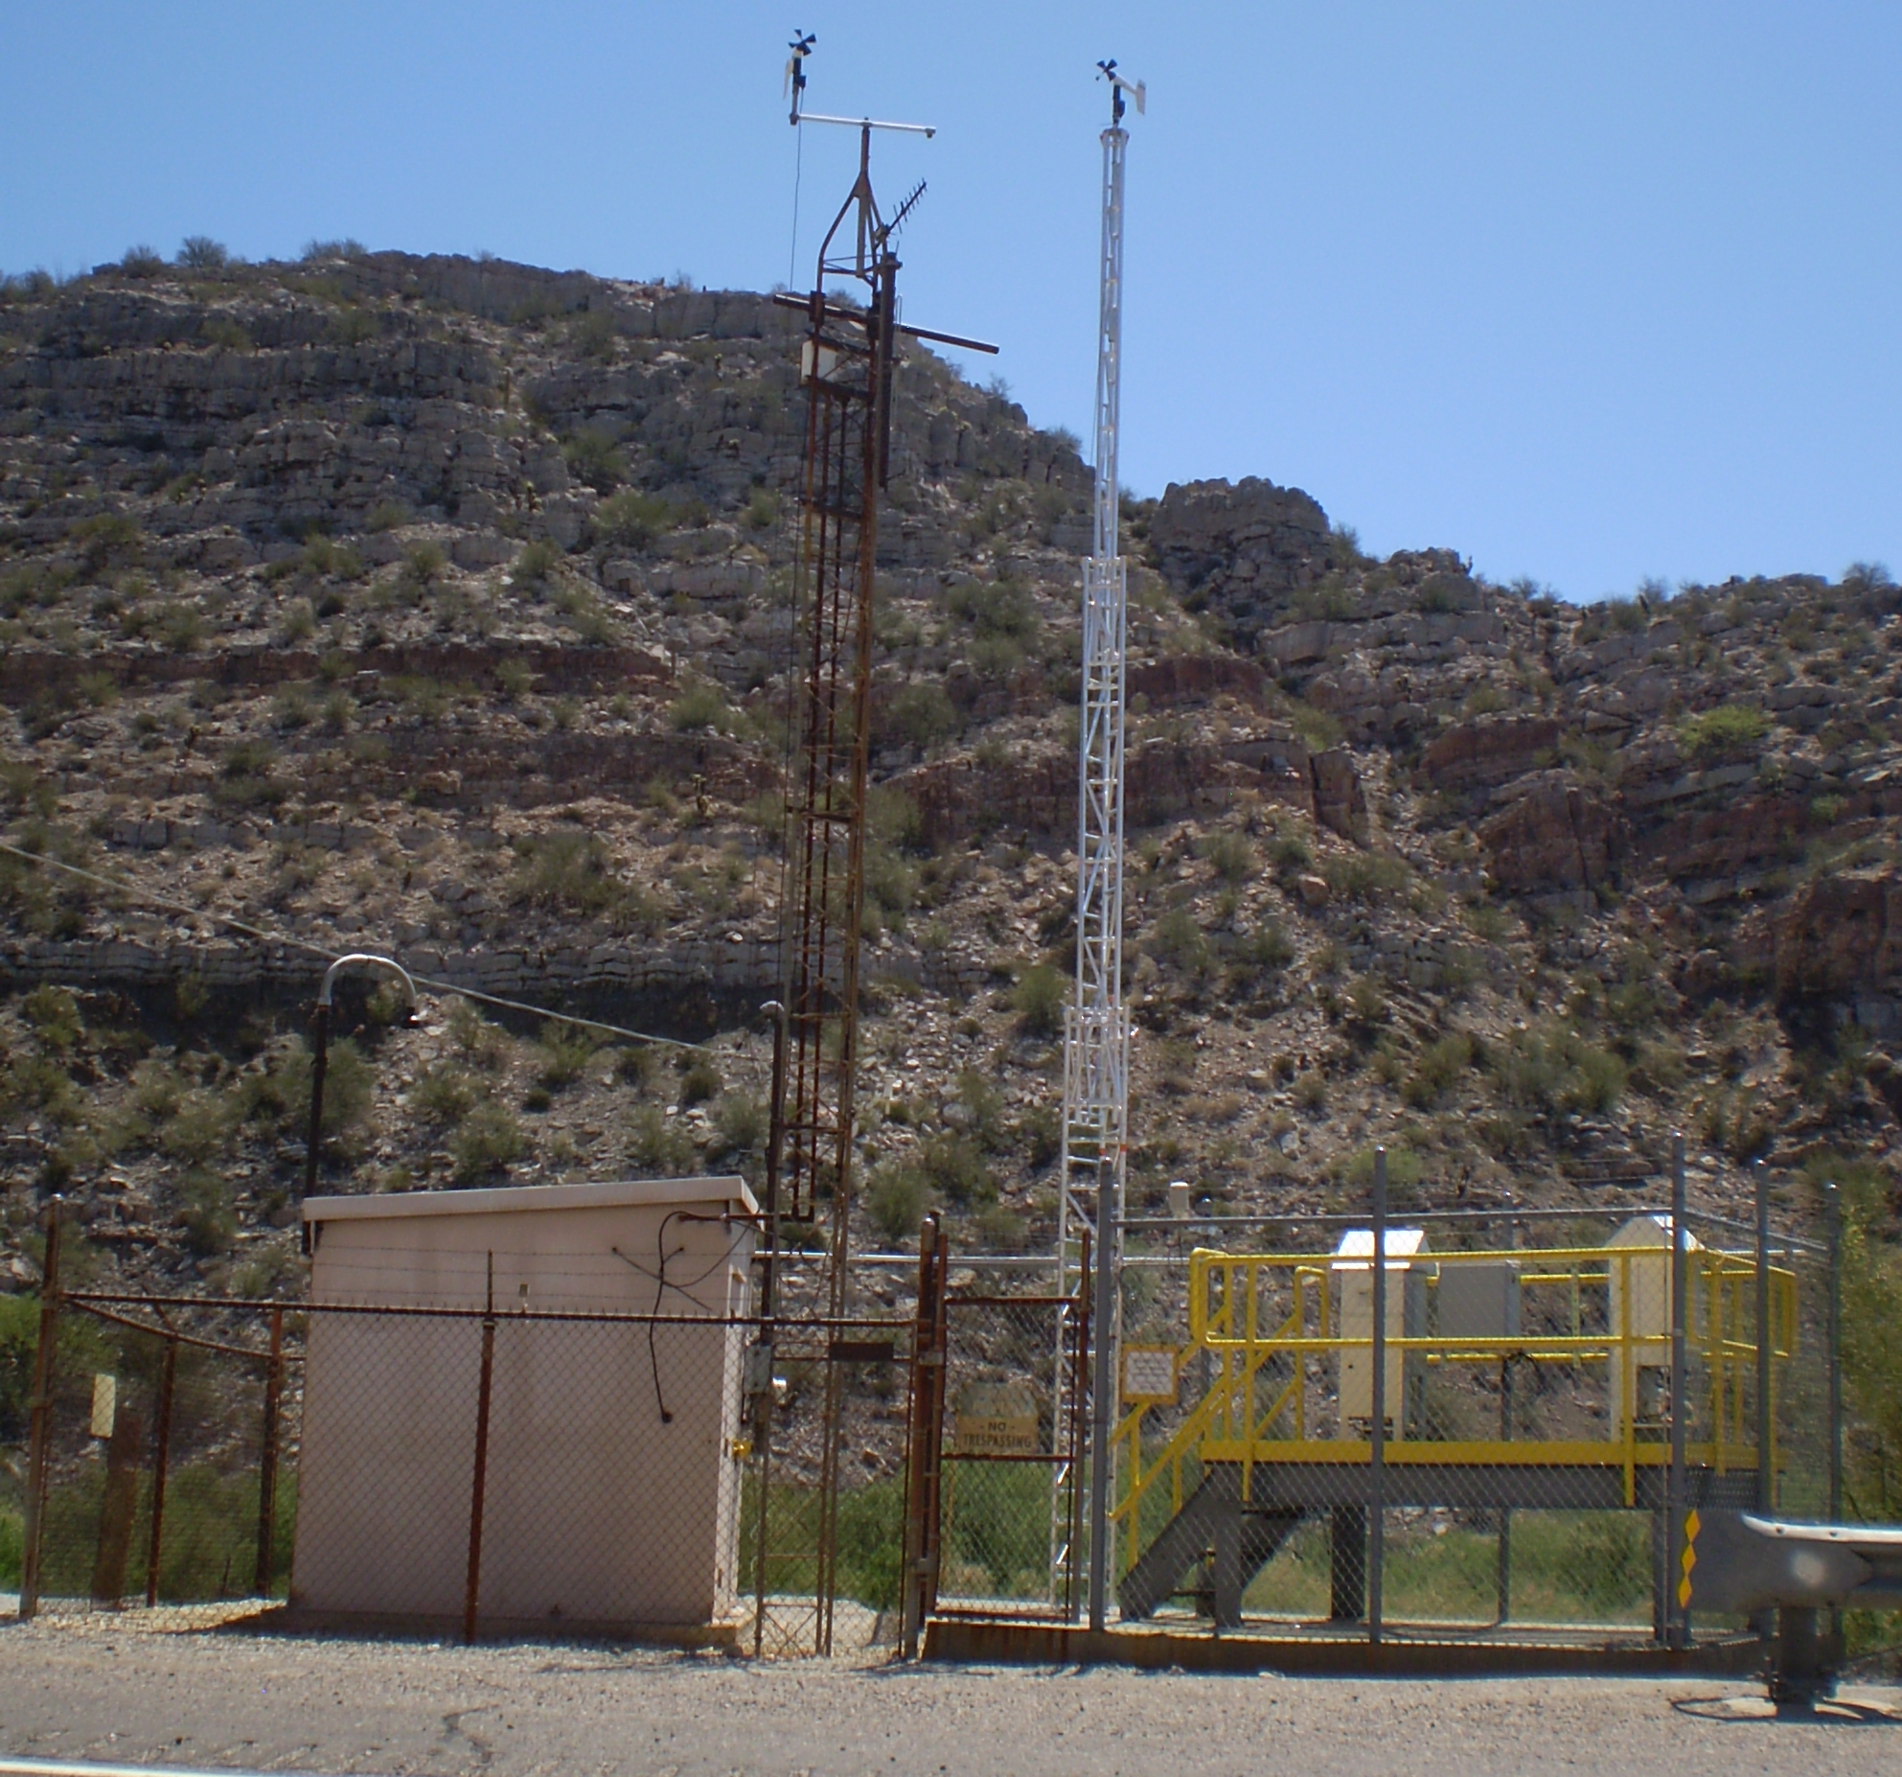  Shelter, towers, and TSP monitors at Globe Highway – 5/10/2011

Table B.2 Site and Metadata Information for the Miami Golf Course Site
Miami Golf Course
Site Purpose: NAAQS compliance network and a source permit requirement.

This site is the location of the TSP-Pb monitor in Miami, AZ. PM₁₀ is also monitored by both Freeport McMoRan and ADEQ at this site. The site is located near the Cobre Valley Country Club with residential areas to the south and east and the Freeport McMoRan facility approximately 2 km to the west/southwest.

Site Information
AQS ID | 04-007-8000 | ADEQ ID | 16629
Address | SR 188 and US 60 Miami, AZ 85539
County | Gila | Groundcover | Gravel
CBSA | Payson | Latitude | 33.4190
Surrounding Area | Residential | Longitude | -110.8296
Distance to road | 230 – E | Elevation | 1000 m
Traffic count | n/a | Site Established Date | 01/01/1997

Pb Monitoring Information
Monitor | Pb TSP | Wind | Temp/RH
Network | SLAMS | MET | MET
Objective | Source | Population | Population
Spatial Scale | Middle | Middle | Middle
Monitor Start Date | 10/01/2010 | 06/08/2011 | 06/08/2011
Instrument | Tisch TE-8550-BL TSP | RM Young 5305 Anemometer | Vaisala HMP 155 Probe
Instrument Start Date | 10/01/2010 | 06/08/2011 | 06/08/2011
Instrument Location | Platform | Tower | Tower
Analysis method | ICP-MS with Heated Ultrasonic Nitric and Hydrochloric Acid Filter Extraction (TSP) | None | None
Method code | 191 | 40 | --
Sampling schedule | 1 in 6 | Continuous | Continuous
Sampling duration | 24 hour | Hourly | Hourly
Sampling season | All year | All year | All year
Probe height from ground | 3.5 m | 10 m | 2 m
Probe distance from structure | -- |  | 1 m
Distance from obstructions | -- | -- | --
Distance from trees | 4 m | 10 m | 5 m
Unrestricted airflow degrees | 180° | 360° | 90°
Distance between collocated monitors | -- | -- | --
In climate-controlled shelter? | N | N | N
Flow-rate verification frequency | Every 12 days | -- | --
Monitor audit frequency | Quarterly | Annual | Annual
PEP audit monitor? | Y | -- | --
Data submitted to AQS? | Y | N | N
Data submitted to AirNOW? | N | N | N

Figure B.2 Photographs of the Miami Golf Course Site

Site Photos
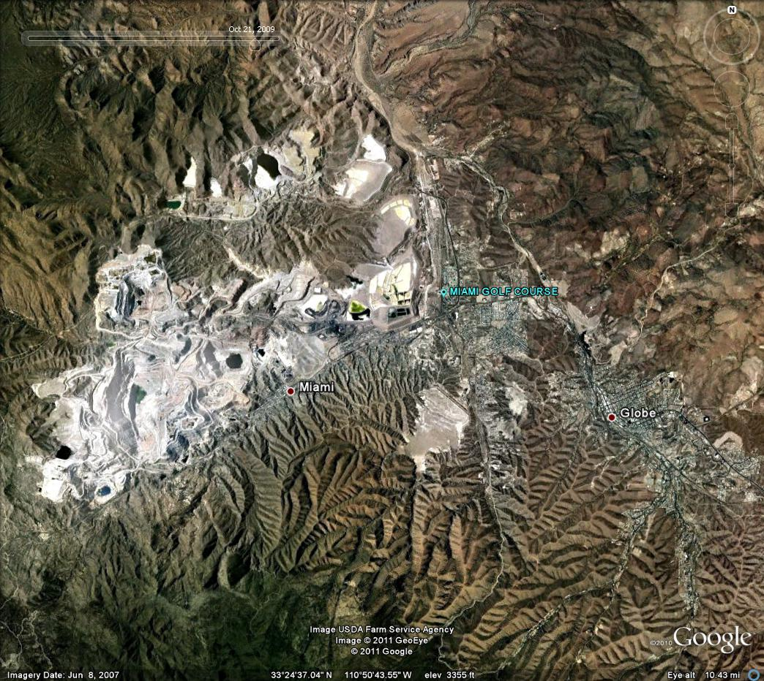  Aerial view of Miami Golf Course | 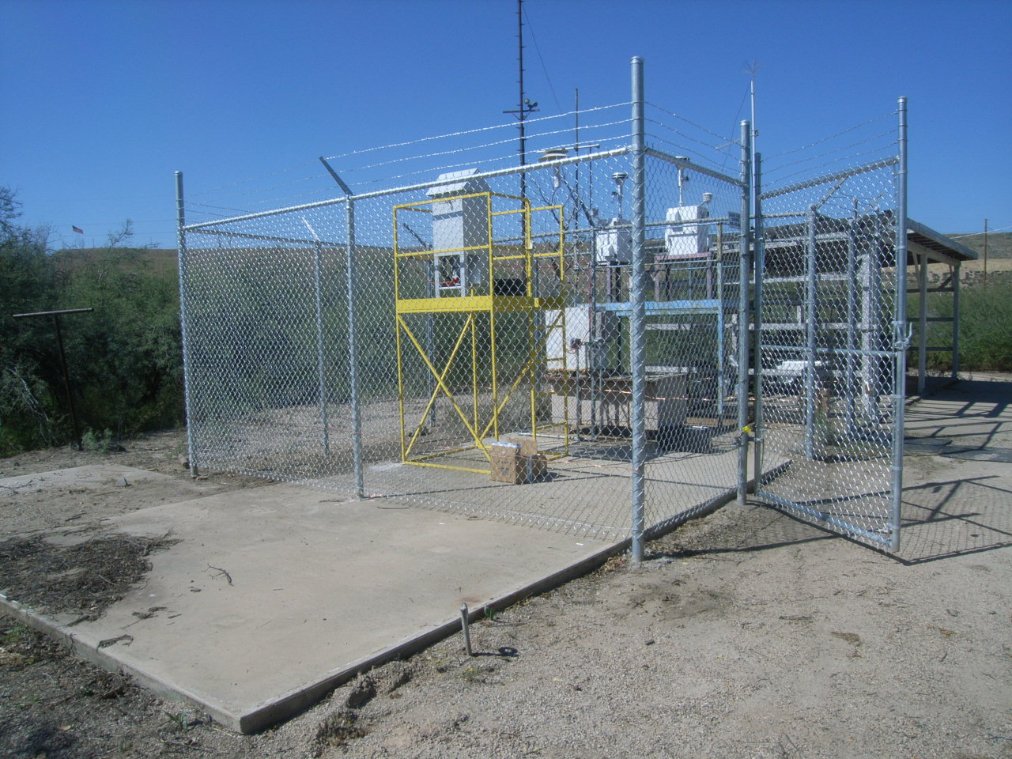  Fenced Miami Golf Course site – 05/2011

Table B.3 Site and Metadata Information for the JLG Supersite
JLG Supersite
Site Purpose: NAAQS compliance network, NCore, PAMS, NATTS, STN, AQI forecasting, monitor urban haze, and meteorological support.

The site was established to represent air quality in the central core of the Phoenix metropolitan area. The surrounding area is primarily residential neighborhoods, with I-17 approximately 1.6 km to the west. This is also an IMPROVE protocol site.

Site Information
AQS ID | 04-013-9997 | ADEQ ID | 16328
Address | 4530 N. 17th Ave. Phoenix, AZ 85015
County | Maricopa | Groundcover | Gravel
CBSA | Phoenix-Mesa-Scottsdale | Latitude | 33.5038
Surrounding Area | Residential | Longitude | -112.0957
Distance to road | 8.5 m – E | Elevation | 354 m
Traffic count | 20,214 – Campbell Ave. | Site Established Date | 07/01/1993

Pb Monitoring Information
Monitor | Pb PM₁₀ | Wind | Temp/RH
Network | SLAMS/NCore | Met/NCore | Met/NCore
Objective | Population | Population | Population
Spatial Scale | Neighborhood | Neighborhood | Neighborhood
Monitor Start Date | 01/01/2005 | 07/01/1993 | 07/01/1993
Instrument | R&P Partisol 2000 | RM Young 5103 Anemometer | Rotronics MP101A Probe
Instrument Start Date | 01/01/2005 | 07/01/1993 | 01/15/2010
Instrument Location | Metal Roof | Tower | Tower
Analysis method | ICP-MS with Heated Hot Block in Dilute Acid and Hydrogen Peroxide Filter Extraction (PM10) | None | None
Method code | 202 | 40 | --
Sampling schedule | 1 in 6 | Continuous | Continuous
Sampling duration | 24 hour | Hourly | Hourly
Sampling season | All year | All year | All year
Probe height from ground | 5 m | 10 m | 2 m
Probe distance from structure | -- | -- | 1 m
Distance from obstructions | 8 m | 8 m | 8 m
Distance from trees | 5 m | 5 m | 5 m
Unrestricted airflow degrees | 210° | 360° | 210°
Distance between collocated monitors | -- | -- | --
In climate-controlled shelter? | N | N | N
Flow-rate verification frequency | Monthly | -- | --
Monitor audit frequency | Biannual | Annual | Annual
PEP audit monitor? | N | -- | --
Data submitted to AQS? | Y | N | N
Data submitted to AirNOW? | N | N | N

Figure B.3 Photographs of the JLG Supersite

Site Photos
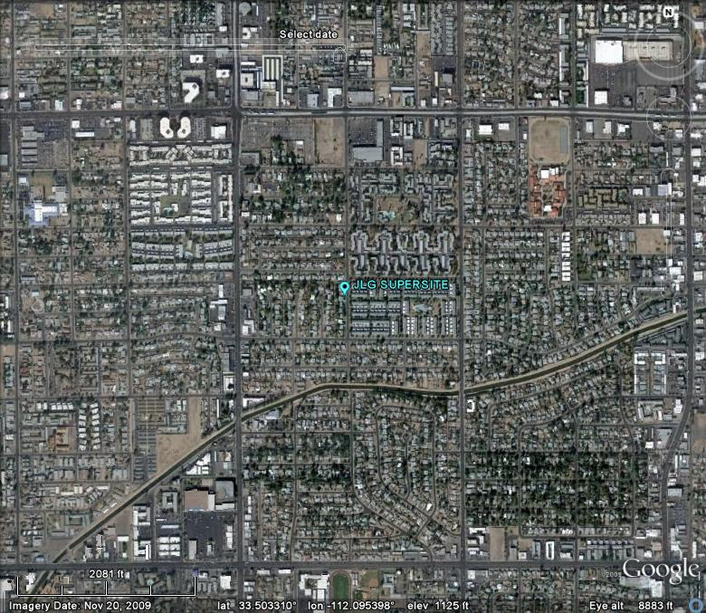  Aerial view of JLG Supersite | 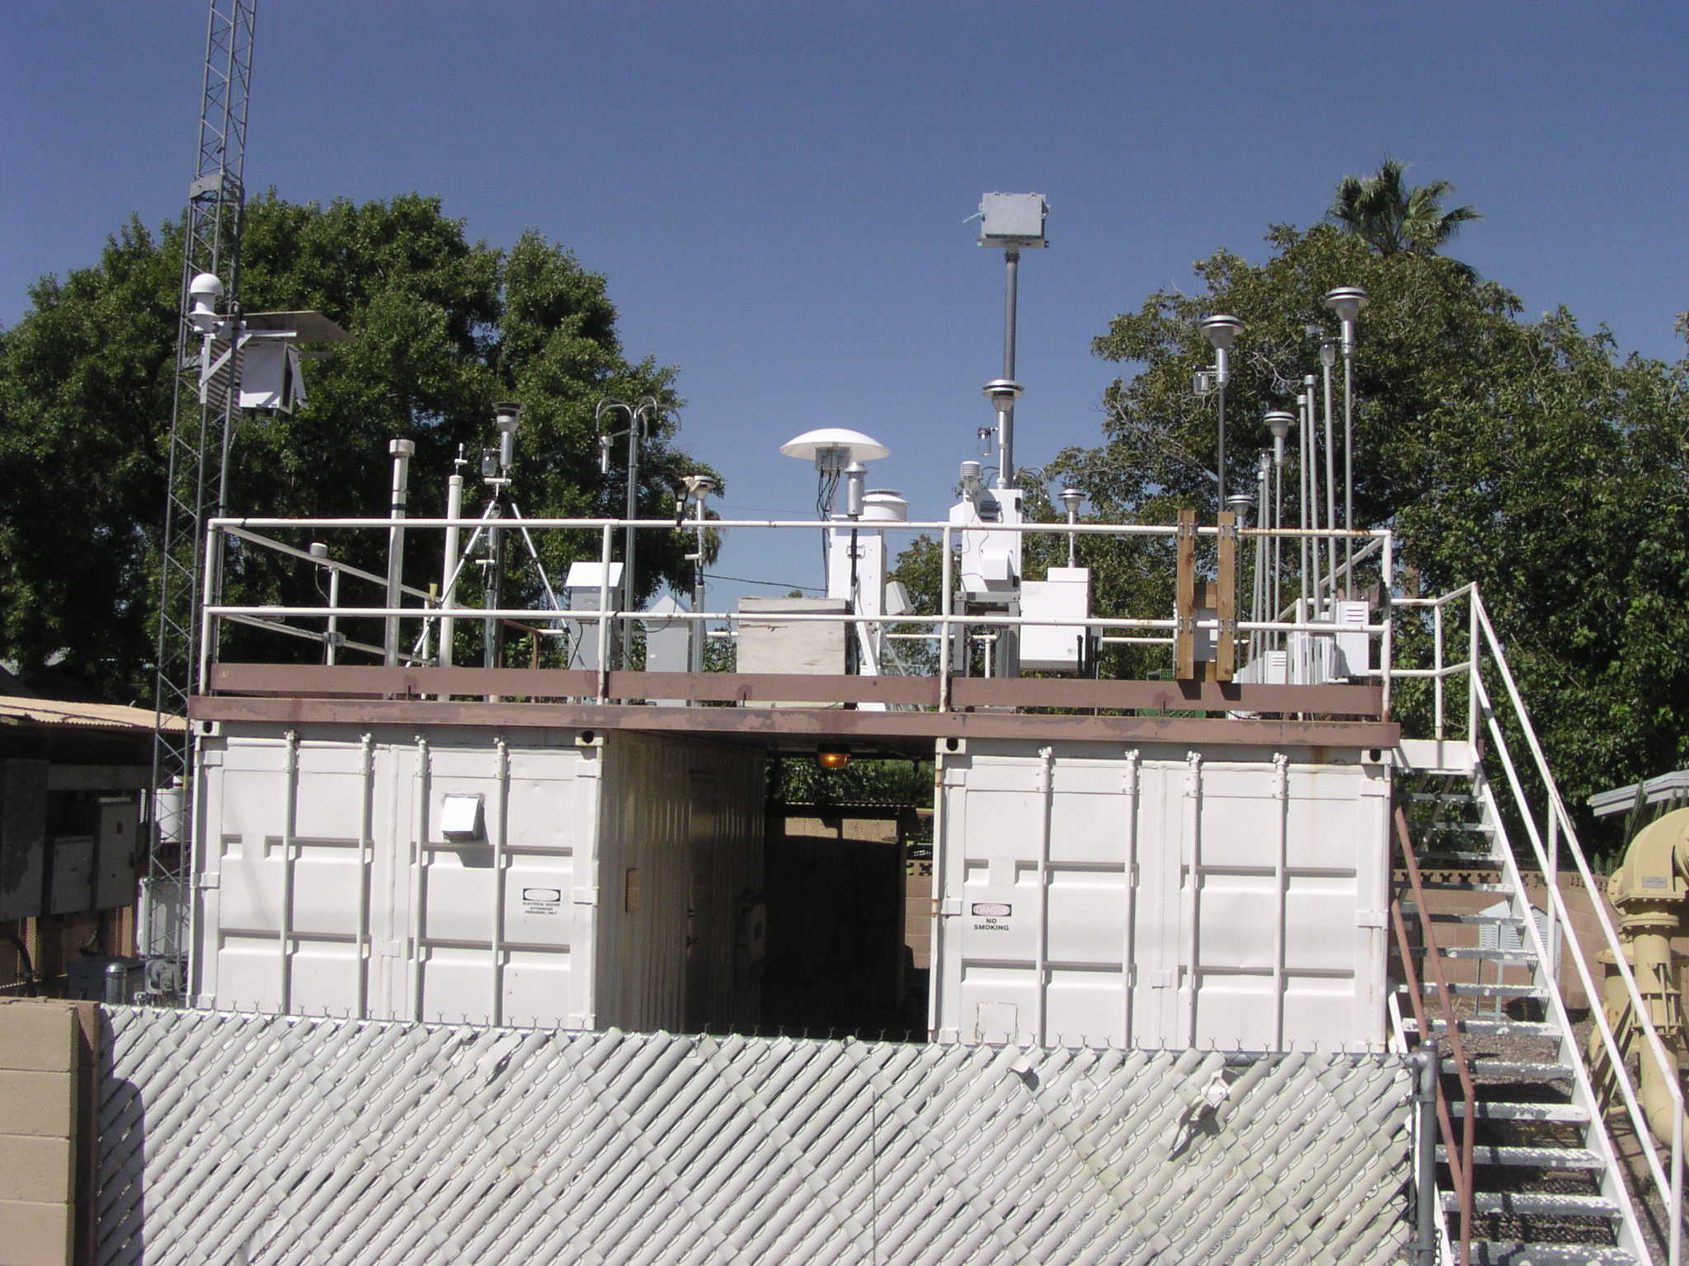  Eastern side of JLG Supersite – 09/2008

Monitoring Plan

As stated under the program’s description, the monitoring plan is to measure airborne Pb near regulated sources emitting 0.5 tons/year (tpy) or more and the in the Phoenix metropolitan area, which is a CBSA with greater than 500,000 population. Continuous meteorological data will also be collected at each site. Measurement error will be kept at minimum by following the established acceptance criteria for air monitoring instruments found in Section B7. There is no anticipated end date for operating the Pb network.

Each calendar year, a total of 60 - 61 routine samples will be collected on the primary samplers following the 1/6 day monitoring schedule, aka, sample run day. A total of 60-61 collocated samples will be collected on the secondary sampler at the collocated Globe Highway site. ADEQ plans to collect collocated samples on each 1/6 sample run day because it is easier to plan for and provides additional samples at minimal costs. ADEQ may elect to revert to the EPA 1/12 day schedule for collocation in the future.

Each quarter, one of the collocated filter samples collected on a non-required 1/6 day monitoring schedule will be used for the EPA’s Pb PEP. ADEQ’s plan is to use the first non-required 1/6 collocated sample for the PEP. If for any reason the Pb PEP sample is not successfully collected on that day or this filter is not used for any other reason, ADEQ will default to using the next non-required collocated sample available. ADEQ will continue to default to the next possible 1/6 sample run day that is not a required 1/12 sample run day in the event collection problems arise. An example of the national monitoring schedule is provided in Attachment C. Near the beginning of each calendar year, the annual schedule will be obtained from EPA here: http://www.epa.gov/ttn/amtic/calendar.html.

To meet ADEQ’s in-house goal of 85% data completeness for sample collection, only two (2) filter-based samples can be missed for each three-month period. To meet the minimum requirement of 75% data completeness, only three (3) filter-based samples can be missed. Completeness will be based on rolling three-month periods, rather than calendar quarters.

Make-up Samples

The EPA makeup sample requirements for the Pb program are aligned with the PM₁₀ and PM_{2.5} requirements. Makeup samples will be collected according to the following guideline:
If a TSP or the low volume PM₁₀ sampler fails to collect a valid sample at a site on the regularly scheduled 1/6 sample day run day, then a makeup sample will be collected at the site prior to the next run day if possible using the unsampled filter provided for the next scheduled run (a replacement filter will be obtained for the next scheduled run day), OR on the 7th day following the missed event.

Since sequential samplers are not in-use, meeting the makeup requirements could pose logistical challenges in the field. Timely communication among the Pb Team regarding any sample loss from the field is important and will allow field personnel to plan for makeup samples as needed providing as much leeway as possible.

Any additional, valid samples collected outside the makeup sample timeframe requirements will be considered extra samples. The Pb concentrations from these samples are useful and will be used in design value calculations that are comparable to the Pb NAAQS; however, extra samples can not be used for data completeness purposes.

Field Blanks
TSP and PM₁₀ field blanks will be collected for each sampler at a frequency of 10%. A field blank will be collected on the 10th run day following the start of sampling for each calendar year.
Site Accessibility

The source-oriented sites are located near or adjacent to major state highways making them easily accessible for service and sample collection. The NCore site is located close to ADEQ’s Main Office in downtown Phoenix which allows easy access to the site. However, it is possible that sample collection could be interrupted if a site becomes temporarily inaccessible due to a variety of unusual circumstances that may include road closures, a wildfire, or a hazardous condition that was not previously present. If this occurs, ADEQ personnel will not attempt to access a site for sample collection or any other purpose until the area has been cleared and reopened by the proper authorities. Field personnel will report the site closure information to their direct supervisor and the program manager will be alerted to the incident as well. Each incident of site inaccessibility and the need for possibly establishing an alternate site or relocating an existing site will be handled on a case-by-base basis.

B.2 SAMPLING METHODS

Lead (Pb) Air Sample Collection

To ascertain the levels of airborne Pb, filter-based samplers will be used.

For source-oriented sampling:

ADEQ will use high-volume total suspended particulate (TSP) samplers to collect filter-based samples from midnight to midnight every sixth day following the EPA’s Monitoring Schedule. These samplers meet EPA’s requirements for the collection of Pb samples. AMU personnel will maintain and operate these samplers according to AMU’s SOP. The QA Auditor will audit the samplers according to the QA SOP for this sampler. Each TISCH TSP sampler contains a microprocessor with the ability to store sample run summary data and 5-minute interval data, a scan diskette for data backup and retrieval, a pump, a step-up transformer (added per the manufacturer’s recommendation to achieve the required flow rate due to altitude at the source-oriented sites), and an automated mass flow controller. Menu-driven software is used to program these samplers so they operate according to the required sampling schedule. These samplers do not use size-selective inlets and can collect particles up to 50 micrometers (µm) in aerometric diameter depending on meteorological conditions. The samplers will operate in Actual Conditions (AC), aka, Local Conditions (LC). Again, Table B.4 shows the air monitoring instruments and the sample collection plan for each site.

Samples will be collected onto 8” X 10” fibrous glass filters supplied annually by the EPA. These filters are assumed to meet all regulatory and acceptance criteria established by EPA prior to receipt. AFL will receive these filters and prepare them for sampling by assigning sample identification numbers to each filter, loading the filters into each sampler’s filter holder cassette, and preparing the associated ADEQ Lead_{TSP} Air Sampling Record for each sample to be collected. The filters will not be weighed before or after sampling to determine a PM concentration because ADEQ does not currently own a microbalance that can accommodate the 8” X 10” filter size. ADEQ may elect to weigh filters in the future. AFL will receive exposed sample filters from the field operator, sub-sample each filter, and prepare and coordinate shipments of Pb filter sample strips to PCWRL. Sub-sampling refers to the process of cutting the filter into strips that are to be used for laboratory analyses. AFL’s processes follow AFL SOPs and all ADEQ SOPs are included as attachments to this QAPP.

For the non-source-oriented sampling:

ADEQ plans to use a low-volume PM₁₀ sampler to collect filter-based samples of particulate matter containing particles up to 10 µm in aerometric diameter on the same monitoring scheduled cited above. The sampler was operated in standard conditions initially, but the sampler’s operating mode was changed from standard conditions to local conditions in mid-September 2012. This change improved the efficiency of determining and reporting each filter sample’s Pb concentration and it better aligned the comparability of the Pb/NATTS filter sample with other monitoring organizations around the country. The sampler will be operated according to AMU’s SOP; and, the QA Auditor will audit the sampler according to the QA SOP. Samples will be collected onto 47 mm Teflon® filters. These samples will not be sub-sampled before shipping to ERG. The sampler produces sample summary and 5-minute interval data that will be downloaded and reviewed as part of the QA process.

Sample volume is provided by each sampler in the summary data. Interval data files are checked to ensure that an over or under run did not occur. Sample volume is periodically checked by hand using the following equation:

Sample Volume = (Collection Time) (Average Ambient Flow Rate)

Table B.4 Lead (Pb) Air Monitoring Plan per Site
ADEQ  Site  (Abbreviation) | Instrument  (Quantity/Type/ Operating Mode/Designation) | Measurement | Collection Media | Collection Frequency  Duration &  Time | Annual Quantity of Samples  Planned | Scale
HAGH* | 1/TISCH HIGH-VOL+ TSP/AC/Primary | Pb particles up to 50µm aerometric diameter depending on meteorological conditions | 8” X 10” fibrous glass filter | 1/6 day  23 – 25 hours midnight to midnight | 60-61 | Middle
HAGH* | 1/ TISCH HIGH-VOL+ TSP/AC/Secondary |  | 8” X 10” fibrous glass filter | 1/6 day  23 – 25 hours midnight to midnight | 60-61  (30-31 are required on 1/12 day schedule; 4 are PEP; remainder are extra samples) | Middle
HAGH* | 1/RM Young Model 5103/Wind Monitor/  Continuous | Wind speed and direction | Direct read -  electronic communication to data logger | Hourly values with 5 second max wind speed | N/A | Middle
HAGH* | 1/Vaisala HMP 45C T&RH Sensor/Continuous | Temperature and relative humidity | Direct read -  electronic communication to data logger | Hourly values | N/A | Middle
MIGC | 1/TISCH HIGH-VOL+ TSP/AC/Primary | Pb particles up to 50µm aerometric diameter depending on meteorological conditions | 8” X 10” fibrous glass filter | 1/6 day  23 – 25 hours/ midnight to midnight | 60-61 | Middle
MIGC | 1/RM Young Model 5103/wind monitor/Continuous | Wind speed and direction | Direct read -  electronic communication to data logger | Hourly values with 5 second max wind speed | N/A | Middle
MIGC | 1/Vaisala HMP 45C T&RH Sensor/  Continuous | Temperature and relative humidity | Direct read -  electronic communication to data logger | Hourly values | N/A | Middle
JLG | 1/Thermo Partisol 2000 FRM/AC/  Primary | Pb particles up to 10µm aerometric diameter depending on meteorological conditions | 47 mm Teflon® filter | 1/6 day  23 – 25 hours/midnight to midnight | 60-61 | Neighbor-hood
JLG | 1/RM Young Model 5103/wind monitor/ Continuous | Wind speed and direction | Direct read -  electronic communication to data logger | Hourly values with 5 second max wind speed | N/A | Neighbor-hood
JLG | 1/Rotronics MP101A T&RH Sensor/  Continuous | Wind speed and direction | Direct read -  electronic communication to data logger | Hourly values | N/A | Neighbor-hood
*Collocated Site Key: HAGH = Globe Highway
MIGC = Miami Golf Course
JLG = JLG Supersite (aka, PXSS)

B.3 SAMPLE HANDLING AND CUSTODY

Sample handling and custody is one of the most important aspects of a quality system. Sample handling procedures must be consistently followed to provide data meeting the DQOs. Currently, EPA does not require that Pb filter samples be collected within a certain timeframe, or that they be chilled to a specific temperature, or analyzed within a certain number of days following collection. ADEQ plans to collect filter samples within 6 days following each run day, usually within 48-hours. The samples will be handled as carefully as possible to prevent loss of particulates from the filters. Shipments of TSP sample strips and 47mm Telfon® filters to the analytical laboratories will be done in a timely manner to ensure adequate time for analysis, data validation and reporting.

To protect a sample from tampering and to ensure that a sample’s history and integrity is known, a chain-of-custody accompanies each sample. The ADEQ LEAD_{TSP} Air Sampling Record serves as the chain-of-custody (COC) as well as the sample collection data card for each TSP sample generated. The ADEQ PM₁₀ Air Sampling Record is used for the same purpose for the Pb samples collected at the NCore site.

A sample is considered to be in custody if it is in one’s actual physical possession, is stored in a secured area restricted to authorized personnel as found with the AFL or AMU office/lab/shop area, or when it is in view after being in one’s possession such as when a sample is being relinquished for shipping or analysis at an analytical laboratory.

To ensure sample integrity, security measures have been taken to prevent unauthorized persons from tampering with a site or the air monitoring instruments. Site access is limited to authorized ADEQ, county, or mine personnel. Each sampler’s shelter door is kept locked except during service or filter changes. Site configurations vary, but each site is protected from trespassers or unauthorized persons using some combination of security mechanisms such as signage/no trespassing posts, fencing that may have an upper perimeter barrier such as barb or razor wire, or a raised platform with locked door or chain. If a site is gated; it is padlocked. In the event security becomes an issue at a site, ADEQ will implement more stringent security mechanisms.

To prevent loss of material from the exposed TSP filter samples, the plan is to cover the exposed TSP filters with a filter holder faceplate following the retraction of the sample saver shield and to remove the filters as soon as possible following sampling. Then, the filter cassette holder is carefully removed from the sampler, placed into a plastic zipper storage bag, and then placed into a site-specific transport case which further protects the sample from disturbance during transport to AFL. For the exposed PM₁₀ filters removed from the low-volume sampler, the plan is to enclose the filter sample in a plastic case, aka, clam shell, prior to transporting to AFL. More details concerning filter handling and custody can be found in the SOPs which are provided as attachments.

To prevent sample contamination, each filter cassette holder, filter holder faceplate, and filter ring assembly is cleaned following sample collection and prior to the next unexposed filter being prepared for the next sample run day. The Pb TSP operator cleans dust from the surface inside the TSP samplers and from the TSP sample saver shield prior to each sample collection. The tools used for sub-sampling, i.e., cutting a filter into strips for analysis, the 8”X10” TSP filter samples are cleaned following each use. The low-volume sampler’s inlet and interior are checked for debris or dust after each sample run and cleaned as needed by the operator.

B.4 ANALYTICAL METHODS

Laboratory Analyses

For source-oriented TSP Pb filter samples:

The AFL receives blank fibrous glass filters used for sampling from the EPA each calendar year. Unexposed filters are prepared for the AMU operator by AFL personnel. AFL receives the exposed filter samples from the AMU operator after sampling. AFL personnel cut the TSP filter samples into strips (sub-sample), verify information on the COC/data information sheets, and ship samples with all required documentation to the PCWRL on a monthly basis to the address shown below. The frequency of shipments will be adjusted as needed. PCWRL plans to provide the laboratory analysis results on a monthly basis.

Pima County (PC) CRAO Lab
3035 W. El Camino Del Cerro
Tucson, AZ 85750 Phone: 520-443-6052

For NCore PM₁₀ Pb filter samples:

The AFL receives blank Teflon® filters used for sampling from the EPA each calendar year. Unexposed filters are prepared for the AMU operator by AFL. AFL receives the exposed filter samples from the AMU operator after sampling. AFL personnel verify information on the COC/data information forms using the sampler’s summary and interval data, and ship samples with all required documentation to the ERG laboratory on a monthly basis to the address below.
The frequency of shipments will be adjusted as needed. ERG plans to provide the laboratory analysis results on a monthly basis.

Eastern Research Group
601 Keystone Park Drive, Suite 700
Morrisville, NC 27560-9998 Phone: 919-468-7800

For the quarterly collocated TSP Pb PEP filter samples:

The AFL prepares the unexposed filters for collocated sampling for the AMU operator. AFL receives the exposed filter samples from the AMU operator after sampling. AFL personnel verify information on the COC/data information form, and ship each sample and all required documentation to the Region 9 laboratory on a quarterly basis. The filters are not sub-sampled, but shipped whole to the address below. Additionally, AFL personnel submit the COC information electronically to the RTI database.

USEPA Region 9 Laboratory
Bldg. 201
1337 South 46th St
Richmond, CA 94804-4600 Phone: 510-412-2389

The analytical laboratories quality manuals and/or SOPs are found as attachments within this QAPP. Each analytical laboratory uses an EPA-approved method for analyzing the Pb filter samples. In Arizona, a state statute contains a provision that any laboratory performing analysis for environmental compliance purposes be licensed by the Arizona Department of Health Services (ADHS) for the analytical method. Table B.5 shows the approved EPA analytical method or equivalency method for determining the concentration of Pb in TSP and PM₁₀ samples as well as the ADHS license number. Currently, only the PCWRL falls subject to the licensure requirement. To date, Pb concentrations measured at the JLG Supersite are considerably lower than the NAAQS. As stated previously, ADEQ measures Pb at this site to satisfy the EPA requirements for an NCore station within a CBSA having a population of 500,000 or more. If Pb concentrations measured at the JLG Supersite start approaching the Pb NAAQS, the need for ERG’s method to be licensed by the Arizona Department of Health Services will be reviewed again.

Table B.5 Analytical Methods for Pb Samples
Parameter | EPA Method | Licensure# | Analytical Method | Laboratory
TSP Pb – applies to routine primary & secondary samples, blanks, audit strips | EQL-0510-191 | AZ Dept. of Heath Services - #AZ0159 | Determination of Lead Concentration in TSP by Inductively Coupled Plasma Mass Spectrometry (ICP-MS) with Heated Ultrasonic Nitric and Hydrochloric Acid Filter Extraction | Pima County Wastewater Reclamation Laboratory, Tucson, AZ
TSP Pb – applies to the quarterly Pb PEP sample generated by ADEQ  and  the annual collocated PEP filter sample generated by EPA | EQL-0710-192 | Not applicable since concentration is not used for comparison to the NAAQS | Heated Nitric Acid Hot Block Digestion and ICP/MS Analysis for Lead (Pb) on TSP High-Volume Filters | US EPA Region 9 Laboratory, Richmond, CA
PM₁₀ Pb – applies to routine primary samples and blanks | EQL-0512-202 | Applicability being determined | Determination of Lead in PM₁₀ by Inductively Coupled Plasma Mass Spectrometry (ICP-MS) with Hot Block Dilute Acid and Hydrogen Peroxide Filter Extraction | Eastern Research Group,  Morrisville, NC

B.5 QUALITY CONTROL

Quality control (QC) is the overall system of technical activities that measure the attributes and performance of a process against established standards to verify that performance meets the stated requirements established by the decision maker or data user. Information on data validation and verification can be found in Section D.

To assure the quality of data from air monitoring measurements, two distinct and important interrelated functions must be performed. One function is the control of the measurement process through broad quality assurance (QA) activities such as establishing policies and procedures, developing DQOs, assigning roles and responsibilities, conducting QA oversight and technical system reviews, and implementing corrective actions.

The other function is the control of measurement error by implementing specific quality control checks at established frequencies to ensure the samplers operate within specified criteria. QC procedures include, but are not limited to: periodic (typically annual) NIST-traceable certification of calibration standards/references (aka, calibrators) used for testing samplers and supporting meteorological instruments; regularly scheduled calibrations, verifications, and PE audits; collocation of samplers and participation in the national EPA Pb PEP. The analytical laboratories perform extensive QC functions on a regular basis that support the analytical instrumentation as well.

Section B of this QAPP contains supporting QA/QC information regarding specifications and performance criteria for the samplers. In addition, the “ADEQ Pb High-Volume (TSP) Validation Template” (see Table D.3.) and the EPA “PM10 Filter Based Local Conditions Validation Template” (see QAHBV2) provide additional information used by ADEQ during the data validation process to ensure the accuracy of Pb concentrations released to the public and used for NAAQS compliance purposes.

B.6 INSTRUMENT TESTING, INSPECTION, AND MAINTENANCE

The purpose of this element is to discuss the procedures planned for verifying that all instruments and equipment are properly maintained and operate within acceptable performance levels. Prior to being deployed to a site, air monitoring instruments are tested in the AMU Shop to verify that they are working properly and that they meet the operating criteria.

The main component of ensuring correct instrument operation is through routine verifications. As mentioned previously, the frequency of TSP sampler verifications may change once the Pb program is well established, but the procedures used to perform the verifications are anticipated to remain essentially the same. The flow rate for a TSP sampler is verified by using a water manometer following ambient temperature and pressure verifications. All this information is used in a calculation to determine the flow rate, and the flow rate calculated is compared to the set point of the instrument. Refer to the AMU’s SOP and Table B.12 for details pertaining to the verification process and acceptance criteria.

For Pb measurements at source-oriented sites, ADEQ plans to use only high-volume TSP samplers that meet 40 CFR Part 50 Appendix B specifications. Currently, Pb samplers do not have manufacturer-specific federal reference method (FRM) or federal equivalent method (FEM) designations. Instruments are properly operated and maintained following 40 CFR Part 50 Appendix B, manufacturers’ requirements, and recommendations of technical personnel from the EPA and ADEQ’s AAS. Table B.6 shows specifications of TSP samplers.

Table B.6 High-Volume TSP Sampler Specifications
Criteria | Acceptable Range | Citation/  Information
Design Criteria | - seal filter to housing without leaks  - filter convenient to change  - adjustable flow rate | Part 50 App B sec 7.2.1
Operational Flow Range | - Operate within 1.1 to 1.7 m³/min (39 – 60 CFM) | Part 50 App B sec 7.2.1
Operational Set Point | - 1.13 m³/min (actual conditions) (40 CFM) | Part 50 App B sec 7.2.1
Motor | - Capable of reliably operating for continuous 24 hr periods | Part 50 App B sec 7.2.4
Sampler Shelter | - Rectangular with gabled roof  - Protects filter from precipitation/weather  - Exhaust discharge 40 cm from inlet  - Designed to minimize collection of dust by incorporating a baffle between exhaust and the supporting surface  - Filter in horizontal position at least 1 m above supporting surface | Part 50 App B sec 7.3.1
Sample Cover | - Uniform inlet on all sides  - Air velocity between 20 and 35 cm/sec (0.66 - 1.15 ft/sec)  - Recommended velocity 25 cm/sec ±2 (0.82 ft/sec +2) | Part 50 App B sec 7.3.2
Filter Exposed Area (nominal) | - 406.5 cm² (63 in²) | Part 50 App B sec 7.1.2
NOTE: Above criteria verified prior to purchase and startup of sampler/sampling

For Pb measurements at the NCore site, ADEQ plans to use only low-volume samplers that have received the EPA’s federal reference method (FRM) or federal equivalent method (FEM) designation for Pb-PM₁₀ sampling. Air monitoring instruments must meet strict criteria in order to obtain the FRM or FEM designation from EPA. ADEQ plans on conducting flow rate, pressure and temperature verifications on the low-volume PM₁₀ sampler at the NCore site every four weeks. These verifications are performed using a NIST-certified flow, barometric pressure and temperature digital calibrator. ADEQ technicians and operators possess a strong understanding of how to operate these samplers because the instruments have been used by ADEQ for the collection of PM₁₀ and PM_{2.5} filter samples for many years. Refer to the AMU’s SOP for details pertaining to the verification and calibration processes.

Inspection and acceptance of filter sample media is also performed. To prevent an interruption in the collection of Pb filter samples and to ensure DQIs are met, ADEQ strives to keep critical supplies and consumables in stock such as fibrous glass and polytetrafluoroethelyne filters, calibrators (standards/references), spare parts for instrumentation, and if possible, backup samplers and meteorological monitors. Supplies and consumables are inspected for defects prior to use and their availability in-house is monitored by the AMU personnel.

Inspection of Field Items

There are several items that need routine inspection in the field before and after a Pb sample has been collected. Table B.7 shows the inspections performed in the field before and after TSP sample collection.

Table B.7 Inspection of Field Items for TSP Sample Collection
Item | Inspection Frequency | Inspection Parameter | Action if Item Fails Inspection | Documentation Requirement
Filter holder cassette including the following components:  - 2-part metal frame  - (2) Thumb (finger) nuts  - Metal wire mesh filter holder support screen  - (2) 8x10” silicon gaskets | Before and after each run | Any damage (warps, cracks, other signs of wear)  AND  Visible particulate or foreign objects | Replace  Clean with a cloth using amended water or other surfactant solution such as Windex | Document in sampler and site logbooks; on AMU Field Service Report and/or other AMU form  Same as above
Filter Holder Faceplate | Before and after each run | Any damage | Replace | Document in sampler and site logbooks and AMU Field Service Report
Filter holder gasket (rubber gasket located between filter holder and blower motor) | Semi-annually | Any damage | Replace | Document in sampler and site logbooks; on AMU Field Service Report and/or other AMU form
Fibrous glass filter | Before and after each run | Any damage or anomalies | Replace | Document on AFL Air Lead_{TSP} Sampling Record and/or other AMU form

Table B.8 shows the inspections performed in the field before and after PM₁₀ sample collection.

Table B.8 Inspection of Field Items for Pb PM₁₀ Sample Collection
Item | Inspection Frequency | Inspection Parameter | Action if Item Fails Inspection | Documentation Requirement
47mm filter holder (plastic ring, plastic clam shell) | Before and after each run | Cleanliness (Visible particulate)  Damage (warps, cracks, other signs of wear) | Rewash or  Replace | Document in laboratory logbooks
Teflon® filter | Before and after each run | Any damage or anomalies | Replace | Document on AFL Air PM₁₀ Sampling Record and/or other AMU form

Preventative Maintenance of Field Items

There are many field items associated with preventative maintenance of a successful field program. Table B.9 details the maintenance checks of the Pb samplers. Details on maintaining the samplers can be found in the associated ADEQ SOPs and manufacturer’s operating manuals.

Table B.9 Preventative Maintenance of Field Items
Instrument | Item | Maintenance Frequency | Responsible Party | Location Maintenance Performed
TISCH HIGH-VOL+ | Filter holder cassette silicon gaskets | Replace every 3 years  OR  Replace if found compromised in any way during routine inspection or when leak is present | AMU Operator  OR  AFL Supervisor or support analyst | AFL
TISCH HIGH-VOL+ | Rubber filter holder gasket | Replace annually | AMU Operator or Technician | In field at site
TISCH HIGH-VOL+ | Wire mesh filter holder support screen | Clean monthly | AMU Operator  OR  AFL Supervisor or Support Analyst | AMU Shop
TISCH HIGH-VOL+ | CPU backup power battery | Replace bi-annually | AMU Operator or Technician | In field at site
TISCH HIGH-VOL+ | Sampler hood and sampling chamber | Clean before and after each sample collection event | AMU Operator | In field at site
TISCH HIGH-VOL+ | Brushless motor | Replace every 8 years or sooner if motor function is compromised | AMU Operator or Technician | In field at site or in AMU Shop
TISCH HIGH-VOL+ | Control and pump box | Clean monthly | AMU Operator or Technician | In field at site
Thermo Partisol 2000 FRM | Inspect Sampling Chamber | Clean as needed after use | AMU Operator or Technician | In field at site
Thermo Partisol 2000 FRM | Inspect Filter Cassettes for contamination | Each filter sample setup | AMU Operator or Technician | In field at site
Thermo Partisol 2000 FRM | Rubber Lip Seal | Each time filter is exchanged | AMU Operator or Technician | In field at site
Thermo Partisol 2000 FRM | Clean PM₁₀ inlet, check o-ring(s) | Every 14 days of inlet usage | AMU Operator or Technician | In field at site
Thermo Partisol 2000 FRM | Replace large in-line filter | Every 6 months of sampler operation | AMU Operator or Technician | In field at site
Thermo Partisol 2000 FRM | Clean air inlet screens | Every 6 months of sampler operation | AMU Operator or Technician | In field at site
Thermo Partisol 2000 FRM | Check battery voltage | Every 6 months | AMU Operator or Technician | In field at site
NOTE: Adjustments to routine, preventative maintenance frequencies will be made as needed based on site conditions.

B.7 INSTRUMENT CALIBRATION AND FREQUENCY

Calibration is defined as the comparison of a measurement standard, instrument, or item with a standard or instrument of higher accuracy to detect and quantify inaccuracies and to report or eliminate those inaccuracies by adjustment. Use of the term “calibration” indicates that an adjustment either in the instrument or the software occurred. EPA recommends that adjustments be minimized to prevent introducing measurement uncertainty and that verifications, “checks without correction”, be used to confirm whether or not an instrument is operating within the acceptable operating range.

The purpose of calibration is to minimize bias. Typically, calibration activities follow a two-step process.

1. Certifying the calibration standard and/or transfer (working) standard against an authoritative standard, usually the NIST.
- Comparing the routine sampling or analytical instrument against a calibration or transfer standard.

The following calibrations are typically performed in the field:

- Verification/calibration of volumetric flow rate of each sampler against the transfer standard;
- Verification/calibration of sampler temperature and pressure sensors against the working temperature and pressure standard; and
- Verification/calibration of sampler’s internal clock against a NIST-traceable timepiece such as a cell phone, GPS, or atomic watch.

For the TISCH HIGH-VOL+ TSP samplers, the primary standard used for calibration is an orifice (top hat) manufactured by TISCH. A water manometer will be used to verify and calibrate the instrument’s flow rate. Flow verifications are performed manually by the field technicians and are conducted in ambient conditions. Flow calibrations are initiated by field technicians, but the calibration process is an automated process. Due to instrumentation limitations, calibrations are performed in standard conditions. Prior to the auto-calibration procedure, the calibration flow range in standard conditions (SC) is entered by the technician so that the equivalent ambient flow range brackets the set point equally on both sides. The flow range may vary from site to site, based on differences in ambient temperature and pressure. See AMU’s SOP for exact calibration flow ranges for sites with TSP samplers. The equivalent ambient flow rates were calculated for each site, based on typical measurements of temperature and pressure. The calibration flow rates are determined by the digital manometer within the instrument. While the digital manometer cannot be verified during the calibration process, it is verified during the flow verifications. If the on-board digital manometer is out of tolerance during the flow verification, a Pcal (inches of water) calibration is conducted. For more details on the calibration procedure, see the AMU SOP in the attachments. A digital temperature and pressure device will be used for verifying ambient temperature and barometric pressure. One-point temperature and pressure verifications are conducted at the same frequency as the flow verifications. The high frequency of one-point verifications allows for an assessment of the temperature and pressure sensors over a wide range of ambient conditions as they are conducted throughout the year. Standard materials and/or apparatus used for Pb TSP sampler calibration and verification are shown in Table B.10.

Table B.10 Standard Materials and/or Apparatus for TSP Sampler Calibration and Verification
Parameter  M=Material A=Apparatus | Std. Material | Std. Apparatus | Mfr. Name | Model# | Acceptance Criteria | Variable Control Settings
Flow Rate  A  A  M+A  A  M  M | NA  NA  NA  NA  NA  Fibrous Glass | Orifice (top hat)  Roots Meter  Water manometer  Syringe  Tubing  8”X10” | TISCH  Dresser  Dwyer  Any  Any  Any | #TE-5025 (or equivalent)  #5M125  30”  NA  NA  NA | Annually NIST-traceable certification  Every 3 years NIST-traceable calibration at minimum  Use with low resistance fluid  1/8” ID or 10 gauge  No visible damage | MFC Set Point  NA  NA  NA  NA  NA
Temperature  A | NA | Digital standard | BGI, BIOS, or other comparable manufacturer | tetraCal® or equivalent digital standard | Annual NIST-traceable certification | NA
Pressure  A | NA | Digital standard | BGI, BIOS, or other comparable manufacturer | tetraCal® or equivalent digital standard | Annual NIST-traceable certification | NA
For the low-volume PM₁₀ sampler, the standard materials and apparatus used for verifications, calibrations, and audits is found in Table B.11.

Table B.11 Standard Materials and/or Apparatus for PM₁₀ Low-Volume Sampler Calibration and Verification
Parameter  M=Material A=Apparatus | Std. Material | Std. Apparatus | Mfr. Name | Model# | Acceptance Criteria | Variable Control Settings
Flow Rate  A  M  M | NA  NA  Teflon® | Digital standard with Venturi 1 (6-30 L/m)  Tubing  47mm diameter | BGI, BIOS, or other Comparable manufacturer  Any  Any | tetraCal® or equivalent digital standard  NA  NA | Annually NIST-traceable certification  1/4” ID  No visible damage | NA  NA  NA
Temperature  A | NA | Digital standard | BGI, BIOS, or other comparable manufacturer | tetraCal® or equivalent digital standard | Annual NIST-traceable certification | NA
Pressure  A | NA | Digital standard | BGI, BIOS, or other comparable manufacturer | tetraCal® or equivalent digital standard | Annual NIST-traceable certification | NA

For the Pb TSP samplers, ADEQ may conduct calibrations more frequently than required by EPA because ambient temperature and barometric pressure vary significantly from season to season throughout the state. Acceptance criteria for calibrations, verifications, and audits of the TSP samplers are found in Table B.12 and the ADEQ Pb Validation Template found in Section D. The associated SOPs are included as attachments. Parameters of the ADEQ Pb TSP samplers that are subject to routine calibrations, verifications, and audits in the field include:

- Flow rate
- Ambient temperature
- Barometric pressure
- Date/Time

Table B.12 shows the acceptance criteria for the TSP Pb samplers ADEQ plans on operating for the Pb network.

Table B.12 Acceptance Criteria for Operating HIGH VOL+ TSP Lead (Pb) Samplers in Actual Condition
Criteria | Frequency | Acceptance Range | Corrective Actions
Monitoring Instrument  Average Flow Rate (FR) | Every 24 hours of operation | Set Point: 1.13 m³/min (40 CFM) | If sampler fails to maintain FR  troubleshoot/repair/calibrate
Standards (Reference)  Flow Rate  TISCH Orifice (Top Hat)  Digital Temperature Probe  Digital Pressure Probe | Certified annually to a NIST-traceable primary standard  Certified annually to a NIST-traceable primary standard | Resolution 0.02 m³ / min  ± 2% reproducibility  ± 0.5 ºC accuracy  ± 5 mm Hg accuracy | Ensure annual certification is completed and repair or replace references as needed
Verification/Calibration  One-point (QC) Flow Rate Verification  Date and Time  Temperature Verification  Pressure Verification  Leak Check  5 point PCal (in H₂O)  Multi-point Flow Rate Verification/Calibration | Prior to every other sample collection event  (may be reduced after operating history is established)  Same as above  “  “  “  Performed prior to  flow rate calibration if needed  Annually, at minimum;  upon installation;  after repair;  following flow rate failure; when action level is triggered | In Actual Conditions:  Action Level: ±5% difference from std  Failure Level: ±7% difference from std  ± 2 min  ± 2ºC  ± 10 mmHg  Audible check with faceplate blocked  ± ≤ 5% difference  5 points over operating range of ~1.02 – 1.25 m³/min (36 – 44 CFM)  R-value limit of ≥0.99 (as per manufacturer’s recommendation) | If failure occurs, adjust, repair, or replace unit. Respond to Auditor using Corrective Action form  Adjust or replace  “  “  “  “  See AMU’s-SOP for calibration range in standard conditions
Performance Evaluations  ADEQ PE Audits  Each Sampler  EPA Pb PEP | Quarterly;  Near beginning of program;  upon instrument change-out; following corrective action; and  prior to sampler removal  Annually - 1 field audit  Quarterly - 1 collocated filter sample | ± 10% of audit standard and design value (40 CFM)  95% CL Absolute bias ± 15% | If sampler fails audit, Submit Corrective Action form and audit field sheet to QA/QC Lead, DM&QA and AMU Managers

ADEQ plans on following the required acceptance criteria for these checks and the associated frequencies shown on the “PM₁₀ Filter Based Local Conditions Validation Template”. Additional information concerning acceptance criteria for calibrations, verifications, and audits are shown in Table B.13. The associated AMU and QA SOPs are included in the attachments as well. Parameters of the low-volume PM₁₀ sampler that are subject to routine calibrations, verifications, and audits in the field include:

- Flow rate
- Ambient temperature
- Barometric pressure
- Date/Time

Table B.13 shows the acceptance criteria for the low-volume PM₁₀ samplers ADEQ plans on operating for the Pb network.

Table B.13 Acceptance Criteria for Operating Partisol 2000 FRM Samplers in Local Conditions
Criteria | Frequency | Acceptance Range | Corrective Actions
Monitoring Instrument  Average Flow Rate (FR) | Every 24 hours of operation | Set Point: 16.7 l/m | If sampler fails to maintain FR  troubleshoot/repair/  calibrate
Standards (References)  Digital Flow Rate Meter  Digital Temperature Probe  Digital Pressure Probe | Certified annually to a NIST-traceable primary standard  Certified annually to a NIST-traceable primary standard | Resolution 0.02 l/m  ± 2% reproducibility  ± 0.5ºC accuracy  ± 5 mm Hg accuracy | Ensure annual certification is completed and repair or replace references as needed
Verification/Calibration  One-point (QC) Flow Rate Verification  Date and Time  Ambient Temperature Verification Filter Temperature Verification  Barometric Pressure Verification  External Leak Check  Multi-point Flow Rate Verification/Calibration | Every four weeks  Same as above  “  “  “  “  Annually, at minimum;  upon installation;  after repair;  following flow rate failure; when action level is triggered | In Local Conditions:  Action Level: ±3% difference from std  Failure Level: ±4% difference from std  ± 2 min  ± 2ºC  ± 2ºC  ± 10 mmHg  <126 mmHg/60 sec  5 points over operating range of 15 to 18.3 l/m  within ± 2% difference of transfer standard | If failure occurs, adjust, repair, or replace unit. Respond to Auditor using Corrective Action form if failed audit is involved  Adjust or replace  “  “  “  “  If multipoint verification does not pass; recalibrate; if sampler does not hold calibration; change out with different sampler and contact Thermo
Performance Evaluations  ADEQ PE Audits of Sampler | Semi-annual;  Near beginning of sampler startup;  upon instrument change-out; following corrective action; and  prior to sampler removal | ± 4% of audit standard and ± 5% of design value (16.7 l/m) | If sampler fails audit, Submit Corrective Action form and audit field sheet to QA/QC Lead, DM&QA and AMU Managers

Table B.14 shows a summary of quality control procedures and their acceptance criteria for PCWRL analysis.

Table B.14 Summary of Quality Control Procedures for the PCWRL
Criteria | Frequency | Acceptance Range | Corrective Actions
Verification/Calibration

Calibration - standards at 1, 5, 25, 50, 75, and 100ppb | Every Run | R² = 0.998 or greater  The lowest standard must recover ±15% of the expected value and the remaining must recover ±10% of the expected values to be acceptable | Must meet criteria to continue, if fails make adjustments to system and reanalyze calibration curve until it meets criteria
Initial Calibration Verification (ICV) – must be from second source | Immediately following calibration | ±10% to continue | Must pass to continue, if fails make adjustments to system, recalibrate and reanalyze.
Initial Calibration Blank (ICB) | Immediately following calibration and ICV | <Reporting Limit to continue | Make adjustments to system, reanalyze.
LLCV Low Level Calibration Verification (LLCV) – Concentration shall not be more than 3X the lowest calibration standard and at a level not used in calibration curve. | Following ICV and ICB and at the end of each run | ±30% of the expected values to continue | The problem must be corrected and the instrument re-calibrated and the analysis repeated. The analysis may be restarted at the last passing set of the LLCV/CCV/CCB
Continuing Calibration Verification – (CCV) | Following ICV, and every 10 extracted samples, and at the end of the run | 10% of the expected values to continue | The problem must be identified, corrected and the analysis restarted at the point where the last set of LLCV/CCV/CCB passed.
Continuing Calibration Blank – (CCB) | Following ICV, and every 10 extracted samples | <Reporting Limit to Continue | The problem must identified, corrected and the analysis restarted at the point where the last set of LLCV/CCV/CCB passed
Quality Control
Laboratory Reagent Blank - (LRB) | Once per batch | <Reporting Limit | If the result of the LRB is greater than the reporting level, then the source of contamination must be identified and corrected..
Laboratory Fortified Blank – (LFB), | Once per batch | ±20% | If the result of the LFB is outside the acceptance criteria, the problem must be identified, corrected and the LFB re-prepped/re-analyzed.
Internal Standard - | All samples and QC Samples | Must meet recovery between 70% and 120%. | If matrix effects are suspected the sample must be diluted and reanalyzed. Dilution is continued until the internal standard falls within the range. Ratio must fall within 0.833-1.42 to pass
Spike – Concentration should be near calibration curve midpoint. | Once per Batch | ±20% of expected value | Document any non-conformance, qualify samples appropriately
Duplicate | Once per Batch | ≤ 20% RPD | Document any non-conformance, qualify samples appropriately.
Serial Dilution – Concentration of 10X the lowest standard. Five fold dilution. | Once per Batch | ±10% of undiluted result | If the serial dilution fails, physical or chemical interferences should be suspected. Qualify sample results appropriately
Table B.15 shows a summary of quality control procedures and acceptance criteria for ERG metals analysis.

Table B.15 Summary of Quality Control Procedures for the ERG
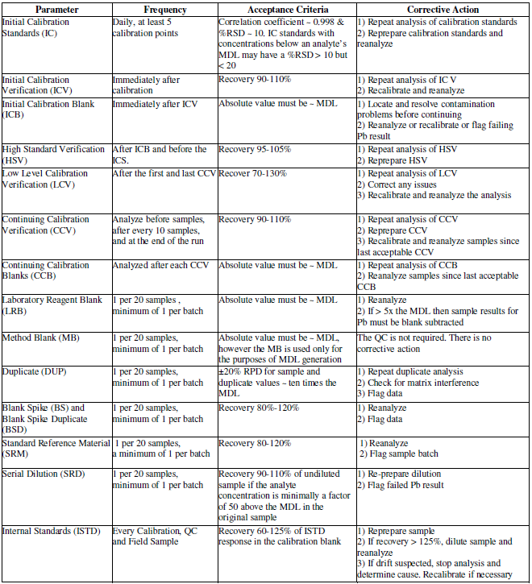
Source: The ERG Quality Assurance Project Plan, Category 1, 2012
B.8 INSPECTION/ACCEPTANCE REQUIREMENTS FOR SUPPLIES AND CONSUMABLES

The purpose of this element is to establish and document a system for inspecting and accepting all supplies and consumables that may directly or indirectly affect the quality of the Pb Program. The ADEQ Pb monitoring network relies on various supplies and consumables that are critical to its operation. This section details the supplies/consumables, their acceptance criteria, and the required documentation for tracking this process.

Sampling Media Supplies

On an annual basis, EPA will provide 8”X10” fibrous glass filters to be used for the collection of routine TSP Pb samples, collocated and PEP TSP Pb samples, and TSP Pb field blanks. Similarly, EPA also provides ADEQ an annual allotment of 47mm Teflon® filters. AFL will collect the shipment upon arrival at the ADEQ Building Shipping & Receiving Office. Typically, EPA provides an ample supply of filters; however, AFL will inspect the shipment to ensure the number of filters shipped is adequate for the year. If filters are consumed at a faster rate than anticipated for any reason, AFL will contact the currently designated EPA representative and request additional filters. In the event the annual allotment of filters is exhausted at an unusually high rate, the QA Team will help determine the root cause of excessive filter use and identify any corrective actions needed to return the Pb network to the normal EPA monitoring schedule.

To prevent damaging the brittle, fibrous glass filters before or after sampling, a second filter holder cassette and faceplate were purchased for each sampler to allow filter setup and removal from the cassette to occur in an indoor environment free of wind gusts and dust. In addition, the duplicate filter holders and faceplates allow the operator to easily set-up a makeup sample run if needed without having to handle exposed and unexposed filters in the field which reduces the opportunity for contamination or physical damage to the filter. The QA Auditor also has a separate filter holder cassette and faceplate which are dedicated to QA and used to protect filter integrity while a PE audit is being conducted.

Unexposed and exposed filters are visually inspected several times during the sample collection process to verify that the filter is without damage or defects including pin holes, tears, and uneven thickness. Filters are examined when loaded into the filter holder cassette, upon installation and removal from the sampler, and during sub-sampling prior to shipment to the analytical laboratory.

Table B.16 shows the critical field supplies for the Pb network.

Table B.16 Critical Field Supplies and Consumables
Area | Item | Description | Vendor
General Supplies | Windex | Used for cleaning - surfactant-based cleaning solutions | Grainger, Costco, Home Depot, Tritec, etc.
General Supplies | Citrus Cleaner | Used for cleaning - surfactant-based cleaning solutions | Grainger, Costco, Home Depot, Tritec, etc.
General Supplies | Canned Air | Used for cleaning - debris removal and/or drying apparatus/material | Grainger, Costco, Home Depot, Tritec, etc.
General Supplies | Iso-propanol or Ethanol |  | Grainger, Costco, Home Depot, Tritec, etc.
General Supplies | Paper Towels |  | Grainger, Costco, Home Depot, Tritec, etc.
General Supplies | Medium-size, soft paint brush |  | Grainger, Costco, Home Depot, Tritec, etc.
General Supplies | Powder-free anti-static gloves | Used to protect sample integrity during filter change-out and operator from exposure to settle dust components | Grainger, Costco, Home Depot, Tritec, etc.
TISCH HIGH-VOL+ Sampler | Combo Philips/Flat-head screw driver | Used during routine service checks and repairs | TISCH, Grainger, Home Depot, etc
TISCH HIGH-VOL+ Sampler | Channel lock pliers | Used during routine service checks and repairs | TISCH, Grainger, Home Depot, etc
TISCH HIGH-VOL+ Sampler | Crescent wrench | Used during routine service checks and repairs | TISCH, Grainger, Home Depot, etc
TISCH HIGH-VOL+ Sampler | 5/16” nut driver | Used during routine service checks and repairs | TISCH, Grainger, Home Depot, etc
TISCH HIGH-VOL+ Sampler | 6 feet of: 1/8” tubing with t-fitting | Used during calibration/verification process | TISCH, Grainger, Home Depot, etc
TISCH HIGH-VOL+ Sampler | Water manometer with colored, low resistance fluid | Used during calibration/verification process | TISCH, Grainger, Home Depot, etc
TISCH HIGH-VOL+ Sampler | Digital Temperature and Pressure sensor/calibrator | Used during calibration/verification process | BGI, BIOS, etc.
TISCH HIGH-VOL+ Sampler | Orifice and resistance plates | Used during calibration/verification process | TISCH
TISCH HIGH-VOL+ Sampler | Back-up fibrous glass filter for calibration/verification/audit checks | Used during calibration/verification process | EPA
THERMO  Partisol 2000 FRM Sampler | Digital Flow, temperature and pressure sensor/calibrator | Used during calibration/verification process | BGI, BIOS, etc.
THERMO  Partisol 2000 FRM Sampler | Multimeter | Used during calibration/verification process | Grainger, Home Depot, etc
THERMO  Partisol 2000 FRM Sampler | O-ring lubricant | Used during calibration/verification process | Grainger, Home Depot, etc
THERMO  Partisol 2000 FRM Sampler | O-ring/seal package (part#59-005514) | Used during calibration/verification process | Grainger, Home Depot, etc
THERMO  Partisol 2000 FRM Sampler | Foam fan cover for filter/pump compartment | Used during calibration/verification process | Grainger, Home Depot, etc
THERMO  Partisol 2000 FRM Sampler | 47 mm Teflon® test filter for calibration/verification/audit checks | Used during calibration/verification process | EPA
THERMO  Partisol 2000 FRM Sampler | 47 mm sealed test cartridge for leak checks | Used during calibration/verification process | Modified in-house by AMU

B.9 NON-DIRECT MEASUREMENTS (Data from other Sources)

This element addresses data to be used in the Pb program that is not obtained by direct measurement from the ADEQ Pb network. These data are obtained from non-measurement sources and historical or concurrently acquired databases not under the direct control of ADEQ.

Chemical and Physical Properties Data

Chemical and physical properties data and values of fundamental constants are often needed in ambient air studies. Examples of acceptable sources for fundamental units and constants and the relationships between metric and U.S. or British units are:

- National Institute of Standards and Technology (available online at www.nist.gov)
- International Organization for Standardization (ISO) (available online at www.iso.ch), International Union of Pure and Applied Chemistry (IUPAC) (available online at www.iupac.org), American National Standards Institute (ANSI) (www.ansi.org), and other national and international standards organizations
- U.S. Environmental Protection Agency (available online at www.epa.gov) sources
- Current editions of handbooks on chemistry and physics such as the Handbook of Chemistry and Physics (CRC Press).

Sampler Operation and Manufacturers’ Literature

Important information is found in the manufacturers’ literature and operating manuals. Manuals for the Pb samplers, the devices used to verify a sampler’s proper operation (temperature sensors, pressure gauges, and flow meters) and to calibrate it, data acquisition devices (laptop computers and the programs they contain), and all analytical instrumentation used in the laboratory will be available.

Geographic Location

Another type of data that will commonly be used is geographic information. For identifying the location of sampling sites, conventional longitude and latitude coordinates, or universal transverse mercators (UTMs) are reported in EPA’s AQS database.

Historical Monitoring Information

Historical monitoring data and summary information derived from previous data may be used in conjunction with current monitoring results to calculate and report trends in pollutant concentrations. In calculating historical trends, it is important to verify that historical data are fully comparable to current monitoring data. If different methodologies were used to gather the historical data, the biases and other inaccuracies will be described in reports using those data.

External Monitoring Databases

Data from the EPA AQS database may be used in published reports with appropriate caution. Care must be taken in reviewing/using any data that contain flags or data qualifiers. If data are flagged, such data shall not be utilized unless it is clear that the data still meet critical QA/QC requirements. It is impossible to assure that a database such as AQS is completely free from errors including outliers and biases, so caution and skepticism is called for in comparing data from other reporting agencies as reported in AQS. Users should review available QA/QC information to assure that the external data are comparable with the measurements and that the original data generator had an acceptable QA program in place.

Meteorological Data from Other Sources

Meteorological data from sources such as the National Weather Service, National Climate Data Center, and other regional climate centers may be used to provide information required when developing monitoring sites, computing corrections needed to convert form standard conditions to actual conditions, and to support analysis and monitoring efforts. These data are not reported to AQS and are identified if they are used in monitoring or reporting.

Data Used to Establish this Network

To ascertain the geographical areas where the highest concentration of airborne Pb is expected to occur, several non-ADEQ data sources were utilized. These data were obtained from ambient air quality and meteorological monitors operated by local facilities. The ADEQ QA Auditor performs annual PE audits on these facility-operated monitors to verify the quality of these data. Also, ADEQ often utilizes meteorological data collected by the National Weather Service (NWS) to aid in the understanding of the relationship between ambient air quality concentrations and meteorological phenomena. AAS personnel have reviewed the QA/QC measures associated with NWS data and have found them to be acceptable. In addition, EPA-approved dispersion modeling was used to assist in the siting of Pb monitors, particularly for the Miami area. The AERMOD dispersion model, utilizing facility and NWS data, was utilized to determine the area of maximum Pb concentrations in the Miami area. ADEQ strives to approve all environmental data and computer software that are to be used to aid in the monitoring effort, though sometimes data of lesser quality are the only information available. For these cases, the limitations and precautions are considered throughout the decision making process.

B.10 DATA MANAGEMENT

Data management (DM) describes how the data are handled through the collection, analysis, validation, and reporting processes; and, it identifies responsibilities and requirements during each process. DM begins with sampling activities and includes any or all of the following operations and their documentation: data recording, transformation, transmittal, reduction, validation, analysis, storage, and retrieval. DM also includes an overview of any mathematical operations and analyses performed on raw (“as-collected”) data. The handling of data is covered in ADEQ and PCWRL SOPs found as attachments to this QAPP.

Data Flow and Management

Data collected from ADEQ-operated instruments in the Pb network will consist of measurements from filter-based samplers operating on an every sixth day (1/6) schedule and from meteorological instruments generating hourly measurements. The DM&QA Unit will apply accepted QA/QC procedures to the Pb and meteorological data.

Source-oriented samplers

For Pb data from the TSP samplers operated by ADEQ’s AMU, interval and sample summary data are scheduled to be downloaded following each sample run day during filter changes and transferred to the appropriate folder in the shared network drive. A Level 1 QA check is performed on the filter samples prior to them being prepped and shipped to the analytical laboratory. This check involves review of the interval data by the AMU lead operator or AFL supervisor to verify that the sampler operated within acceptance criteria and each filter sample was not exposed to air flow before or after the scheduled sample collection day. In addition, the summary data for each sample run day is checked to verify the information provided on the corresponding ADEQ Lead_{TSP} Air Sampling Record sheet is correct. Following analysis, PCWRL performs verification and validation on Pb concentration data prior to sending results in µg/m³ and µg/strip to DM&QA. This constitutes the Level 2 validation. PCWRL assigns the appropriate validation flag to data as needed. The data are submitted in electronic AAAD format on a monthly basis. These data are then loaded to ADEQ’s AAAD by the DM&QA Lead Pb Data Reviewer, who then performs Level 3 validation on the data. Upon completion of the Level 3 validation, the data are then transferred to the EPA AQS database.

Non-source-oriented samplers

For Pb data from the low-volume PM₁₀ samplers operated by ADEQ’s AMU, interval and sample summary data are scheduled to be downloaded weekly during filter changes and transferred to the appropriate folder in the shared network drive. A Level 1 QA check is performed on the filter samples prior to them being prepped and shipped to the analytical laboratory. This check involves review of the interval data by the AMU lead operator or AFL supervisor to verify that the sampler operated within acceptance criteria and each filter sample was not exposed to air flow before or after the scheduled sample collection day. In addition, the summary data for each sample run day are checked to verify the information provided on the corresponding ADEQ PM₁₀ Air Sampling Record sheet is correct. Following analysis, ERG performs verification and validation on Pb concentration data prior to sending results in µg/m³ to DM&QA. This constitutes the Level 2 validation. The ERG assigns the appropriate validation flag to data as needed. The data are submitted in electronic Excel file on a monthly basis. These data are then reviewed by the DM&QA lead Pb data reviewer or the lead air toxics data reviewer, who then performs Level 3 validation on the data. Upon completion of the Level 3 validation, DM&QA staff report any discrepancies noted in the monthly report to ERG, and provide approval for ERG to load the data to the EPA AQS database. Having ERG load these data to the AQS database does raise some concerns about data ownership. These concerns are being investigated by ADEQ, ERG, and EPA staff to allow maximum flexibility to the PQAO. SOPs will be updated to reflect any changes in these data reporting procedures.

Meteorological Measurements

For meteorological data, ADEQ has established electronic communication with the meteorological instruments using a DCS data logger system. DM&QA personnel will perform all levels of data validation on wind direction, wind speed, ambient temperature, and relative humidity data. Figure B.4 shows the data collection system hardware architecture for retrieving continuous data.

Other measurements

If secondary Pb or meteorological data are used, DM&QA will be responsible for determining if it meets EPA and/or internal standards for quality.

Figure B.4 Continuous Data Collection System Hardware Architecture
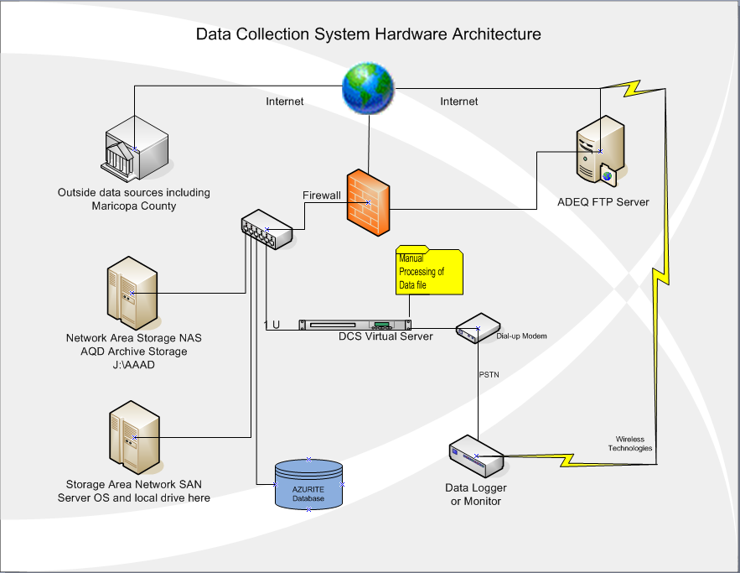
Data Management Responsibilities by Entity

DM activities and responsibilities at ADEQ for the Pb network will be shared by the AMU, AFL, and the DM&QA Units.

Air Monitoring Unit Responsibilities

The AMU is responsible for:

- set-up, operation, maintenance, and take-down of the ADEQ air monitoring and meteorological instruments and the three monitoring sites (MIGC, HAGH, JLG)
- documenting all instrument verifications, calibrations, maintenance, change-outs, instrument and site log books, site information forms; and, providing such reports to DM&QA for QA purposes
- transporting unexposed filters and exposed filter samples to and from sites; loading and unloading of filters into samplers; and, providing sample collection information in the field portion of the ADEQ Lead_{TSP} Air Sampling Record and/or the ADEQ PM₁₀ Air Sampling Record form for each sample
- downloading of data from filter-based samplers and transferring such files to proper ADEQ network drives
- ordering and managing air monitoring instruments, supplies and consumables
- responding to corrective action notices generated by the QA Auditor for failed PE audits
- site maintenance unless the site is not owned by ADEQ – then ADEQ will work with site owner regarding any changes or upgrades needed
- reporting and documenting any changes to a monitoring site to management

The AMU will follow good data practices by:

- filling out all hand-recorded documents completely, accurately, and legibly
- verifying all hand-recorded documents
- maintaining the site and instrument logbooks
- using consistent naming conventions for each site
- storing electronic and hard copy documents in AMU and/or with DM&QA
- communicating status of air monitoring to management

Good data management practices also include personnel accountability for completion of specific tasks. Therefore, all field sheets, ADEQ Lead_{TSP} Air Sampling Record and PM₁₀ Air Sampling Record forms, shipping documents, etc., will be reviewed by the appropriate AAS personnel member for correctness and completeness, including any required signatures or initials.
Air Filter Laboratory Responsibilities

The AFL is responsible for:

- pre-sampling - for all three monitoring sites setting-up filters in the filter cassette holders for each sampler and initializing ADEQ Lead_{TSP} Air Sampling Record and the ADEQ PM₁₀ Air Sampling Record for each sample and field blank collected
- post-sampling – removing exposed filter samples and field blanks from the filter cassette holders
- sub-sampling filter samples and shipping sample strips along with all needed paperwork to PCWRL
- shipping PEP Pb filter samples to the USEPA Region 9 analytical laboratory
- keeping relevant correspondence including emails, shipping records, copies of ADEQ Lead_{TSP} Air Sampling Records (COC/data form), and other documents as needed

The AFL personnel will follow good data practices by:

- reviewing all ADEQ Lead_{TSP} Air Sampling Record and the ADEQ PM₁₀ Air Sampling Record information for completeness and correctness
- developing and using consistent identification numbers for filter samples and blanks
- storing hard copy documents (COC, shipping schedules and records, etc.) in the appropriate files
- communicating with management

Good DM practices rely upon personnel accountability for completion of specific tasks. To ensure good DM practices are continuously employed, documentation, such as ADEQ Lead_{TSP} Air Sampling Records and the ADEQ PM₁₀ Air Sampling Records, shipping documents, etc., and required signatures/initials, is routinely reviewed by AAS personnel for correctness and completeness.
Data Management & Quality Assurance Unit Responsibilities

The DM&QA Unit is responsible for conducting PE audits and TSAs, reviewing all field sheets, managing and reviewing all data, performing final validation of all data and reporting data to EPA’s AQS database. Specific responsibilities for the Pb network are:

- collecting site and instrument metadata and entering it into AAAD
- reviewing PCWRL and ERG data results for the filter samples and blanks from the three monitoring sites
- loading of lead concentration and meteorological data into DCS, AAAD and AQS
- overseeing the automated Level 1 QA procedures performed within the AAAD
- performing Level 2 and 3 QA of the meteorological data in AAAD
- verifying deliverables needed from PCWRL and ERG for Pb concentration data
- performing Level 3 QA on Pb concentration data results,
- loading Pb data into AAAD (TSP data only)
- reporting any changes needed with Pb concentration data to ERG (PM₁₀ data only)
- reporting to the ADEQ program manager when review, loading, and reporting of each batch of data is completed
- maintaining files containing all hard copy field sheets, instrument checks, audit reports, site and instrument change forms, etc.
- PE audits of TSP and PM₁₀ samplers and meteorological equipment
- generating and tracking of any corrective actions for monitoring instruments and data
- preparing metadata and quality assured data summaries for delivery to the program managers
- overseeing and evaluating PE and PEP results to ensure high degree of data quality

The validated data deliverables from the PCWRL will be provided in the appropriate units and format for loading into the AAAD. DM&QA provided the format and specific variables required.

As stated above, good data management practices also include personnel accountability for completion of specific tasks. DM&QA will follow good data practices and document the data management processes by:

- verifying any electronic data entry of files during loading into AAAD and other software applications for analysis
- developing and using consistent naming conventions for each data set
- storing hard copy documents from the AMU personnel
- providing reports to management

Contract Laboratories’ Data Management Responsibilities

Details regarding the laboratories internal data management procedures are described in their respective QM and SOPs which are found in the Attachments. The contract laboratories, PCWRL and ERG, are responsible for:

- processing the collected samples and blanks
- validating the sample and blank results
- transforming the results into AAAD format (PCWRL only)
- delivering the results in a timely manner to ADEQ
- storing the data and associated documents
- uploading data to AQS (ERG only)

The PCWRL uses a Laboratory Information Management Systems (LIMS) to store sample metadata, analysis, flags, and any additional information available for validation of the sample results. The laboratory must retain any data review documents provided by ADEQ. ADEQ expects the PCWRL to follow EPA and ADHS guidelines such as good laboratory practices. They are also expected to follow good data management practices regarding sample identification and tracking, data entry, verification, storage and security. The laboratory is responsible for integrating field data from the ADEQ Lead_{TSP} Air Sampling Record with the analyzed data from the filter samples. The laboratory is also responsible for maintaining sample analysis and COC information. The ADEQ AMU with support from AFL will follow their usual procedures for providing preliminary Level 1 sample validation of filter samples prior to the filter samples being sub-sampled and sent to PCWRL. PCWRL will conduct Level 2 QA reviews of analytical results prior to sending the data to DM&QA Unit for review and entry into the AAAD.

The ERG also uses a LIMS to facilitate data storage, retrieval, analysis, and reporting. Each PM₁₀ Pb filter sample received will be logged into the system. The ADEQ PM₁₀ Air Sampling Records are reviewed to verify that all data entry is complete as well. Sample tracking and COC information are entered into the LIMS system as shown in Figure B.5. All LIMS users must be authorized by the ERG Program Manager. The LIMS aides in maintaining data quality by generating data summaries, QC charts, flags, and other graphs in a consistent manner.

Figure B.5 ERG’s Data Management and Sample Flow Diagram
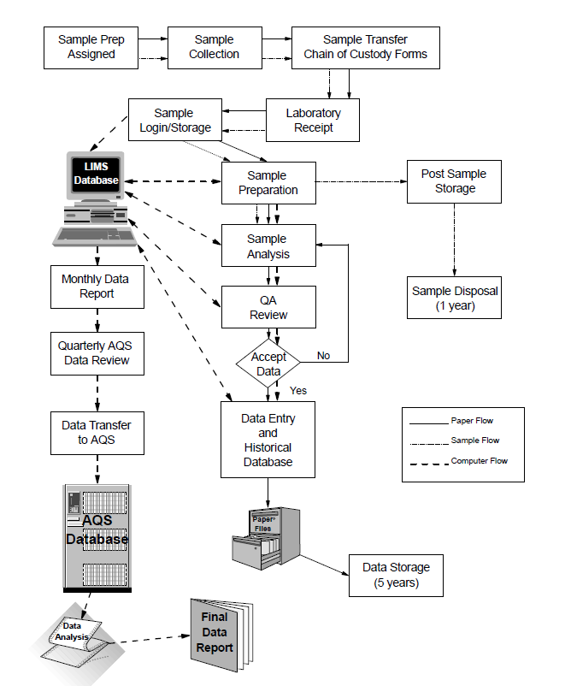
Data Management Responsibilities by Activity

Pre-sampling and Start-up Activities

For source-oriented sampling:

The AMU will set-up three TISCH HIGH-VOL+ TSP samplers at two monitoring sites, perform initial and subsequent calibrations, and verify flow rates prior to every other run until otherwise approved by the AAS Manager. AMU will set-up the meteorological instruments needed at the sites and perform initial and subsequent calibrations and precision checks.

The DM&QA will conduct PE audits on all of the instruments near the beginning of monitoring activities; quarterly thereafter on samplers; annually on meteorological instruments. DM&QA personnel will perform site evaluations on an annual basis. DM&QA personnel will enter the required information in DCS, AAAD, and AQS, and establish file folders for hard copy field sheets.

The AFL will obtain and prepare the unexposed fibrous glass filters to be used in the samplers. The AFL will establish an ADEQ Lead_{TSP} Air Sampling Record for all TSP Pb filter samples and blanks. The AFL will set-up and adjust as needed a shipping schedule for sending the TSP Pb filter samples and field blanks for ICPMS analysis with PCWRL. All required supporting data will also be sent to the laboratory.

For non-source-oriented sampling:

The AMU plans to operate a Partisol 2000 FRM low-volume PM₁₀ filter-based sampler at the JLG Supersite for Pb measurements. Initially, the sampler was operated in standard conditions, but was changed to operating in local conditions in September 2012. AMU will perform initial and subsequent calibrations and verify flow rates once every four weeks. AMU will operate meteorological instruments that meet NCore height requirements and perform initial and subsequent calibrations and precision checks.

The DM&QA plans to conduct PE audits on the sampler once every six months and annually on meteorological instruments. DM&QA personnel will perform site evaluations on an annual basis. DM&QA personnel will enter the required information in DCS, AAAD, and AQS; and, establish file folders for hard copy field sheets.

The AFL will obtain and prepare the unexposed 47mm Teflon® filters to be used in the sampler. The AFL will establish an ADEQ PM₁₀ Air Sampling Record for all PM₁₀ Pb filter samples and blanks. The AFL will set-up and adjust as needed a shipping schedule for sending the PM₁₀ Pb filter samples and field blanks for ICPMS analysis with ERG. All required supporting data will also be sent to the laboratory.
Sample Collection Activities

The AMU operator or their designee will collect the prepped, unexposed filters/filter cassette holders and their associated ADEQ Air Sampling Record forms from AFL and load the TSP and PM₁₀ samplers per the EPA Monitoring Schedule for 1/6 day collection. The AMU operator or their designee will collect filters/filter cassette holders after the sampling has completed and fill-in the ADEQ Air Sampling Record forms. The AMU operator or their designee will download summary and interval data from the Pb samplers. The AMU operator or their designee will return filters and ADEQ Air Sampling Record forms to AFL. The downloaded electronic data files will be reviewed and loaded to the designated location(s) on ADEQ’s network drives.

AFL Laboratory Supervisor or their designee will process the Pb filter samples and blanks from the samplers following procedures found in the Attachments. AFL personnel will ship filter strips to PCWRL and ERG for analysis on a monthly basis or other timeframe as needed.

The AMU operator or their designee will download summary and interval data files from the samplers onto laptops, thumb drives, palm pilot or other suitable electronic device and copy to the ADEQ network drive. Data downloads are schedule to occur after each sample run day at source-oriented sites and weekly at JLG.

The AMU operator or their designee will perform a Level 1 review of the sample summary and interval data files. The Lead Pb Data Reviewer or their designee will perform Level 3 validation on the Pb data once it is received from PCWRL. The Lead Air Toxics Data Reviewer will provide data review support as needed.

AMU will perform routine maintenance, verifications, and calibrations. DM&QA QA Auditor will perform routine PE audits on air monitoring instruments in the Pb network on a regular basis.

AFL will ship Pb filters to PCWRL and ERG for ICPMS analysis on monthly basis, or other frequency if needed.

The Lead Continuous Data Reviewer or their designee will load files from meteorological instruments into DCS and then AAAD and will do a Level 2 QA check on data and report the results to DM&QA Unit Manager.

Post Sample Collection Activities

DM&QA Auditor will perform final PE audits on samplers and meteorological instruments prior to their shutdown. AMU will remove equipment from monitoring sites. DM&QA will verify presence of field documents for completion of Level 3 QA review. The DM&QA Lead Pb Data Reviewer or their designee will load the final data into AAAD and into AQS.
Data Management Practices

This section describes the data handling practices that will be followed by ADEQ. The data handling practices followed by the PCWRL, ERG, and the Region 9 laboratories are described in detail in their respective quality manuals and SOPs.

Manual Data

In general, whenever data are recorded by hand, manually copied or entered into an electronic medium, the personnel member performing the operation and, if possible, the personnel member receiving the data, must verify that the operation was performed correctly. Manual data checks include:

- verifying that the information was recorded or copied correctly (e.g. from instrument screens to field sheets)
- verifying that handwriting is legible and handwritten numbers are clearly identifiable
- verifying that documents have been dated and signed or initialed as required
- verifying that the documents have been filed in the appropriate location

Field records are reviewed for completeness and accuracy and initialed by the Lead Service Report Reviewer, the Lead for QA/QC, and the Lead Pb Data Reviewer.

Electronic Data

All electronic files must be visually inspected by opening the files and viewing the records. This includes files downloaded from samplers and dataloggers, files from the AFL, and files received from the contract laboratory. The purpose of this inspection is to:

- verify that the file can be opened and is readable
- verify that all deliverables have been received per the contract
- verify that the dataloggers have been correctly programmed
- identify the format of the data prior to loading into a database or software application

It is best to inspect these files as soon as possible after receiving the files, especially if data review will not occur immediately. Any questions or problems that arise during this inspection can be resolved in a timely manner.

In general, when electronic data are copied or saved to another file format or loaded from one software application to another, the person performing the operation must verify that the data have transferred correctly. Checks on electronic data operations include:

- verifying that the data are in the correct fields
- verifying that the old and new files have the same number of records
- verifying that formats are correct (i.e., leading zeroes are included and the data are rounded or truncated to the correct number of decimal places)
- verifying that the files are in the correct locations

Sample and Data Tracking and Documentation

The following information and documents are used by ADEQ to track and control the movement and handling of samples and data, to ensure proper procedures are followed, and to support the data review and validation processes.

Site and Metadata Information

The representativeness of a site or monitor can be the most important factor when making decisions about the data collected from that site or monitor. The metadata associated with the site or monitor serves as the documentation of this representativeness. All necessary site and instrument information (e.g., site location, sampler siting information, date(s) of sampler installation and/or removal, etc.) is recorded in a Site Information and Metadata File which is maintained by the DM&QA Unit. Site and instrument change forms are used to document changes. In addition, logbooks are kept at each site and with each Pb sampler for use by the field technicians to record all activities at each site visit and note any problems. Site and metadata information for the three sites generating data for this network is shown in Tables B.1, B.2, and B.3 and on Figures B.1, B.2, and B.3.

Chain-of-Custody & Field Data Forms

A chain-of-custody (COC) will be used with each Pb filter sample and blank generated by ADEQ. Both the COC and field data information for each sampling event are recorded on the appropriate ADEQ Air Sampling Record form. The COC portion tracks who is in possession of and responsible for the filter. The COC originates with the first party responsible for the filters. For the Pb network, the COC for the Pb filters will be initiated by AFL personnel.

The field data portion provides critical sample collection information which is needed for calculating the Pb concentration for each sample. The ADEQ Lead_{TSP} Air Sampling Record has specific spaces for each item below. The handwritten notations on the forms provide critical information including, but not limited to the following:

- site, date, and time that sampling actually occurred
- total volume sampled
- minimum, maximum, and average temperature, flow rate, and barometric pressure (BP) during the sampling period
- identification numbers for samples and blanks, and
- operators’ names and free-form notes regarding any irregularities

Examples of these forms and additional information regarding their use are provided in the AFL & AMU SOPs found in the attachments. Completed ADEQ Air Sampling Record forms will be made available to the PCWRL, ERG, and DM&QA personnel validating Pb data. A copy of each ADEQ Air Sampling Record is retained by ADEQ and checked to ensure that all information is complete, accurate, and legible prior to samples being shipped for analysis.

Shipping and Handling Records

The ADEQ AMU/AFL will maintain shipment records.

Data Corrections

Following good data management practices helps to ensure that mistakes will either be avoided or found and corrected early in the process. Occasionally, however, errors will be made and overlooked, or problems discovered at a later date. In such cases, it may be necessary to change data after it has been uploaded to the AAAD or AQS. The DM&QA Unit is responsible for making the changes in these databases for TSP data.

The DM&QA Unit is responsible for communicating changes needed to PM₁₀ Pb data to ERG, and ERG is responsible for making changes to Pb data in the AQS. The DM&QA data reviewers are responsible for checking that requested changes were made successfully.

Data Storage and Retrieval

Data management includes storing and archiving all data, data files and any related documents needed to ensure data quality. Table B.17 summarizes the specific ADEQ records and documents and the Unit responsible for storing them. The contract laboratories’ data storage and retrieval techniques are described in their respective QM and SOPs.

The analyzed data will be kept in AAAD. In addition, the analyzed data will be kept in the original electronic form produced by the contract laboratories and stored on ADEQ AQD’s network drive. A brief description of the AAAD database is provided below.

AAAD

The AAAD is the central data repository for data collected and used by the AAS. The AAAD is an Oracle relational database built by ADEQ’s Information Systems Development Unit (ISDU) and put into production in July 2002. It contains both continuous data from the DCS and non-continuous data from filters, canisters, and cartridges (FCC). The AAAD also contains instrument information and has graphics capability to assist users in quality assurance data review. AAAD is linked to the ADEQ AZURITE database which contains place information for the monitoring sites.

Access to the AAAD is controlled by a valid User ID and password. There are also six user roles which control user privileges including table access, screen access, and the ability to insert, update and delete data and metadata. User roles are assigned by the database administer (the DM&QA Unit Manager). In addition, the AAAD is linked to ADEQ’s central AZURITE database which contains ‘Place’ and ‘Customer’ information. The user role to access the ‘Place’ information required for the AAAD is assigned by ADEQ’s Information Technology Section (ITS) after the user has completed an in-house training course.

The AAAD database is housed on the ADEQ Oracle server kept in the ITS server room. The ITS has daily, weekly, and monthly back up procedures as well as back-up power support to the server room. The Oracle server is inside the ADEQ firewall and protected with antivirus and other security software. The ITS has Oracle database administrators with 24-hour/7-day access to identify any server issues. The back-up and security procedures of the ITS are described in the ADEQ QMP.

The AAAD was designed to store up to ten years of data online with older data rolled off to archive storage space. Archived data will be kept in simple text-delimited files that can be accessed via special request to the ITS. These procedures have not been finalized and may be part of the current ISDU development of an AZURITE data warehouse.

Table B.17 Summary of Data Records Stored at ADEQ
Type of Record | Medium | Data Storage Location or Responsibility
Completed COC and field data forms | Hardcopy and electronic | AMU and DM&QA
Site and instrument logbooks | Hardcopy | DM&QA
Shipping and receiving records | Hardcopy | AMU/AFL
Certificates for all instruments and standards (e.g., NIST or manufacturer's certificate) | Hardcopy | AMU and DM&QA
Instrument calibration and verification records | Hardcopy | AMU and DM&QA
Instrument maintenance and service records | Hardcopy | AMU and DM&QA
Downloaded files from monitors with QC data | Electronic | AMU  (computer - network drive)
QA records, including PE audit and technical system audit reports | Hardcopy and electronic | DM&QA
Lab validated data sets sent from the laboratory to ADEQ including metadata | Electronic | DM&QA  (computer – network drive)
Data Review forms | Hardcopy and electronic | DM&QA
Quality Assured Data | Electronic (AAAD) | DM&QA
AQS Reports | Hardcopy and electronic | DM&QA
Purchasing records | Hardcopy | AMU and AAS
Correspondence between ADEQ and the PCWRL | Electronic | AMU and DM&QA
Correspondence and business records with subcontractors involved with the program | Hardcopy and electronic | AMU and AAS
Training records | Hardcopy | AAS
Correspondence and reports with subcontractors performing data analysis (if applicable) | Hardcopy and electronic | DM&QA and AAS

SECTION C. ASSESSMENT AND OVERSIGHT

C.1 ASSESSMENTS and RESPONSE ACTIONS

This element describes the external and internal checks planned for the Pb network to ensure that:
- elements of the QAPP are correctly implemented as prescribed,
- the data generated are of high quality and meet the needs of users, and
- response/corrective actions, when needed, are implemented in a timely manner and their effectiveness is confirmed.

An assessment, for this QAPP, is defined as an evaluation process used to measure the performance or effectiveness of the quality system for a monitoring network, its sites, and various measurement phases of the EDO. The results of assessments indicate whether the QC efforts are adequate or need to be improved. To ensure the adequate performance of the quality system, ADEQ and EPA Region 9 plan to perform assessments on the ADEQ’s various air monitoring networks periodically.

Assessments of External, Auxiliary Organizations

As stated in Section A, ADEQ does not plan to independently perform assessments of the contract laboratories, but technical personnel will work with EPA as needed to evaluate the laboratories practices. ADEQ plans to review assessment reports generated by other government agencies as a means to evaluating laboratory performance periodically. The QA information received from the ERG and PCWRL will be reviewed on a regular basis when batches of data are submitted for Level 3 validation.

Assessments of ADEQ Program Activities

Surveillance

Surveillance is the continual monitoring and analysis of records to ensure that specified requirements are being fulfilled. On a routine basis, AMU and DM&QA personnel review log books and instrument service reports (calibrations, verifications, PE audits, instrument change forms, and corrective action reports, etc.) generated from the operation and maintenance of the Pb samplers to verify that the acceptance criteria are being met. In addition, ADEQ plans to review the electronic data files from the Pb samplers before and after sample collection to ensure that the samplers operated correctly.

Technical Systems Audits (TSAs)

A TSA is a thorough and systematic on-site qualitative audit, where facilities, equipment, personnel, training, procedures, and record keeping are examined for conformance to the QAPP and governing EPA regulations. 40 CFR Part 58 requires EPA to conduct TSAs on air monitoring organizations under their jurisdiction. EPA may opt to use the services of a third party contractor for external TSAs. The EPA Region 9 plans to conduct a comprehensive TSA on ADEQ’s air monitoring program every three years. ADEQ also plans on conducting a comprehensive TSA on a three year schedule. However, an internal TSA may be conducted more frequently or a TSA may be conducted on a specific air monitoring network if requested by management or if the QA Team has reason to believe an assessment is needed on a specific network.

Typically, the AAS QA Team, which is comprised of the QA/QC Lead and QA Auditor, conducts TSAs as a joint effort, but it is possible that the TSA may be conducted by one QA Team member. In addition, the QA Team anticipates that other AAS personnel or technical experts will want to participate on internal TSAs and may be needed as participants on occasion. Therefore, the members of an Audit Team may vary from TSA to TSA.

To increase uniformity of a TSA, the QA Team plans on using a checklist and/or questionnaire. The checklist and/or questionnaire may be amended overtime in order to ascertain information more precisely. Although the TSA is comprehensive, each TSA may be tailored toward specific issues currently under focus. These items may include emerging issues at a local or national level or requests for more information regarding a specific air monitoring network from management or the EPA.

TSA activities commonly involve:
- visiting air monitoring sites,
- reviewing records such as logbooks, service reports on air monitoring instruments and NIST-traceable certifications of calibration standards/references,
- interviewing key personnel (individuals involved with planning, laboratory and field operations, QA/QC, data management, and reporting), and
- evaluating data for accuracy.

For the Pb network, there are three distinct service areas that will be reviewed:

- Laboratory – filter ordering and receiving, pre-sampling filter and chain-of-custody setup, post-sampling filter cutting, shipping, archiving; third party audits of contract laboratories will also be reviewed
- Field – station and sampler siting and operation, filter sample collection, sample handling during change out and transport
- Data Management – metadata and pollutant data collection, flagging, editing, validation, security, archiving, and uploading to AAAD and AQS databases.

ADEQ’s air monitoring program and its quality system are ultimately evaluated against the EPA regulations, 40 CFR Parts 50 and 58, any applicable State of Arizona rules and regulations, and ADEQ’s QAPPs and Quality Management Plan. The QA Team is available to help identify solutions to audit findings and usually meets with the audited group as needed to help identify solutions that will yield a positive result for all concerned. Findings and recommendations identified during both the external and internal TSAs are reported in a formal report. Usually findings and recommendations derived from the TSA process fall into major and minor categories. These findings and recommendations as well as the solutions implemented are recorded. This preserves valuable historical information pertaining to the air monitoring program’s networks.

Any deficiencies that are deemed “serious” meaning there is reason to believe that the quality of pollutant data is being significantly compromised and the matter needs immediate attention from management, will be identified using a specific form. The ADEQ Internal Audit Finding (IAF) form will be used to present such findings to the audited group and their management at the TSA debriefing (See Figure C.1). An IAF form will be generated for each serious deficiency and it will clearly identify pertinent information such as: pollutant(s) impacted, estimated time period of deficiency, site(s) affected, and reason of action. During the debriefing discussion, evidence may be presented that reduces the significance of the finding; in which case, the finding may be removed. If the audited group is in agreement with the finding, the discussion is documented and the form is signed by the organization’s director, or their designee, during the exit interview. If a disagreement occurs, the Audit Team will record the opinions of the audited group and set a time at some later date to address the finding at issue. The Audit Team and the audited group may work together to solve required corrective actions. An ADEQ Internal Audit Response (IAR) form (Figure C.2) will be initiated by the audited group’s unit or section managers in response to each ADEQ IAF generated that can not be resolved at the debriefing.

It is customary for both external and internal TSAs to end with a closing or debriefing meeting with key personnel and management. This provides a forum for discussion with auditors regarding positive observations as well as the findings and recommendations geared toward the continuous improvement of an air monitoring network and the data it produces. If needed, an attempt will be made to rank the findings in order of their potential impact on data quality if needed.

The major post-audit activity is the preparation of the TSA report. The Audit Team will prepare the TSA report that includes a written executive summary of findings covering the following service areas: laboratory, field, and data management. To prepare the TSA report, the Audit Team will compare observations with collected documents and results of interviews and discussions with key personnel. The audit findings, both accomplishments and deficiencies, will be discussed in adequate detail in the written report. ADEQ plans to use information gleaned from TSAs as well as other types of audits to improve QAPPs and SOPs in order to produce the highest quality data possible. See Section C.2 for more on the TSA report.

Figure C.1. ADEQ Internal Audit Finding Form

Figure C.2 ADEQ Audit Response Form

ADEQ Internal Audit Finding

Audited Unit/Team: ______________________________________________________

Audited Activity: Audit Date: Finding #: _______________

Finding:

___________________________________________________________________________________

Discussion:

Audit Team Lead Signature: __________________________ Date: ______________

Audited Unit Supervisor Signature:____________________ Date: ______________

ADEQ Internal Audit Finding Response Form

Audited Unit/Team:______________________________________________________________

Audited Activity: ____ Audit Date: ________ Finding #: __________

Finding:

Cause of the problem:

Actions taken or planned for correction:

Responsibilities and timetable for the above actions:

Prepared by: Title________________ Date: _____________

Audited Unit Supervisor: Title _______________ Date: _____________

Audit Team Lead: Date: _____________

Remarks:

Is this audit finding closed? When?

File with official audit records. Send copy to Auditee

Audits of Data Quality

An audit of data quality (ADQ) reveals how the data are handled, what judgments were made, and whether uncorrected mistakes were made. ADQs can often identify the means to correct systematic data reduction errors and they may help to identify improvements needed in a network’s operations. ADQ are detailed evaluations of a small percentage of the data reported to the EPA’s national database and include an evaluation of both the raw data and the supporting documentation. The QA Team plans on conducting an ADQ once every 6 months on the various types of data generated by the AAS’s air monitoring program or more frequency if requested by management.

The auditor or QA Team will devote sufficient time and effort to this activity to ensure a clear and complete understanding of data flow and the associated documentation is well-founded. Pertinent ADQ questions will appear on the TSA checklist or questionnaire to ensure that the data maintain their integrity at each level of validation. The ADQ may serve as an effective tool for organizing the extensive amount of information to be gathered during a TSA from the laboratory, field, and data management functions. The ADQ will have the same reporting/corrective action requirements as the TSA. The QA/QC Lead and QA Auditor plan to conduct an ADQ in conjunction with a TSA. The EPA Region 9 QA Office may also conduct ADQs. The ADQ should not be confused with the data quality assessment (DQA).

Data Quality Assessments

A DQA is a statistical analysis of air quality, or other environmental data, that is used to determine whether data generated by a particular air monitoring network have met the established DQOs and MQOs, and in doing so, are of adequate quality for use by decision makers. The DQA process is discussed in detail in Section D.3 of this QAPP.

Management Systems Review (MSR)

An MSR is a qualitative assessment of a data collection operation or organization to establish whether the prevailing quality management structure, policies, practices, and procedures are adequate for ensuring the type and quality of data needed are obtained. MSRs are conducted or lead by the ADEQ QA/QC Unit Manager and are targeted for every three years. The reviewer(s) will ensure that sufficient management controls are in-place and carried out by the organization to adequately plan, implement, and assess the results of the program. The QA activities for all criteria pollutants including Pb should be part of the MSR. The ADEQ QA/QC Unit will report the findings to the AAS Manager within sixty (60) days of completion of the MSR. The report will be appropriately issued to ADEQ Directors. Follow-up and progress on corrective action(s) will be tracked, documented, and filed appropriately as per AAS’s corrective action plan.

Performance Evaluation

The EPA defines a performance evaluation (PE) as a type of audit in which the quantitative data generated in a measurement system are obtained independently and compared with routinely obtained data to evaluate the proficiency of an analyst, or laboratory. Laboratories analyzing both type of Pb filter samples, TSP and Teflon®, will participate in a proficiency test (PT) on a quarterly basis where 6 filters strips of a known concentration are analyzed and reported to EPA. ADEQ will monitor how well the analytical laboratories perform.

In addition, the DM&QA QA Auditor performs independent audits, or QC checks (verifications), using a different NIST-traceable calibration standard, or reference, on both the TPS and PM₁₀ Pb samplers. ADEQ PE audits are conducted once a quarter by the QA Auditor. These checks do not generate Pb data; but they provide assurance that air monitoring instruments are performing as shown during regular verification checks performed by the AMU technicians. The main components audited are: site conditions and an air monitor’s flow rate, ambient temperature, and ambient pressure.

ADEQ’s Pb TSP samplers are required to participate in the EPA Pb Performance Evaluation Program (Pb PEP) which is part of the EPA’s National Performance Evaluation Program (NPEP). The QAHBV2 provides the following list of benefits derived from the NPEP:

- Allows one to determine data comparability and usability across sites, monitoring networks (Tribes, States, and geographic regions), instrument and laboratories;
- Provides a level of confidence that monitoring systems are operating within an acceptable level of data quality so data users can make decisions with acceptable levels of certainty;
- Helps verify the precision and bias estimates performed by monitoring organizations;
- Identifies where improvements (technology/training) are needed; and
- Assures the public of non-biased assessments of data quality.

PEP reports will be compiled by EPA and disseminated to air monitoring agencies. The EPA is applying the following two-part approach to the Pb PEP QA/QC process:

- One, annual, EPA-generated, collocated filter sample will be collected by an independent field auditor (EPA personnel or EPA contractor) who temporarily sites, an EPA-selected TSP audit sampler beside one of ADEQ’s TSP samplers at a source-oriented site. Then, a 24-hour collocated sample is collected on a regularly scheduled sample collection (run) day. The auditor then collects the audit, or PEP, filter sample and sends it in its entirety, i.e. does not sub-sample, to an independent laboratory for analysis. The ADEQ sampler audited is expected to vary each year and the EPA Region 9 Laboratory is analyzing the Pb PEP samples.

- One, quarterly, ADEQ-generated, collocated filter sample will be collected by an ADEQ operator in addition to the routinely required collocated filter samples. ADEQ submits the audit, or PEP, filter sample in its entirety to the EPA Region 9 Laboratory for analysis. The sampler used is the designated secondary sampler at the collocated Globe Highway site. NOTE: Collocated filter samples are required every other run day. ADEQ opted to collect a collocated filter sample on all sample run days which (1/6 day) because it was easier to plan and provided extra samples without significantly increasing time and effort by personnel.

Table C.1. Summary of Assessments Planned by External Agencies
Assessing Agency | Type of Assessment |  | Agency Assessed | Frequency
EPA | Pb PEP |  | ADEQ | Annually
 |  | EPA-generated TSP collocated filter sample | ADEQ | Annually
 |  | ADEQ-generated TSP collocated filter sample | ADEQ | Quarterly
EPA | Pb PT Audit Strips (both TSP and Teflon®) |  | PCWRL, ERG, R9 Lab | Quarterly
EPA | DQA |  | ADEQ | Once every three years
EPA Region 9 | MSR or TSA |  | ADEQ | Once every three years
ADHS | MSR/TSA |  | PCWRL | Once every three years
EPA | PT for PM₁₀ filter sample* |  | ERG | Periodically
* - a NATTS-driven PT for the PM₁₀ toxic metals filter sample

Table C.2. Summary of Internal Assessments Planned by ADEQ
Units Responsible | Type of Assessment | Frequency
ADEQ QA/QC Unit | MSR | Once every three years
DM&QA | TSA  DQAs (all data)  ADQ  PE Audits (flow rate) | Once every three years  Annually  Semi-annually  Quarterly
DM&QA, AMU, and Evaluation | Surveillance | Ongoing
DM&QA, AMU | Air Monitoring Network Plan | Annually
DM&QA, AMU, and Evaluation | Air Monitoring Network 5-Year Assessment Report | Once every five years beginning 2010

C.2 REPORTS to MANAGEMENT

Effective communication among all personnel is also an integral part of a quality system. Reports to management provide the opportunity to alert management of data quality problems, to propose viable solutions to problems, and to procure necessary additional resources. Routine reporting also provides a means for tracking the following:

- adherence to scheduled delivery of data and reports;
- documentation of deviations from approved QA and test plans, and the impact of these deviations on data quality; and
- analysis of the potential uncertainties in decisions based on the data.

The following sections describe the quality-related reports and communications to management necessary to support the Pb network operations and the associated data acquisition, validation, assessment, and reporting.

Quarterly and Annual Data and QA Summary Reports

Data summary reports will be distributed quarterly to management to brief them on the status of the operations of the instrumentation as well as the status of data summary metrics in comparison to the NAAQS. These quarterly reports are based on quality assured Level 3 data. During the first year of Pb monitoring, monthly reports will also be provided to management to provide more timely updates on the overall operation of the instrumentation and the status of data summary metrics in relation to the NAAQS. These monthly reports are based on preliminary Level 2 data.

Periodic assessments of the Pb data quality are required to be reported to EPA (40 CFR 58 Appendix A). This requirement is fulfilled by the reporting of precision and bias data to the AQS. These precision and bias data are also taken into consideration when certifying the ambient Pb data as documented in the annual data certification package to EPA. The precision and bias data are obtained from:

- AMU flow verifications (precision and bias checks)
- QA Auditor flow rate audits (bias checks)
- Routine collocated sample results (precision estimates)
- Pb PEP audits and quarterly collocated PEP sample (bias estimates)
- Quarterly audit strip analyses (bias estimates)

Data from the AMU flow verifications and DM&QA flow rate audits are uploaded to the AQS once a quarter for the previous quarter. All precision and bias data for the calendar year must be entered before the annual certification deadline of the following year.

DM&QA staff produce quarterly reports that document the data validation process and provide data summaries for various programs. The data validation and data summaries from the Pb-TSP samplers are included with the SLAMS filter-based particulate data report. The data validation and data summaries from the Pb-PM₁₀ sampler are included with the speciation and toxics data report. The Pb data and QA summaries are included as a section within these reports. Information such as data completeness, NAAQS comparisons, collocation details, and a summary of quality assurance issues are contained within these reports. These reports are reviewed by the DM&QA Unit manager.

Annual reports to management primarily include the annual data certification letter and the annual audit report. The data certification letter is a requirement that is due to EPA by May 1 of the following year for which the data have been collected. ADEQ’s DM&QA Unit includes an overall assessment of the data from all of the monitoring networks as an attachment to the annual data certification letter. This letter and accompanying report focuses on the quality assurance and data review aspects that are associated with ambient air quality monitoring. DM&QA personnel utilize the AQS AMP255 Data Quality Indicator Report to summarize and assess precision and bias information for each monitor ADEQ operates. If any significant issues arise throughout the year or during the annual review of the QA data, this is documented in the certification letter.

At the end of each calendar year, an annual audit report is developed by the ADEQ AQD QA Team and distributed as above. This document describes the quality objectives for measurement data and how those objectives have been met. The QA Annual Report includes quality information for all data collected by each network, including Pb beginning in 2011. The Annual Audit Report includes, but is not limited to, the following QA information:

- monitoring program overviews and updates on any changes to the audit program,
- a summary of the flow rate and performance audits performed in that year for each network, and
- a summary of any internal or EPA TSAs conducted during the year and any corrective actions taken in response

For reporting measurement uncertainties, the QA Annual Report contains the annual AQS QA summary report and summary statistics of the following for each monitoring network or program:

- Precision
- Bias
- Completeness
- Timeliness

Annual Monitoring Network Plan and Five-Year Network Assessment

Effective December 18, 2006, 40 CFR 58.10 requires states to complete an annual monitoring network plan and submit it to the EPA Regional Administrator for approval by July 1st of the following year. The monitoring network plan identifies the purpose of each monitor and provides evidence that the siting and operation of each monitor meets EPA requirements. It is used to determine how well a particular air monitoring network is achieving its required air monitoring objective(s) and what modifications are needed for it to continue or to better meet its objective(s).

The annual monitoring network plan must be made available for public inspection (website, hardcopy posting in libraries and public offices, and/or newspaper listing) for at least 30 days prior to submission to EPA. Although not required, EPA recommends soliciting comments during the public inspection period. If an opportunity for public comment is provided, any comments received must be included in the network plan, and any changes made to the plan after the public comment period must be identified.

Every 5 years, in addition to the annual plan, an assessment of the air quality network must be submitted to EPA Region 9. This five-year network assessment must determine 1) if the network meets the monitoring objectives defined in 40 CFR 58 Appendix D, 2) whether new sites are needed, 3) whether existing sites are no longer needed and can be terminated, and 4) whether new technologies are appropriate for incorporation into the ambient air monitoring network. This assessment must also include a review of existing and proposed sites to determine if areas with relatively high populations of susceptible individuals (i.e., populations with sensitivities such as children with asthma) are characterized. In addition to the requirements above, the five-year network assessment may also include 1) re-evaluation of the objectives and budget for air monitoring, 2) evaluation of a network’s effectiveness and efficiency relative to its objectives and costs, and 3) development of recommendations for network reconfigurations and improvements. The first assessment under these new regulations was due July 1, 2010.

Technical System Audit Reports

External TSAs are scheduled to be conducted at least every three years by the EPA Region 9 Office as required by 40 CFR Part 58. The report with the audit findings will be provided to the ADEQ AQD Director and forwarded to the AAS Manager. Internal TSA reports provided by the DM&QA QA Team will be provided to the AAS unit managers, AAS section manager, and made available to EPA personnel when they audit ADEQ or provided upon request. The reports will be filed appropriately.

The internal TSA report will include:
 
- audit title and any other identifying information such as an audit ID number;
- audit team leaders, audit team participants and audited participants;
- background information about the project, purpose of the audit, dates of the audit; particular measurement phase or parameters that were audited, and a brief description of the audit process;
- summary and conclusions of the audit and corrective action requires; and
- attachments or appendices that include all audit evaluations and audit finding forms.

The goal is to have the TSA draft audit report prepared within thirty days (30) following the debriefing. The report will be made available to the audited group for comment. The audited group will have at least two (2) weeks to review the report and make comments. If the audited group has written comments or questions concerning the audit report, the Audit Team will review and incorporate them as appropriate, and subsequently prepare and resubmit a final report. The final report should be ready for distribution about sixty (60) days following the TSA debriefing. The report will include an agreed-upon schedule for corrective action implementation or follow-up meetings will be held to develop a schedule.

Corrective Action Process and Performance-Related Records

A corrective action process (CAP) is in-place for the Air Assessment Section (AAS). The program ensures personnel have a means of communicating any perceived problems involving potential safety issues that may present a risk to the site technicians, operators, and auditors, or, operational or procedural problems that may adversely affect data in a number of ways. The CAP is geared toward problems, or deficiencies, to which no prescribed corrective action has been identified in SOPs or QAPPs. The CAP is a closed-loop system and is geared toward preventing recurrence of a problem by addressing its root cause. Failed PE audits fall under the CAP. For more information on the CAP, see AAS’s SOP which is included in the attachments.

SECTION D. DATA VALIDATION AND USABILITY

D.1 DATA REVIEW, VALIDATION, and VERIFICATION REQUIREMENTS

Data review is the set of verification and validation procedures used to examine the products of data collection and data processing to determine their quality and usability. It spans a wide scope of tests from low level checks on sample identity to high level checks on spatial and temporal comparability. The main goal of the review is to determine if the data products (measurements) are representative of their environment. This is accomplished through verification and validation of the preliminary data results with sample collection procedures, sampler operation, and laboratory processing. In general, whenever an operation affects the data product, verification and validation checks should be defined and implemented to ensure the operation was done correctly.

Data review also provides feedback on the field and laboratory analysis activities; it identifies those data points that may indicate the need for corrective action to a field or laboratory procedure. Data are only invalidated when specific evidence exists that show a clear cause for the invalidation, i.e., a failed flow verification. Outliers not explained by instrument or processing errors are considered valid from an operations’ standpoint and require further investigation with meteorological, climatological, and other environmental information to determine what event they represent. However, if there is supporting information that indicates environmental data are not representative of the ambient environment, the data may be invalidated through a weight of evidence approach as long as it is thoroughly documented. More information regarding this approach is provided in data review SOPs. Ideally, data review is to be performed as soon as possible after data collection and on a regular schedule during the project to enable timely investigation of questionable data, to meet data reporting requirements, and to take corrective action.

Data verification and validation are defined as follows:

- Data Verification techniques confirm through provision of objective evidence that specified requirements have been fulfilled. Data verification ensures and documents that the data are what they purport to be; i.e., it verifies what was actually done and documents that the data fulfill applicable requirements. Data not meeting the requirements are to be identified and documented with the cause of the insufficiency.

- Data Validation techniques confirm by examination and through provision of objective evidence that the particular requirements for a specific intended use are fulfilled. Data validation focuses on the particular data needs for a project and ensures that reported values meet the quality goals of the environmental data operations. The purpose of data validation is to verify that data values are representative of air quality conditions at a sampling station and to detect those data values that do not represent actual air quality conditions.

Data verification and data validation are typically sequential steps performed by different persons. Data validation begins with the outputs from data verification and, ideally, it is performed by a data reviewer independent of the data collector, data processor, and data user. In general, data verification techniques occur during the sample collection and processing phases of the project. Data validation techniques are then applied on the resulting data product, which requires review of information generated throughout the entire sample collection, sample analysis, and data handling process. Additional verification and validation checks can be created as necessary to check the results of any operation affecting the data product.

Data review is not the same as data quality assessment or evaluation of the DQOs. Only after the data set has been reviewed, verified, and validated can it be fully assessed and/or used to address the specific scientific and regulatory questions embodied in the DQOs. The following sections describe ADEQ’s data review processes and requirements. The specific data review procedures used by the contract laboratories are not included here.

The Data Verification and Validation Process

Data verification and validation will be performed by both the contract laboratories and by ADEQ. AMU personnel will review summary and interval data for each sample collected and verify that the field data information matches the sampler’s record. AMU personnel verify that a valid sample was collected before processing the sample for laboratory analysis. The information on the COC is verified and reviewed before shipment of the sample to the ERG and PCWRL laboratory. These sample verification procedures constitute the level 1 review and validation.

ERG and PCWRL will perform additional verification and validation procedures, most of which are specific to laboratory analysis procedures. These laboratory verification and validation procedures constitute the Level 2 review and validation. ADEQ is responsible for Level 3 validation but will also perform additional Level 2 checks as a means of verifying the results obtained from the laboratory. Level 2 checks include verification of the processed data with the ADEQ Air Sampling Records and review of all flagged data including invalid and qualifier flags. Level 3 data validation will be performed to identify and validate outliers, monitor trends over time, and incorporate field QC checks into the data validation decision making process.

The ERG and PCWRL will provide the validated filter data results from the ICPMS analyses for further validation by ADEQ. ERG and PCWRL provide the required deliverables in batches approximately 30 to 60 days after sample shipment based on the contract agreement with DM&QA at ADEQ. These deliverables include electronic files of:

- raw and validated sample data in the laboratory’s format with detection limits or uncertainties
- a definition list for all acronyms and abbreviations used by the laboratory
- an index or key to identify sites, sample ids and sample dates
- a list of flag definitions
- any narratives by laboratory personnel
- validated data in AAAD format (PCWRL data only)

The DM&QA Unit will continue with Level 2 QA checks of the validated data by reviewing the data flags applied by the laboratory in the laboratory’s files. ADEQ will use its in-house records to examine data that have been flagged for attribution, sampler problems, and outliers. Questions about flags applied by the laboratory will be directed to the laboratory manager.

The DM&QA lead Pb data reviewer and Air Toxics data reviewer will perform Level 3 QA on the Pb TSP and Pb PM10 data sets, respectively. The specific procedures used for data validation are described in the Pb and Air Toxics data validation SOPs found in the attachments.

Data Review, Validation and the Air Assessment Ambient Database (AAAD)

Much of the data review and validation process is done within the AAAD. As discussed in Section B, AAAD offers some tools to assist data reviewers and validators throughout the data review and validation process. The degree to which each datum has been reviewed is documented in AAAD through the QA Levels. The QA Levels range from Raw to Final. The raw data are considered to be the original data derived from the instrumentation or laboratory analysis. Occasionally, transformations of the data are performed by DM&QA within AAAD. These data transformations typically occur during the AAAD automated upload and validation processes and only occur so that data reported from various instruments, laboratories, and agencies are of a common data format. While these data transformations may occasionally occur, the raw data files are always archived.

Levels of Data Review

The data review procedure at ADEQ requires all data measurements to move through multiple levels of quality assurance. When each level of data review is completed, the data are assigned a Quality Assurance Level that is entered in the AAAD, ADEQ’s central data repository, along with the status (valid, invalid, or suspect) of the data at that level and a code or flag that further describes the status. The primary objective of each level of quality assurance is to examine the data results, to verify the measurements are what they purport to be, and to validate their quality in relation to the requirements of conformance to procedures, equipment operation, and environmental effects. Those measurements not meeting the requirements are assigned an invalid or suspect status with a reason code describing the nonconformance.

AAAD flagging protocol requires a reason code for each sample value at each quality assurance level. The reason code format consists of a letter followed by a number or another letter depending on the code type. The data validation code types are shown in Table D.1. The unique combination of letters and numbers creates specific reason codes that further explain the status code. If additional explanation is needed, the comment field can be utilized. Each data record is comprised of a data value field, a QA status field, a reason code field, and a comment field.

Table D.1 Data Validation Code Types
Data Field | Letter | Number or Letter | QA Status | Meaning
Null | B | Number | Invalid | Sample not processed or determined invalid
Data Value | V | Number | Valid | QA complete
Data Value | S | Number | Suspect | Requires further QA
Data Value | Q | Number or Letter | Valid | Letter or number following ‘Q’ is the AQS qualifier code

In general, data are corrected, flagged, or invalidated based on the best assessment of the individual situation. Data corrections and flagging are noted in regular QC reports to management. Systematic problems that lead to unacceptably large biases are investigated and documented by DM&QA. Corrective actions are initiated as needed.

Data completing all three levels of review and considered to be valid can be promoted to Level Final or can remain at Level 3. Promoting data to Level Final occurs on an annual basis and is associated with an overall review of QA/QC results and activities that occurred throughout the given year. This annual review and promotion of data to Level Final occurs during the data certification process. The primary documentation of this process occurs via the data certification letter and accompanying report(s), but this process may also be documented within the AAAD. A description of ADEQ’s QA Levels is listed in Table D.2.

Table D.2 ADEQ Quality Assurance Levels for Filter-based and Continuous Measurements
QA Level | QA Objective | QA Results
Raw | Original unchanged sample data recorded at sampler or produced by laboratory analysis; to be archived. | None
1 | Data are reviewed (either manually or programmatically) to determine if:  - sample value produced came from proper and assumed instrument  - instrument producing sample value came from proper and assumed site  - instrumentation problems occurred, as documented by instrument flags or error log | Flag data as valid, invalid, or suspect.  Add comments.  Corrective actions taken if necessary.
2 | Review Level 1 data to:  - identify outliers or anomalous data (typically temporal-based) and make a preliminary validation decision.  - identify media preparation problems, laboratory transformation problems, etc. | Flag Level 1 data as valid, invalid, or suspect.  Add qualifiers to valid and suspect data if necessary.  If necessary, add comments to data values further explaining issues at hand.  Initiate Corrective Action if necessary.
3 | Review Level 2 data over longer periods of time (≥ one month for continuous data and ≥ three months for filter-based data). Additionally, Level 3 data review is intended to:  - compare data both spatially and temporally  - incorporate and verify the field generated QC results into the data review process  - make a final determination on the validity of outliers identified during the Level 1-3 QA process  - identify environmental events (natural or human-caused) with appropriate flagging protocol | Flag Level 2 data as valid or invalid.  Add qualifiers to valid data if necessary.  If necessary, add comments that help explain validation rationale.  Initiate corrective action if necessary.
Final | Field generated QC data associated with environmental data are reviewed annually for precision, bias, and completeness. This occurs as part of the data certification procedures. Certified data are promoted to Level Final. | Promote Level 3 data to Level Final after performing annual certification procedures.

D.2 VERIFICATION and VALIDATION METHODS

All data collected by the AAS must be reviewed and quality assured to the appropriate QA Level for the data type. These levels of quality assurance have the objective of reviewing the data at different scales to identify those measurements influenced by sampler problems, collection errors, or laboratory analysis errors. The remaining data are considered representative of their ambient environment; measurements above or below expected values are investigated to determine the nature of the environmental conditions they represent.

Data verification and validation requirements and the multiple levels of quality assurance have been previously described in Section D.1. This section will describe the data review methods employed to verify and validate data at these levels and ensure that QA requirements have been met. These QA levels segregate the verification and validation checks to focus the data review in a particular way. QA Level 1 reviews the data from an individual sample at a single site. QA Level 2 focuses on internal and between sample consistency on a site by site basis; data may be reviewed over a week (continuous data) or in sample batches (FCC data) to examine the behavior of the data through time. QA Level 3 reviews the data over longer periods of time, investigating data behavior seasonally or annually or in comparison with historic data. QA Level 3 also reviews the data spatially, looking at regional patterns and performs a final validation based on all information that was collected and documented during the sample collection and analysis process.

Data Verification and Validation Processes

The complete data review process spans a wide scope of tests from low level verification checks on sample identity to high level validation checks on temporal and spatial comparability. For FCC samples, the process is a cooperative effort between laboratories, which conduct the chemical analyses and complete the first stages of data validation, and ADEQ, which conducts further validation and verification. For continuous measurements collected by the DCS, ADEQ is solely responsible for the data validation. FCC and DCS data are stored in the AAAD, the data repository for the AAS. As discussed in Section D.1, AAAD, and the tools within AAAD, is used to perform certain data review checks and to move the data through the QA Levels. The data review methods used by ADEQ are described in the following sections.

DCS Data Review Methods

The meteorological measurements collected at the Pb monitoring sites will be collected using the DCS. Each meteorological instrument is connected to a data logger that continuously records and calculates hourly averaged measurements. At least once per day, the DCS will poll each site, download data from the dataloggers, and store both raw data files and AAAD formatted data files on the ADEQ network drives for loading to the DCS and AAAD. The AAAD load and validation process performs Level 1 automated checks to verify the presence of all hours, all site and instrument metadata are accurate and exist in the database, conversion of units if necessary, and initial flagging of outliers. Level 2 data validation will be done by the lead continuous data reviewer as soon as possible after the load process to identify any problems with the data caused by the instruments (instrument failures, clock errors, power outages, etc.). The QA Level 3 reviewer will incorporate the field QC checks into the data validation process, but at this time, does not perform the standard Level 3 data review procedure(s). As a result, the meteorological data are only validated through QA Level 2 in AAAD since they do not undergo the entire Level 3 data review process. All data are assigned reason codes (flags) at each QA level. The comment field within AAAD is often utilized as a means of communication between the various data reviewers and QA levels. This field is also used to further clarify the use of flags during the QA process.

DCS QA Level 1 Review

Loading data into the AAAD from the DCS is a two-step operation consisting of automated checks:

- Data Upload from DCS to AAAD using Oracle SQL Loader: The upload process verifies correct formatting of each data record coming from DCS; i.e., correct number of fields and valid data type in each field. If the record is incorrect, a file containing the invalid record is written back to the DCS. The lead continuous data reviewer or their designee checks the file and makes corrections and uploads the file or deletes the record. Valid records enter the AAAD staging table.

- Data Validation: The data in the staging tables are validated and moved to the database where they are accessed with the DCS Quality Assurance screen or the DCS Secondary Quality Assurance screen (Figure D.1). The original DCS value is displayed in the Raw Data section of the screen; the validated data are displayed in the lower portion of the screen at QA Level 1 with a QA status and QA reason code assigned.

The following automated validation checks are performed:

- check for missing observations and fill in the time period with a null value assigned for the raw value and the QA value at Level 1. A preliminary determination of the QA status and reason code is assigned
- check for hour beginning or hour ending; adjust all data from hour ending instruments to hour beginning
- convert English unit measurements to metric units
- check screening limits for the parameter and assign Level 1 QA status of Suspect if outside the limits

Figure D.1 AAAD DCS Secondary Quality Assurance Screen

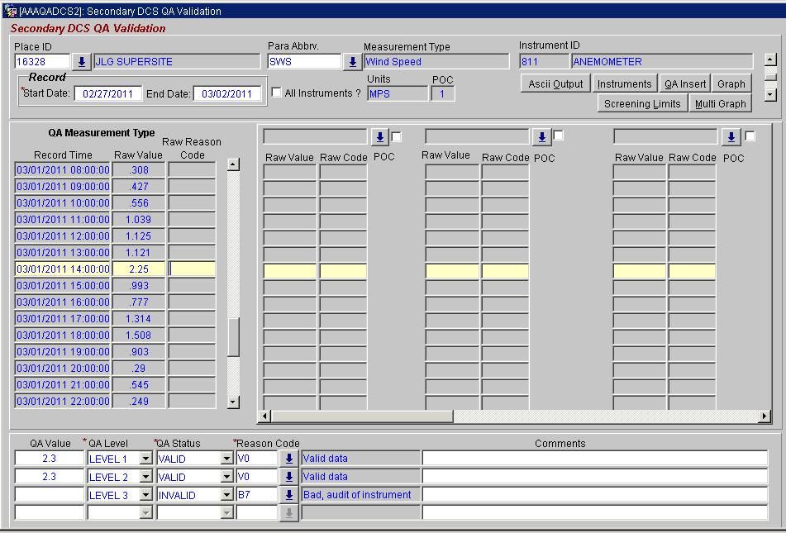

DCS QA Level 2 Review

QA Level 2 review will be done by the lead continuous data reviewer or their designee as soon as possible after loading the data into the AAAD. The Level 2 QA is performed to verify data collection by DCS and AAAD, to identify any values that are not representative of ambient conditions, i.e., data influenced by instrument checks or other outages, and to identify any problems in data collection. In addition to the data collection verification, Level 2 review includes a manual review of data on a scale of three to nine days. Typically, criteria pollutant data undergo Level 2 quality assurance procedures on a daily basis, while meteorological data and non-criteria pollutant data undergo Level 2 data review on a weekly or monthly basis. The Level 2 review includes the following steps:

- Check the AAAD DCS Upload Validation screen to verify upload and validation processes. Records appearing in this screen are in the AAAD staging tables and have not met the automated verification requirements. The deficiency will be identified, the records corrected or deleted, and the validation process run.
- Using the DCS Secondary QA screen, graph data and evaluate for outliers. Pay particular attention to data that were flagged and suspect during the Level 1 review. If invalid, enter the Level 2 status of invalid and assign the appropriate ‘B’ code using information from field reports, verbal communication, or email communication. Check flagged data and if valid, copy the data to Level 2 and assign the V1 flag. Promote the remaining data to Level 2 using the appropriate reason code.

DCS QA Level 3 Review

The QA Level 3 review is completed by the lead continuous data reviewer or their designee. Level 3 data review includes an evaluation of the data on longer temporal scales, usually on the order of months. The Level 3 data review process also serves as a final validation of data and incorporates the official field activity reports (and the instrument QC data) into the validation decision-making process. It is also during the Level 3 data review process that data are flagged with the appropriate qualifier flag, if needed. Most often, this includes flagging of data that have been influenced by natural or exceptional events. An Oracle Discoverer procedure is used to query AAAD and extract Level 2 data by parameter. The data review steps are:

- Review all field sheets associated with the parameters of concern. Verify that all instruments passed their QC checks. The QC checks that are considered during the Level 3 data review process can be found in the critical criteria section of the validation template (see Table D.3). If a QC failure occurs, data should be invalidated back to the last successful QC check unless the QC data or ambient data indicate an exact point of instrumentation failure.

- Using the DCS Secondary QA screen or other graphical software, examine the parameters for a period of one to three months worth of measurements. Graph the Level 2 data and examine. The AAAD graphing tool will identify any data that were determined suspect during the level 2 validation process. Evaluate all data that are represented in the graphical plot. Check flagged and suspect data.

- Identify any additional anomalous data that were not identified during the previous QA level reviews. Communicate and coordinate with other data reviewers, air quality forecasters, and instrument technicians to determine validity of data. Other data sources may be utilized, such as the data from the NWS, to assist with the validation process.

- Perform spatial comparisons of the data parameters, when applicable.

- When completed, promote values in AAAD to QA Level 3 with appropriate status and reason codes.

FCC Data Review Methods

The TSP and PM₁₀ Pb data consist of discrete 24-hour samples. ADEQ plans to load the TSP data into the FCC section of the AAAD as stated previously. These data are loaded into the AAAD through the DCS computer, but do not become part of the DCS database. ERG and PCWRL perform extensive Level 1 and Level 2 checks on the data collection and ICPMS analysis results from the filter samples. The data are delivered to the DM&QA Unit for review and loading into the AAAD for Level 2 and Level 3 validation checks by the lead Pb data reviewer or their designee. At this point in time, the PM₁₀ Pb data are not expected to be loaded to ADEQ’s internal database (AAAD). Instead, the data will be loaded directly to EPA’s AQS database by ERG after ADEQ and ERG perform all validation and ADEQ gives ERG the approval to load the data. This process may be reviewed and amended in the future.

FCC QA Level 1 & 2 Review of Filter Lab and Contract Lab Files

Filter-based data undergo the majority of their Level 1 and 2 data review within a laboratory setting or out in the field. Unlike continuous data collection which goes through an automated validation process, the Level 1 and 2 data review and validation process for filter-based data is predominantly subjected to a manual review to verify the following:

- For each sample, the chain-of–custody and field data forms are completely filled out and accurately document the transfer of filters throughout the data collection and analysis process
- Filters have been analyzed for any deformities or anomalous particulate deposits and documented if any exist
- Review the chain-of-custody and field data forms along with the electronic data to verify that the samplers operated for the desired amount of time and any instrumentation errors are documented
- Confirm that the laboratory has provided all information a user would need to interpret the analysis results
- Review and verify results of laboratory equipment calibrations

In addition to the manual Level 1 and 2 validation procedures above, some automated validation procedures may also be incorporated. These include:

- Continuous laboratory environment (verifying correct temperature and humidity during filter analysis) or analytical instrument monitoring (verifying calibration),
- Similar to the DCS validation process, FCC data (Pb TSP) undergo an automated validation process that verifies the instrument and site metadata are accurate and exist within the AAAD

The laboratories are primarily responsible for Level 2 validation and data review. This consists of verifying that all samples and analyses passed their QC criteria, or flagging those data that exceeded laboratory specific acceptance criteria. For a list of these laboratory specific acceptance criteria, see Tables B.14 and B.15. Upon receipt of the filter-based data from the laboratories, the lead Pb and/or air toxics data reviewer performs a final Level 2 review of the data checking for data formatting issues or ambiguities in the flags issued by the laboratory.

FCC QA Level 3 Review

The FCC Level 3 QA and data review procedures are similar to that of the DCS Level 3 procedures. FCC Level 3 data review includes an evaluation of the data on longer temporal scales, usually on the order of months. The Level 3 data review process also serves as a final validation of data and incorporates the official field activity reports (and the instrument QC data) into the validation decision-making process. It is also during the Level 3 data review process that data are flagged with the appropriate qualifier flag, if needed. An Oracle Discoverer procedure is used to query AAAD and extract Level 2 data by parameter. The data review steps are:

- Review all field sheets associated with the parameters of concern. Verify that all instruments passed their QC checks. The QC checks that are considered during the Level 3 data review process can be found in the critical criteria section of the validation template (see Table D.3). If a QC failure occurs, data should be invalidated back to the last successful QC check unless the QC data or ambient data indicate an exact point of instrumentation failure.

- Using the FCC Quality Assurance screen or other graphical software, examine the parameters for a period of one to three months worth of measurements. Graph the Level 2 data and examine. The AAAD graphing tool will identify any data that were determined suspect during the level 2 validation process. Evaluate all data that are represented in the graphical plot. Check flagged and suspect data.

- Identify any additional anomalous data that were not identified during the previous QA level reviews. Communicate and coordinate with other data reviewers, air quality forecasters, instrument technicians, and laboratory personnel to determine validity of data. Other data sources may be utilized, such as the data from the National Weather Service, to assist with the validation process.

- Perform spatial comparisons of the data parameters, when applicable.

- When completed, promote values in AAAD to QA Level 3 with appropriate status and reason codes.

For additional details on the data review and validation process, refer to the DM&QA SOP(s) which is/are included as an attachment(s).

D.3 RECONCILIATION and USER REQUIREMENTS

On an annual basis and in conjunction with the data certification process, the ambient data collected by ADEQ and their associated QA/QC data are subjected to a data quality assessment (DQA). This DQA includes a final review of the ambient data (via a data summary review), a review of data completeness, and a review of the QA/QC data in comparison with the DQOs and/or MQOs that have been established. This DQA serves two primary purposes:

- Acts as a final validation of the ambient data which typically results in official certification of the data
- Serves as an overall assessment of data quality for a particular program or network by comparing the desired objectives with the actual results

For criteria pollutant data, EPA’s Data Quality Indicator Report (AMP 255) is the primary statistical tool for relating the QA/QC results to each monitoring program’s DQOs and/or MQOs. If it is determined that ADEQ is continuously not meeting the DQOs and/or MQOs established in this QAPP for the Pb network, the AAS will re-evaluate any internal objectives for the Pb network. Based upon this evaluation, ADEQ AAS will identify improvements that can be made to the Pb network and/or determine if the internal DQOs are too stringent for the monitoring methodologies in-use. If ADEQ AAS determines that any internal DQOs or MQOs are too stringent, then AAS personnel will develop and implement more realistic internal objectives. If the national DQOs established by the EPA are not met, ADEQ AAS personnel will work with the EPA as needed to develop more realistic DQOs for the national Pb network.

Once it has been determined that the Pb data collected by ADEQ meets the EPA’s requirements, the data can then be used to determine compliance with the NAAQS.

Measurement Quality Objectives and Validation Templates

ADEQ expects EPA to provide a 3-year summary report regarding how well air monitoring agencies around the country met the established Pb MQOs. In the event the Pb MQOs are revised in the future, ADEQ plans to follow the most current MQO goals provided by EPA.

ADEQ anticipates that the EPA will provide updates to the TSP validation template found in the QAHBV2 in 2013. However, at this time, ADEQ plans to use the Pb TSP validation template produced in-house and approved along with this QAPP in lieu of the EPA’s TSP template should there be a differences in acceptance criteria for operating the TSP samplers. As always, ADEQ will work with EPA to resolve any concerns that may arise from this plan. For the Pb PM₁₀ samples, ADEQ plans on using the “PM₁₀ Filter Based Local Conditions Validation Template” provided in QAHBV2.

ADEQ developed the following in-house validation template for the Pb TSP samplers. The template establishes the information used to consistently validate Pb TSP mass concentrations collected by the agency and to ensure consistency with monitoring organizations across the US. This validation template has been developed based on the current state of knowledge. The template should evolve as new information is discovered about the impact of the various criteria on the error in the resulting mass estimate. Interactions of the criteria, whether synergistic or antagonistic, will also be considered and incorporated as seen fit when the impact of these interactions becomes quantified. Due to the potential misuse of invalid data, data values that are invalidated will not be uploaded to AQS, but a record or flag documenting the invalidation will be included in AQS. More detailed information including comments and the multiple levels of QA will be retained in the ADEQ AAAD database or on the ADEQ network drives. These data will be invaluable to the evolution of the validation template.

There are three tables of criteria where each table has a different degree of implication about the quality of the data. The criteria and information included on the tables are derived from the TSP sampling method found in 40 CFR Part 50 Appendix B and 40 CFR Part 58 Appendix A, as well as analytical methods found in 40 CRF Appendix G, the “TSP Hi-Vol Compendium Method IO-2.1”, and a few criteria that were provided by TISCH.

The first table, which is colored purple, has the criteria that must be met to ensure the quality of the data. An example criterion is that the average flow rate for the sampling period must be maintained to within ±10% of the set point which is currently 40 CFM in actual conditions for the TSP samplers. The second table, which is colored yellow, has the criteria that indicate that there might be a problem with the quality of the data and further investigation is warranted before making a determination about the validity of the sample or samples. The third table, which is colored blue, has criteria that indicate a potentially systematic problem with the environmental data collection activity. Such systematic problems may impact the ability to make decisions with the data. An example criterion is that at least 75% of the scheduled samples for each quarter should be successfully collected and validated.

To determine the appropriate table for each criterion for the ADEQ Pb TSP validation template, the ADEQ Pb Team members considered how significantly the criteria impact the resulting concentration. This was based on experience from Pb Team members, experience from EPA Region 9 and OAQPS, criteria contained in the 1977 Pb High Volume (TSP) Validation Template which was developed for sampling by TSP and analysis by atomic absorption, and feasibility of implementing the criterion.

Criteria that were deemed critical to maintaining the integrity of a sample or group of samples were placed on the first table. Observations that do not meet each and every criterion on the Critical Criteria Table should be invalidated unless there are compelling reasons and justification for not doing so. Basically, the sample or group of samples for which one or more of these criteria are not met is invalid until proven otherwise. The cause of not operating in the acceptable range for each of the violated criteria must be investigated and minimized to reduce the likelihood that additional samples will be invalidated.

Criteria that are important for maintaining and evaluating the quality of the data collection system are included on the second table, the Operational Criteria Table. Violation of a criterion or a number of criteria may be cause for invalidation. The decision should consider other quality control information that may or may not indicate the data are acceptable for the parameter being controlled. The reason for not meeting the criteria must be investigated, mitigated or justified.

Finally, those criteria which are important for the correct interpretation of the data but do not usually impact the validity of a sample or group of samples are included on the third table, the Systematic Criteria Table. For example, the DQOs are included in this table. If the DQOs are not met, this does not invalidate any of the samples, but it may impact the error rate associated with the attainment/non-attainment decision.

For each criterion, the tables include (1) the operational range that is acceptable, (2) the frequency with which compliance is to be evaluated, (3) the number of samples that are impacted if violation of a criterion occurs (possible values include single filters, a batch of filters, or a group of filters from a specific instrument), and (4) sections of 40 CFR that describe the criterion. The tables also indicate whether samples violating the criterion must be flagged before entering them into AQS.

The following Pb validation template is derived from information found in: 40 CFR Part 50 Appendices B and G, 40 CFR Part 58 Appendix A, 40 CFR Part 136, Federal Register 73 FR 66964, Draft Technical Notes developed by EPA OAQPS, PCWRL Method EQL-0510-191 and ADEQ SOPs. Note that The TISCH TSP samplers are designed to be calibrated in the standard temperature and pressure (STP) setting, but verified and audited in ambient (actual) setting.

Table D.3 ADEQ Pb High-Volume (TSP) Validation Template
Criteria | Frequency | Acceptable Range | Citation/Information
CRITICAL CRITERIA- Pb in TSP
Sampling Period | all filters | 1440 minutes ± 60 minutes  midnight to midnight | Part 50 App B 7.7.1  Part 50 App B 8.10  Part 50 App G sec 7.1
Average Flow Rate | every 24 hours of operation | *1.13 m³/min (40 CFM) in Actual Conditions | ADEQ specification
Verification/Calibration
System Leak Check | Every other sampling event | Visual and Auditory Inspection | TISCH
FR Multi-point Verification/Calibration | Quarterly – (Annually at minimum);  After receipt, upon installation, after repair or motor maintenance, or failure of 1-point check, when action level is triggered | 5 points spanning range of 1.13 actual m³/min ± 10%  R value > 0.99 | Part 50 App B sec 9.3
One-point Flow Rate Verification | Every other sampling event  (Quarterly in Part 58) | ± 10% from transfer standard  ADEQ Action Level ± 5% from transfer standard | ADEQ specification  Part 58 App A sec 3.2.3 & 3.3.2  TSP Hi-Vol Compendium Method IO-2.1
Filter Checks Verified for Each Sample
Visual Defect Check (unexposed) | all filters | - Initial backlight inspection - no pinholes or imperfections  - Visual inspection prior to shipping to analytical lab | Part 50 App B sec 8.2
Sampling Instrument | Verified prior to start of sampling | See Pb QAPP in Element B.6
* - Based on sampler air velocity being between 20 to 35 cm/sec
OPERATIONAL EVALUATIONS TABLE Pb in TSP
Precision
Collocated Samples | 15% of each method code in PQAO  Frequency - every sampling event (may be reduce to 1/12 days) | CV ≤ 20% of samples> 0.02 µg/m³ | Part 58 App A, sec 3.3.4.3
Audits
Semi Annual Flow Rate Audit | Quarterly – (Semi-annually at minimum); near beginning of program; upon instrument change-out; following corrective action; and prior to sampler removal |  15% of audit standard and design value | Part 58, App A, sec 3.2.4, 3.3.4.1 & 3.3.3
Lead Strip Analysis | 6 strips/quarter  2/conc. ranges | ± 10% difference | Part 58, App A, sec 3.3.4.2
Blanks
Field Filter Blank | 10% | < 10 µg/filter | ADEQ recommendation
Sampler Run Information (collected each run)
Sample ID |  | Record and verify filter ID | Part 50 App B sec 8.9
Verify Run Conditions |  | Based on flow verification during or after sampling | Part 50 App B sec 8.11
Time, Flow, Temperature and Pressure |  | Record and verify readings from the instrument | Part 50 App B sec 8.12  Part 50 App B sec 8.15
Handling |  | Filter handled only from the outer edges and folded in half lengthwise | Part 50 App B sec 8.13  Part 50 App B sec 8.14
Verification/Calibration
Field Thermometer | Every other sampling event | ±2º C | Part 50, App B sec 7.5
Field Barometer | Every other sampling event | ±10 mm Hg | Part 50, App B sec 7.6
Verification/Calibration Standards and Recertifications – All calibration devices should have multi-point certifications against NIST Traceable standards
Flow Rate Transfer Std. (Orifice) | 1/yr | Connects without leaks  Approximate range: 1.0 – 1.8 m³/min (~35 – 66 CFM)  Resolution 0.02 m³/min  ±2% reproducibility  Maximum pressure drop at 1.7 std m³/min; 50 cm H₂0 | Part 50, App B sec 7.4  Part 50, App B sec 7.8  Part 50, App B sec 9.2
Field Thermometer | 1/yr | ± 0.5º C | Method Sec 4.2 & 6.4
Field Barometer | 1/yr | ±5 mm Hg | Method Sec 4.2 & 6.5
Filter (Specs for Manufacturer)  (Report to EPA and assess impact on data quality if noted.) |  |  | Part 50 App B sec 7.1
Size | all filters | 20.3+0.2 cm x 25.4 +0.2 cm | Part 50 App B sec 7.1.1
Material | all filters | Glass fiber | Part 50 App B sec 7.1.2  Part 50 App G sec 6.1.1
Collection Efficiency | all filters | 99 % minimum | Part 50 App B sec 7.1.4
Pressure Drop Range | all filters | 42 – 54 mm Hg at 1.5 std m³/min | Part 50 App B sec 7.1.5
pH | all filters | 6-10 | Part 50, App B sec 7.1.6
Integrity (may not need for Pb) | all filters | 2.4 mg maximum weight loss | Part 50, App B sec 7.1.7
Pin holes | all filters | none | Part 50, App B sec 7.1.8
Tear Strength | all filters | 500 g minimum for 20 mm strip | Part 50, App B sec 7.1.9
Brittleness | all filters | No cracks or material separations after single lengthwise crease | Part 50, App B sec 7.1.10
Lead Content | all filters | < 5 µg/filter | ADEQ specification based on 10 times less than the NAAQS of 0.15 µg/ m³ based on a flow rate of 1.1 m³/min
SYSTEMATIC CRITERIA - Pb in TSP
Data Completeness | quarterly | Rolling three -month mean (i.e., the 3-month data capture rate) ≥ 75% | Part 50 App R. sec 3
Filter Sample Recovery | all filters | Within 6 days of sampling | Part 50 App B
Reporting Units | all filters | µg/m³ at local temperature and pressure. | Part 50 App R sec 3 (b)
Rounding Convention | all filters | Report data to 3 decimal places (data after 3 are truncated). | Part 50 App R sec 3 (b)
Detection Limit
ICPMS | Each analytical batch | MDL of 0.00006 µg Pb/m³  PQL of 0.000018 µg Pb/m³ | PCWRL SOP
Sampler Maintenance
Sampler hood & sampling chamber | Before and after each sampling event | Inspect/Clean | recommendation
Motor/housing gaskets | Annually | Replace | recommendation
Brushless blower motor | Every 8 years | Replace | recommendation
Control and pump box | Monthly | Clean | recommendation
Filter cassette holder & sample saver shield | Before and after each sampling event | Inspect/Clean | recommendation
SYSTEMATIC CRITERIA - Pb in TSP cont.
Analytical Standards
Reagents  Nitric acid (HNO₃)  Hydrochloric acid (HCl) | Each analytical batch | ACS reagent grade | Part 50 App G sec.6.2
Pb nitrate (Pb(NO₃)₂) | Each analytical batch | ACS reagent grade | Part 50 App G sec.6.2
Verification/Calibration
Clock/timer Verification | Every other sampling event | ±2 min/mo | Part 50, App B sec 7.7.2
Bias
Performance Evaluation Program (PEP) | Annually – 1 field audit  Quarterly – 1 collocated filter sample | 95% CL Absolute bias 15% | Part 58, App A, Sec 2.3.1
SD= standard deviation
CV= coefficient of variation

