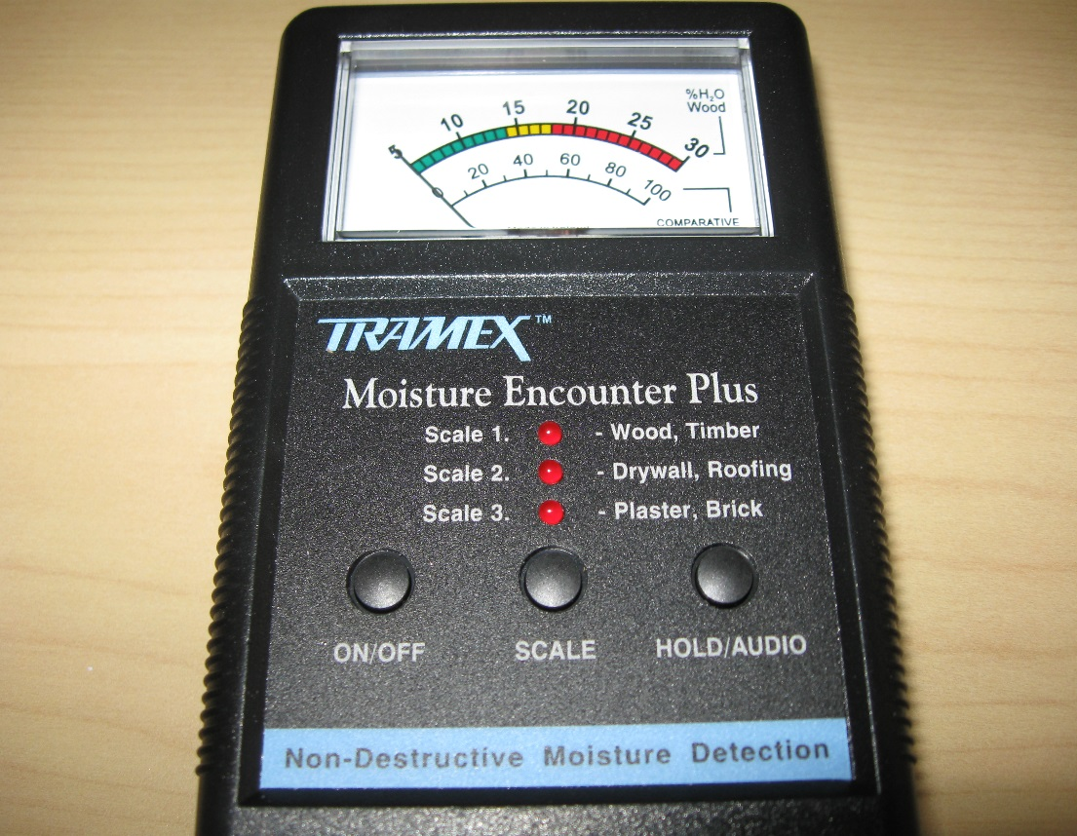

Press ON/OFF button to turn on meter and repeatedly press SCALE button to select Scale 1, 2, or 3 which will be indicated by the red LED. Pressing HOLD/AUDIO freezes the moving coil meter for taking readings with the meter out-of-sight.
Hold the meter directly on the material being tested, with both rubber electrodes fully in contact with the surface. The instrument field can penetrate approximately 1 ¼ inches which needs to be taken into account when testing thin materials.
Scale 1. For wood, timber, and wood products; use the upper line-%H₂O Wood-which is marked from 5%-30% to read the moisture content.
Scale 2. For drywall and roofing; use the lower line-Comparative-which is marked from 0 to 100.
Scale 3. For Plaster and Brick; use the lower line-Comparative-which is marked from 0 to 100.
Note: For accurate determination of percent moisture in wood, use the Wood Specific Gravity table on page 9, and the Wood Specific Gravity Adjustment Table on pages 10-11 of the Manufacturer’s User Guide.
Note: From page 13 of the Manufacturer’s User Guide: “The moisture profile of a wall can be determined by sliding your Moisture Encounter Plus across the surface where it will read through most paints, vinyl, wall coverings and even ceramic tiles. The Moisture Encounter Plus will help identify the different levels of moisture even if not apparent on the surface. Moisture can often be trapped behind drywall and wall covering. Always press the electrodes firmly against the surface.”
Manufacturer User Guide Web Address: http://www.tramexltd.com/User_Uploads/Manual_MEP.pdf

