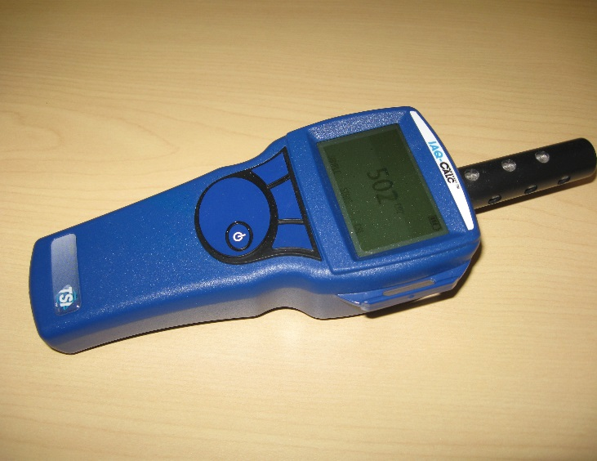
ON/OFF Key-Press to turn meter on.
Sample/End Key-Press and release to start the sample, then press the End key to stop the sample.
Stats Key-Press to view the minimum, maximum and average of the last sample taken.

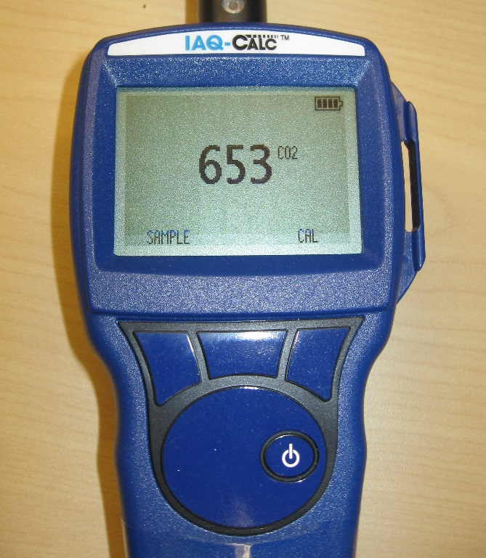

Battery Indicator

CO2 Level in PPM

Sample/End Key Calibration Key

Stats Key ON/OFF Key

Calibration Key-Press to begin field calibration. First connect zero gas to the instrument and open the regulator. Then use the ↑, ↓ , and ENTER keys to select ZERO. The instrument will automatically zero itself after one minute. (The three buttons are redefined to the label on the LCD above each button)
After zeroing the sensor, connect span gas to the instrument and open the regulator. Then use the ↑, ↓ , and ENTER keys to select SPAN. The instrument will take one minute to provide a reading. Next use the ↑, ↓ , and ENTER keys to adjust the concentration displayed on the instrument to match the concentration on the gas cylinder.

