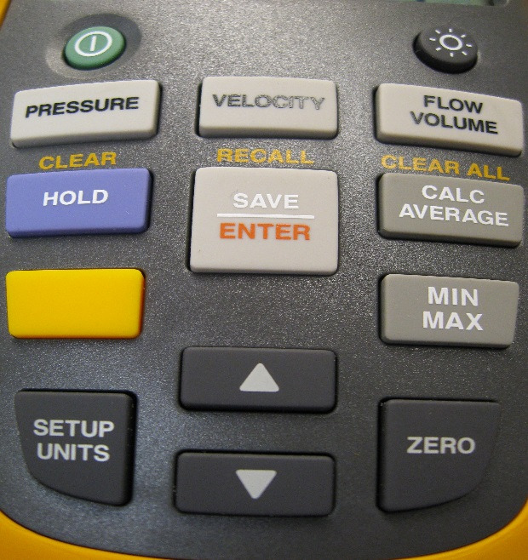
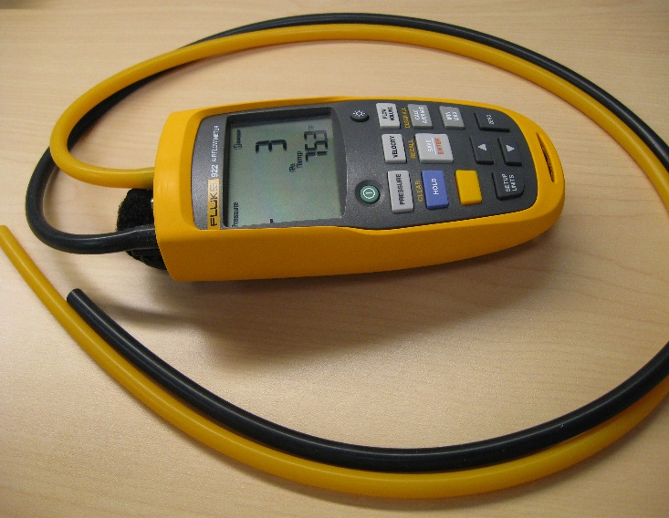

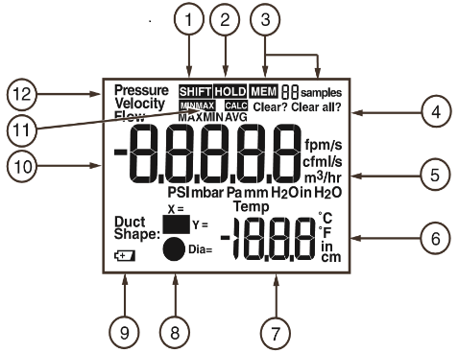
1 Yellow shift key pressed: Clear, Recall, or Clear all.
2 Hold is engaged. Current reading is captured.
3 Memory and number of samples.
4 Clear stored sample or samples?
5 Units of pressure, velocity, and flow.
6 Units of length and temperature.
7 Temperature and setup parameters.
8 Duct shape choices.
9 Low battery indicator.
10 Pressure, Velocity, or Flow values.
11 Min/Max Avg indicators
12 Active mode indicator-Pressure, Velocity, or Flow
USING THE METER
ON/OFF The round button on the upper left turns the unit on, and the round button on the upper right turns the display backlight on/off.
SETUP UNITS Press the Setup Units button to change units for Pressure, Velocity, Flow, Temperature and Duct Dimensions. Use ↑ and ↓ keys to change units and Save/Enter key to accept the change. The meter will move to the next parameter.
PRESSURE The Pressure button starts a differential pressure measurement:
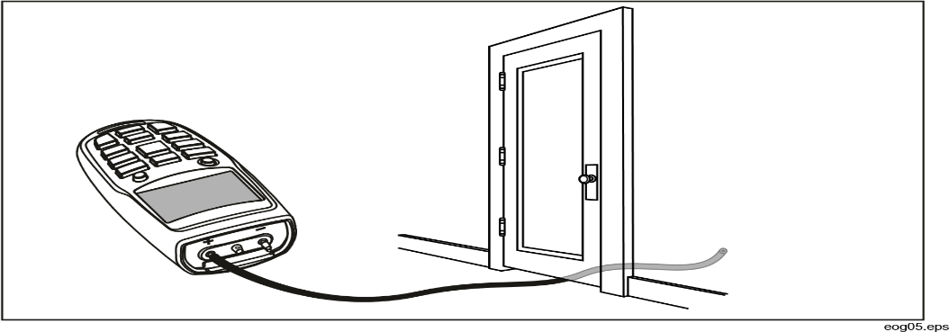
Connect a single hose to the Input (+) port. With the tubing open to ambient conditions press and hold ZERO for two seconds. Then place the input hose in a different zone than the meter. The meter displays the difference in pressure between the input zone with respect to the reference zone.
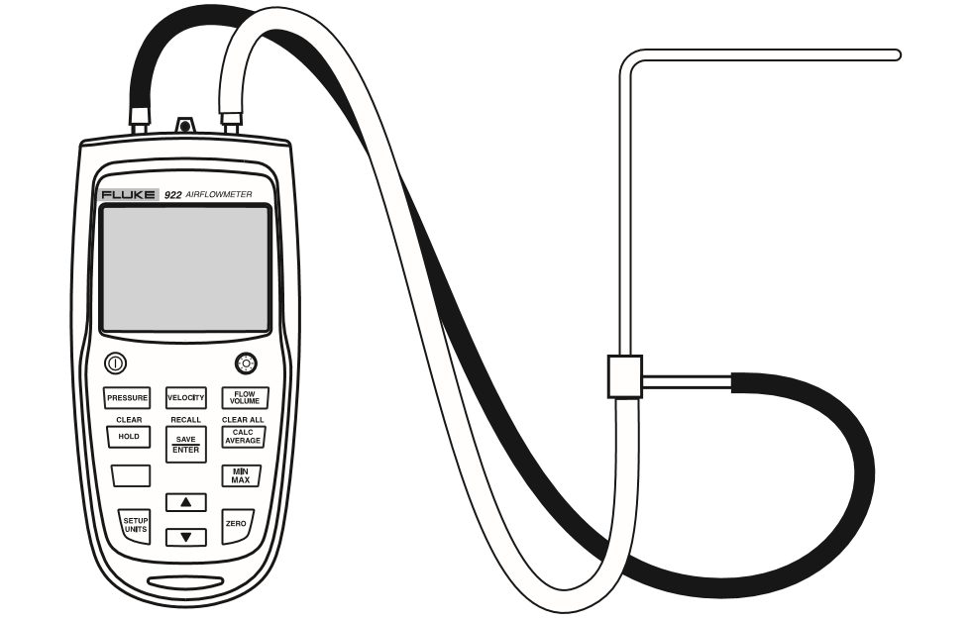
MEASURING VELOCITY
Press Velocity to enter velocity mode. The Input (+) pressure port connects to the yellow hose from the total pressure connection of the pitot tube. The Ref(-) pressure port on the meter connects to the black hose from the static pressure connection of the pitot tube. With the pitot tube open to ambient conditions press and hold Zero for two seconds. Then place the pitot tube into the ductwork for a measurement.

MEASURING FLOW
Press Flow/Volume. The meter requests the duct shape or Use the ↑ and ↓ keys to select the proper shape, then press Enter. Then again use the ↑ and ↓ keys and the Enter key to select the X and Y dimensions for a rectangular duct or the diameter for a round duct. The pitot tube is connected in the same manner as a velocity measurement: The Input (+) pressure port connects to the yellow hose from the total pressure connection of the pitot tube. The Ref(-) pressure port on the meter connects to the black hose from the static pressure connection of the pitot tube. With the pitot tube open to ambient conditions press and hold Zero for two seconds. Then place the pitot tube into the ductwork for a measurement.
SAVING SAMPLES
Press Save/Enter to store a sample. The meter can save up to 99 samples in each of its three modes. Press Calc/Average to view the average of all the samples taken. Min/Max stores live minimum and maximum values. When there is a new minimum or maximum, the meter beeps and stores the new value. Pressing Min/Max repeatedly, scrolls through the maximum, minimum, average and live readings. To exit Min/Max mode hold the Min/Max button in for two seconds. In this mode, the meter will not Auto-power off, so measurements can be taken while you are away.
To recall data, press Pressure, Velocity, or Flow/Volume to select the data to recall. Press the yellow shift key and (recall) to recall samples and use the ↑ and ↓ keys to locate the desired sample.
To clear data, press Pressure, Velocity, or Flow/Volume to select the data to clear. Then press the yellow shift button and press (clear) for clearing one data value, use the ↑ and ↓ keys and the Enter key to clear that data value. For clearing all data, press (clear all) and then the Enter key.

