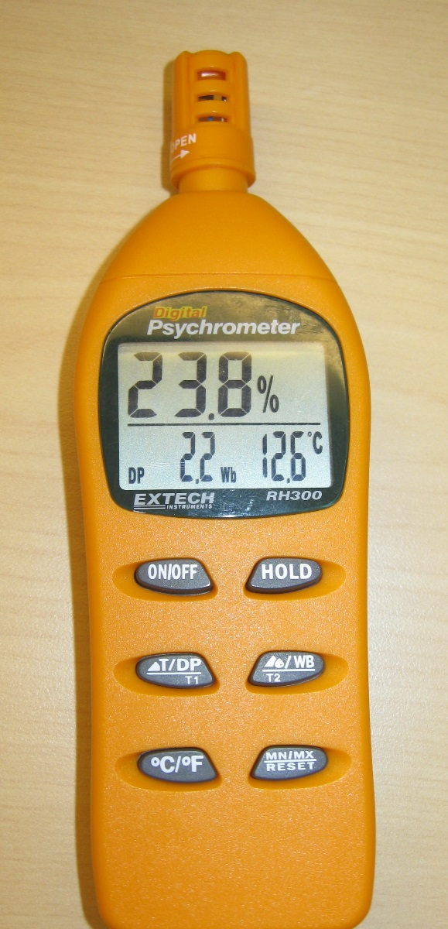

Sensor and Protective Cap

External Temperature Probe

Relative Humidity
Temp or Dew Point Wet Bulb Temp

On/Off Hold Button

Temp/Dew Point Toggle Wet Bulb/External Temp Toggle

Celsius/Fahrenheit Toggle Min/Max Reset

OPERATION
Open the protective sensor cap by twisting counter-clockwise a quarter of a turn. Press the ON/OFF button and the meter will perform a short self-test. Hold the unit in the area to be tested and allow a few seconds for the readings to stabilize. The Relative Humidity appears in the top display.
BUTTON OPTIONS
The Temp/Dew Point Toggle button will select Temp or Dew Point for the lower left display value. Pressing Celsius/Fahrenheit will direct the display to be in degrees C or F. The Hold Button will cause the display to freeze the current reading. Without the External Temp probe the Wet Bulb/External Temp Toggle will not affect the display, the lower right displayed value will remain as Wet Bulb temperature. Press the Min/Max Reset button once and the display will be minimum values in memory for RH and Temp, pressing again the displayed values are the maximum values in memory, pressing a third time will return to live display. Pressing the Min/Max Reset button and holding it in for more than two seconds will clear the current Min/Max values in memory.

Accuracy Verification and Calibration:
The following verification and Calibration procedures require 33% and 75% reference bottles (Model RH305 kit).
VERIFICATION
Insert the meter’s sensor into either the 33% or the 75% reference bottles and check the reading after 10 minutes. The observed RH value should be between 32.0 and 34.0 RH using the 33% reference or between 72.8 and 77.3 RH using the 75% reference to be within the Accuracy Specification of the manual. The temperature accuracy should be ±1.8 degrees F or ±1 degrees C when comparing to a calibrated thermometer to be within specification of the manual.
CALIBRATION (Quoted from the manual)

Relative Humidity Calibration (33% and 75%)

Calibration Preparation
- Ensure that fresh batteries are installed in the meter.
- Move the protective vent cap to the Open position.
- Power the meter ON and set it to display dew point (DP) and wet bulb (Wb) in the lower display area.

Calibration Procedure
- Follow the Preparation steps above before continuing.
- Power the meter OFF.
- Insert the meter into a 33% salt bottle.
- Leave the meter OFF for one hour (to stabilize).
- After the meter has stabilized for one hour:
  - Press and hold the °C/°F button while powering the unit ON.
  - The unit enters calibration mode (32.8% flashes on the display).
  - The DP and Wb display areas show DP ---- Wb ----°C.
- Once the 33% calibration is complete, the display stops flashing and a constant 32.8% is displayed.
- Allow the meter to remain ON and move it to the 75% salt bottle.
- Allow the meter to remain for one hour in the 75% salt bottle to stabilize.

Important: Do NOT power the meter OFF while in the Calibration mode! Note that AUTO POWER OFF is disabled while in the Calibration mode.

- After one hour, press and hold the MN/MX button until 75.3% begins flashing on the meter display. The meter has now entered the 75.0% calibration stage.
- After 30 minutes have elapsed, the meter will automatically exit the calibration mode and return to the normal operating mode.
- The Calibration is complete, turn power OFF.

Note: To exit from the calibration procedure before completion, press the ON/OFF button.

Note: If the salt at the bottom of the calibration bottles appears dry, the bottles should be replaced

