Data Validation Report for
Casa Blanca, PM10 hourly data collected between
7/1/15 and 9/31/15

Name of reviewer: ITEP: Melinda Ronca-Battista, at the Gila River Air Dept.
Conducted: 10/30/15-12/10/15

List of Supporting Information:
- AirVision release 2.13.158 (abbreviated AV in this report)
- Airnowtech Navigator website, http://www.airnowtech.org/data/ accessed October-December 2015, used to download data from the sites and dates as shown in the screenshots in this report.
- Site Check Form (available for auditors in the Gila River Air Program offices) covering checks done on 7/15, 7/24, 8/12, 8/20, 9/10, 9/16, and 10/1/15
- QC forms from the 7 QC checks done spanning 7/15 through 10/1/15
- Initial Data Review memo from site operator (Russell Betsuie) dated 12/9/15

Id of data flagged (line or time begin/end) | Null code | Other flags: | Reason: | Supporting info:
no data recommended for invalidation

QC Review Report:

- Reviewed QC forms from the 7 QC checks done spanning 7/15 through 10/1/15. At least one calculated field in each QC sheet was hand-calculated to verify the result. Initials were added next to the calculated fields that were double checked by hand. All QC checks were complete and accurate, and the site operator’s notes were thorough and well documented. Some very minor changes to the QC forms were suggested, including adding a time in/out field to assist in data flagging in AV, a change to the zero drift field, and a % formatting change. All limits were double checked against the most recent EPA validation template (QA Handbook) and the most recent GRIC QAPP.

- The dates and times of these QC checks were checked in AV, and the parameter data was appropriately coded and when appropriate, the site operator had already added the null value codes for these hours in the parameter data. The data in AV that was already correctly invalidated by the site operator is listed in table 2, but there is one recommendation, which is to cease automatic invalidation of data less than negative 15 microg/m3. The AQS code table for method 079, reporting in hourly intervals (shown in table 1) lists a federal MDL (method detection limit) of negative 50 microg/m3. By automatically invalidating values only due to their concentration, the overall long term average concentration may be misrepresented as higher than it really is. The values automatically invalidated due to their concentration are shown in green italics in table 2.

Table 1: Parameters extracted from AQS Code Table on 12/7/15 https://aqs.epa.gov/aqsweb/codes/data/Parameters-CRITERIA.html
Parameter Code | Parameter Desc | Standard Unit | Meth Code | Duration Code | Duration Desc | Reported Unit | Reported Unit Desc | Collection Desc | Sample Analysis Disc | FED MDL | Summary Scale | Designated Method Desc | Designated Method ID | ABS Max Sample Value | ABS Min Sample Value
81102 | PM10 Total 0-10um STP | 1 | 79 | 1 | 1 HOUR | 1 | Micrograms/cubic meter (25 C) | INSTRUMENTAL-R&P SA246B-INLET | TEOM-GRAVIMETRIC | -50 | 0 | RUPRCHT&PATSHNCK TEOM SER 1400 | EQPM-1090-079 | 13000 | -50
81102 | PM10 Total 0-10um STP | 1 | 79 | 1 | 1 HOUR | 5 | Milligrams/cubic meter (25 C) | INSTRUMENTAL-R&P SA246B-INLET | TEOM-GRAVIMETRIC | -50 | 0 | RUPRCHT&PATSHNCK TEOM SER 1400 | EQPM-1090-079 | 13000 | -50
81102 | PM10 Total 0-10um STP | 1 | 79 | 1 | 1 HOUR | 72 | Cubic feet/minute STP | INSTRUMENTAL-R&P SA246B-INLET | TEOM-GRAVIMETRIC | -50 | 0 | RUPRCHT&PATSHNCK TEOM SER 1400 | EQPM-1090-079 | 13000 | -50
81102 | PM10 Total 0-10um STP | 1 | 79 | 1 | 1 HOUR | 73 | Liters/minute STP | INSTRUMENTAL-R&P SA246B-INLET | TEOM-GRAVIMETRIC | -50 | 0 | RUPRCHT&PATSHNCK TEOM SER 1400 | EQPM-1090-079 | 13000 | -50
81102 | PM10 Total 0-10um STP | 1 | 79 | 1 | 1 HOUR | 83 | Cubic meters/minute STP | INSTRUMENTAL-R&P SA246B-INLET | TEOM-GRAVIMETRIC | -50 | 0 | RUPRCHT&PATSHNCK TEOM SER 1400 | EQPM-1090-079 | 13000 | -50
81102 | PM10 Total 0-10um STP | 1 | 79 | 1 | 1 HOUR | 118 | Liters/minute LC | INSTRUMENTAL-R&P SA246B-INLET | TEOM-GRAVIMETRIC | -50 | 0 | RUPRCHT&PATSHNCK TEOM SER 1400 | EQPM-1090-079 | 13000 | -50
81102 | PM10 Total 0-10um STP | 1 | 79 | 1 | 1 HOUR | 119 | Cubic meters/minute LC | INSTRUMENTAL-R&P SA246B-INLET | TEOM-GRAVIMETRIC | -50 | 0 | RUPRCHT&PATSHNCK TEOM SER 1400 | EQPM-1090-079 | 13000 | -50
81102 | PM10 Total 0-10um STP | 1 | 79 | 7 | 24 HOUR | 1 | Micrograms/cubic meter (25 C) | INSTRUMENTAL-R&P SA246B-INLET | TEOM-GRAVIMETRIC | -50 | 0 | RUPRCHT&PATSHNCK TEOM SER 1400 | EQPM-1090-079 | 13000 | -50
81102 | PM10 Total 0-10um STP | 1 | 79 | 7 | 24 HOUR | 5 | Milligrams/cubic meter (25 C) | INSTRUMENTAL-R&P SA246B-INLET | TEOM-GRAVIMETRIC | -50 | 0 | RUPRCHT&PATSHNCK TEOM SER 1400 | EQPM-1090-079 | 13000 | -50
81102 | PM10 Total 0-10um STP | 1 | 79 | 7 | 24 HOUR | 72 | Cubic feet/minute STP | INSTRUMENTAL-R&P SA246B-INLET | TEOM-GRAVIMETRIC | -50 | 0 | RUPRCHT&PATSHNCK TEOM SER 1400 | EQPM-1090-079 | 13000 | -50
81102 | PM10 Total 0-10um STP | 1 | 79 | 7 | 24 HOUR | 73 | Liters/minute STP | INSTRUMENTAL-R&P SA246B-INLET | TEOM-GRAVIMETRIC | -50 | 0 | RUPRCHT&PATSHNCK TEOM SER 1400 | EQPM-1090-079 | 13000 | -50
81102 | PM10 Total 0-10um STP | 1 | 79 | 7 | 24 HOUR | 77 | Micrograms | INSTRUMENTAL-R&P SA246B-INLET | TEOM-GRAVIMETRIC | -50 | 0 | RUPRCHT&PATSHNCK TEOM SER 1400 | EQPM-1090-079 | 13000 | -50
81102 | PM10 Total 0-10um STP | 1 | 79 | 7 | 24 HOUR | 118 | Liters/minute LC | INSTRUMENTAL-R&P SA246B-INLET | TEOM-GRAVIMETRIC | -50 | 0 | RUPRCHT&PATSHNCK TEOM SER 1400 | EQPM-1090-079 | 13000 | -50

Table 2: CB PM10 data between 7/1/15 and 9/30/15 that was already correctly invalidated by the site operator, with values in green italics indicating automatic invalidation due to concentration alone:
site | parameter | interval | date-time | microg/m3 | raw value | null code | flags |  | method code
CB_Casa Blanca, Arizona | 01_PM10_CONTIN | 001h | 7/21/2015 12:00 | 24 | 24.75792 | BL | <M |  | 79
CB_Casa Blanca, Arizona | 01_PM10_CONTIN | 001h | 7/21/2015 13:00 | 0 | 0 | BL | <M |  | 79
CB_Casa Blanca, Arizona | 01_PM10_CONTIN | 001h | 7/21/2015 17:00 | -14 | -14.491 | BA | <M |  | 79
CB_Casa Blanca, Arizona | 01_PM10_CONTIN | 001h | 7/21/2015 18:00 | 0 | 0 | BA | M> |  | 79
CB_Casa Blanca, Arizona | 01_PM10_CONTIN | 001h | 9/10/2015 11:00 | 12 | 12.82664 | AZ | <M |  | 79
CB_Casa Blanca, Arizona | 01_PM10_CONTIN | 001h | 9/10/2015 12:00 | 16 | 16.50283 | AZ | M> |  | 79
CB_Casa Blanca, Arizona | 01_PM10_CONTIN | 001h | 7/15/2015 12:00 | 8 | 8.965278 | AY | <M |  | 79
CB_Casa Blanca, Arizona | 01_PM10_CONTIN | 001h | 7/15/2015 13:00 | 0 | 0 | AY |  |  | 79
CB_Casa Blanca, Arizona | 01_PM10_CONTIN | 001h | 7/24/2015 15:00 | 1 | 1.339444 | AY | <M |  | 79
CB_Casa Blanca, Arizona | 01_PM10_CONTIN | 001h | 8/12/2015 16:00 | 9 | 9.127139 | AY | <M |  | 79
CB_Casa Blanca, Arizona | 01_PM10_CONTIN | 001h | 8/12/2015 17:00 | 0 | 0 | AY |  |  | 79
CB_Casa Blanca, Arizona | 01_PM10_CONTIN | 001h | 8/20/2015 16:00 | 14 | 14.45417 | AY | <M |  | 79
CB_Casa Blanca, Arizona | 01_PM10_CONTIN | 001h | 8/20/2015 17:00 | 0 | 0 | AY |  |  | 79
CB_Casa Blanca, Arizona | 01_PM10_CONTIN | 001h | 9/10/2015 17:00 | 6 | 6.914667 | AY | <M |  | 79
CB_Casa Blanca, Arizona | 01_PM10_CONTIN | 001h | 9/10/2015 18:00 | 0 | 0 | AY |  |  | 79
CB_Casa Blanca, Arizona | 01_PM10_CONTIN | 001h | 9/16/2015 15:00 | 2 | 2.502333 | AY | <M |  | 79
CB_Casa Blanca, Arizona | 01_PM10_CONTIN | 001h | 9/16/2015 16:00 | 0 | 0 | AY |  |  | 79
CB_Casa Blanca, Arizona | 01_PM10_CONTIN | 001h | 7/3/2015 15:00 | -10 | -10.6811 | AN |  |  | 79
CB_Casa Blanca, Arizona | 01_PM10_CONTIN | 001h | 7/3/2015 16:00 | -15 | -15.8749 | AN |  |  | 79
CB_Casa Blanca, Arizona | 01_PM10_CONTIN | 001h | 7/4/2015 12:00 | -16 | -16.6275 | AN |  |  | 79
CB_Casa Blanca, Arizona | 01_PM10_CONTIN | 001h | 7/5/2015 17:00 | -33 | -33.1137 | AN |  |  | 79
CB_Casa Blanca, Arizona | 01_PM10_CONTIN | 001h | 7/6/2015 14:00 | -17 | -17.5436 | AN |  |  | 79
CB_Casa Blanca, Arizona | 01_PM10_CONTIN | 001h | 7/8/2015 22:00 | -22 | -22.0767 | AN |  |  | 79
CB_Casa Blanca, Arizona | 01_PM10_CONTIN | 001h | 7/12/2015 8:00 | -30 | -30.6303 | AN |  |  | 79
CB_Casa Blanca, Arizona | 01_PM10_CONTIN | 001h | 7/19/2015 13:00 | -18 | -18.3263 | AN |  |  | 79
CB_Casa Blanca, Arizona | 01_PM10_CONTIN | 001h | 7/21/2015 14:00 | -35 | -35.6831 | AN |  |  | 79
CB_Casa Blanca, Arizona | 01_PM10_CONTIN | 001h | 7/21/2015 15:00 | -24 | -24.3841 | AN |  |  | 79
CB_Casa Blanca, Arizona | 01_PM10_CONTIN | 001h | 9/2/2015 2:00 | -40 | -40.5536 | AN |  |  | 79
CB_Casa Blanca, Arizona | 01_PM10_CONTIN | 001h | 9/3/2015 15:00 | -14 | -14.2823 | AN |  |  | 79
CB_Casa Blanca, Arizona | 01_PM10_CONTIN | 001h | 9/15/2015 12:00 | -19 | -19.7857 | AN |  |  | 79
CB_Casa Blanca, Arizona | 01_PM10_CONTIN | 001h | 9/18/2015 13:00 | -17 | -17.0138 | AN |  |  | 79
CB_Casa Blanca, Arizona | 01_PM10_CONTIN | 001h | 9/21/2015 12:00 | -29 | -29.608 | AN |  |  | 79
CB_Casa Blanca, Arizona | 01_PM10_CONTIN | 001h | 9/21/2015 13:00 | -22 | -22.3771 | AN |  |  | 79
CB_Casa Blanca, Arizona | 01_PM10_CONTIN | 001h | 9/21/2015 18:00 | -16 | -16.9053 | AN |  |  | 79
CB_Casa Blanca, Arizona | 01_PM10_CONTIN | 001h | 9/27/2015 14:00 | -30 | -30.2255 | AN |  |  | 79
CB_Casa Blanca, Arizona | 01_PM10_CONTIN | 001h | 9/30/2015 13:00 | -15 | -15.3728 | AN |  |  | 79

- The only data that was invalidated for a reason other than a QC check were hours when values less than negative15 microg/cubic meter were automatically invalidated, as described above.

Dates reviewed:
7/17, 7/18 and 7/19/15: As shown, the high PM10 was accompanied by high wind speeds and is therefore valid.

7/18/15, because the concentration is so high (1018 microg/m3) we verified that high winds were associated with high PM10:
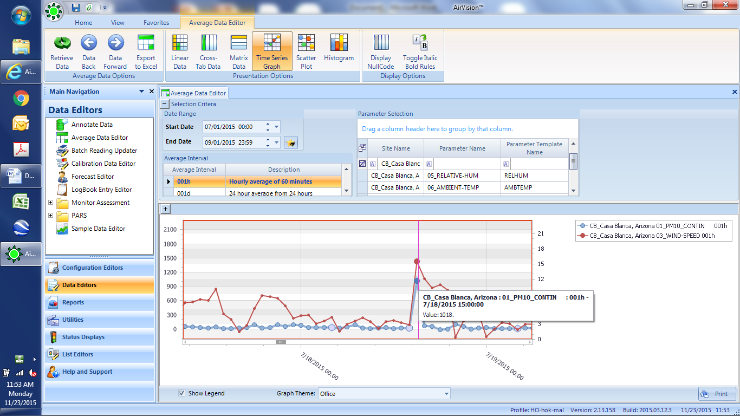
In addition, because this value was so high, data from the nearby Pinal County site was downloaded from AirNowTech Navigator that shows consistency with high PM10 concentrations for 7/18/15:
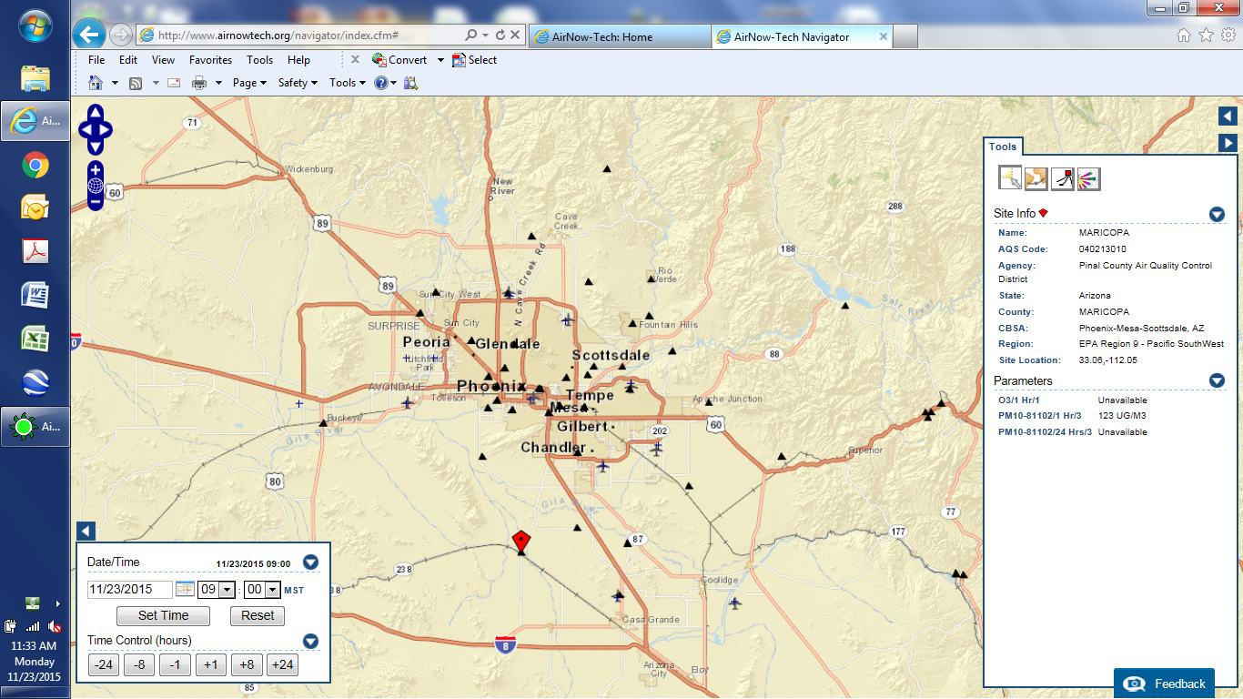
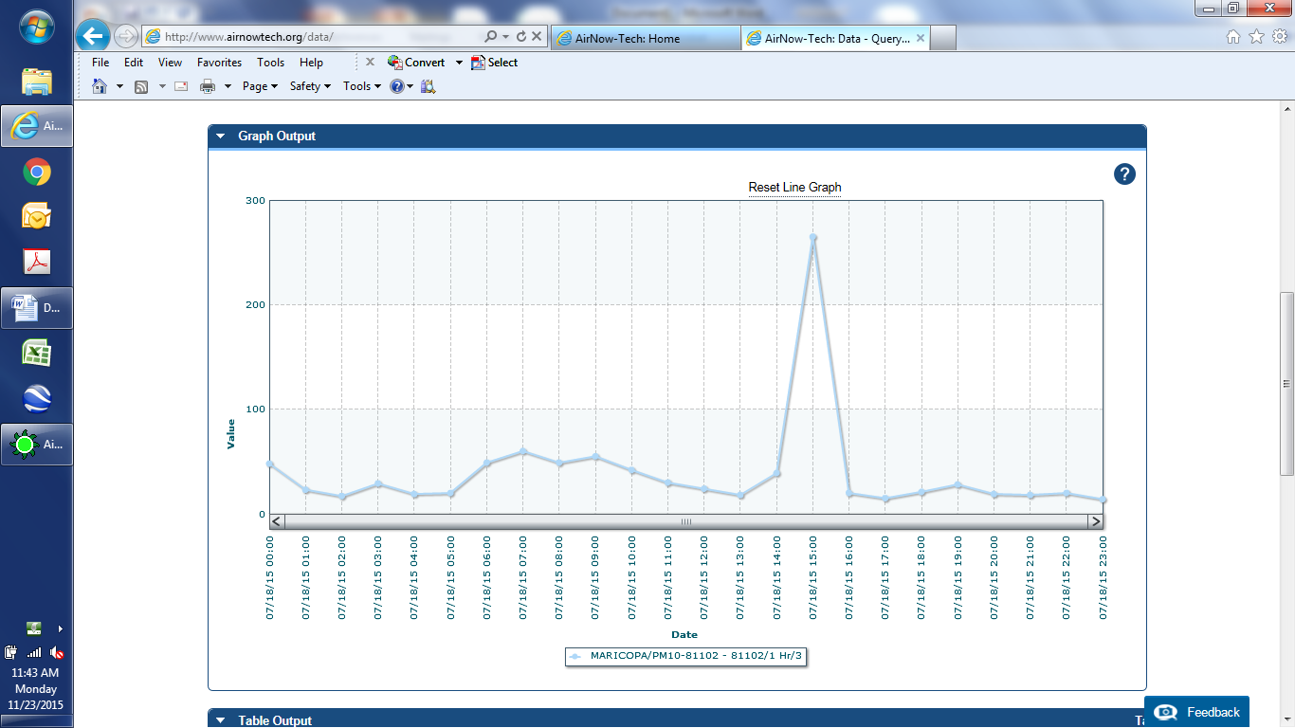

7/28/15:
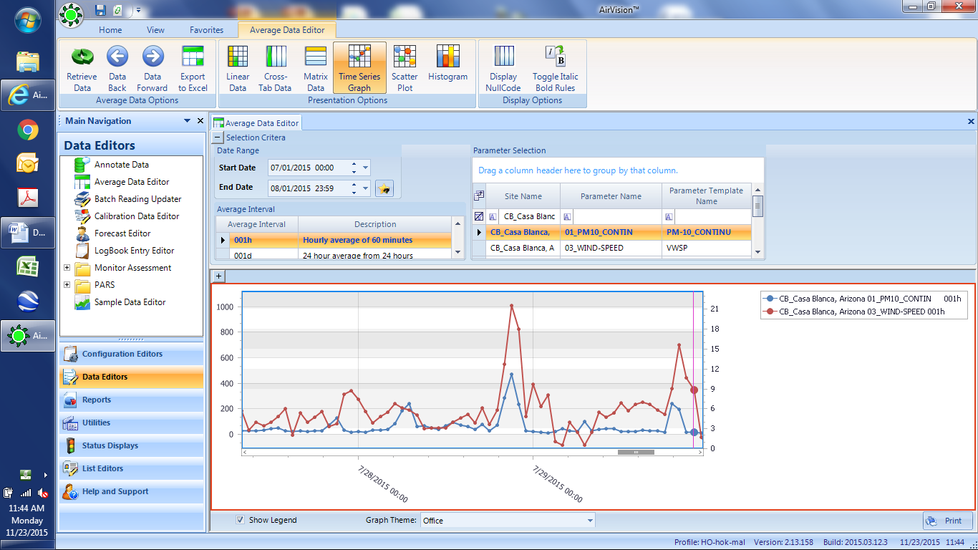

8/14/15:
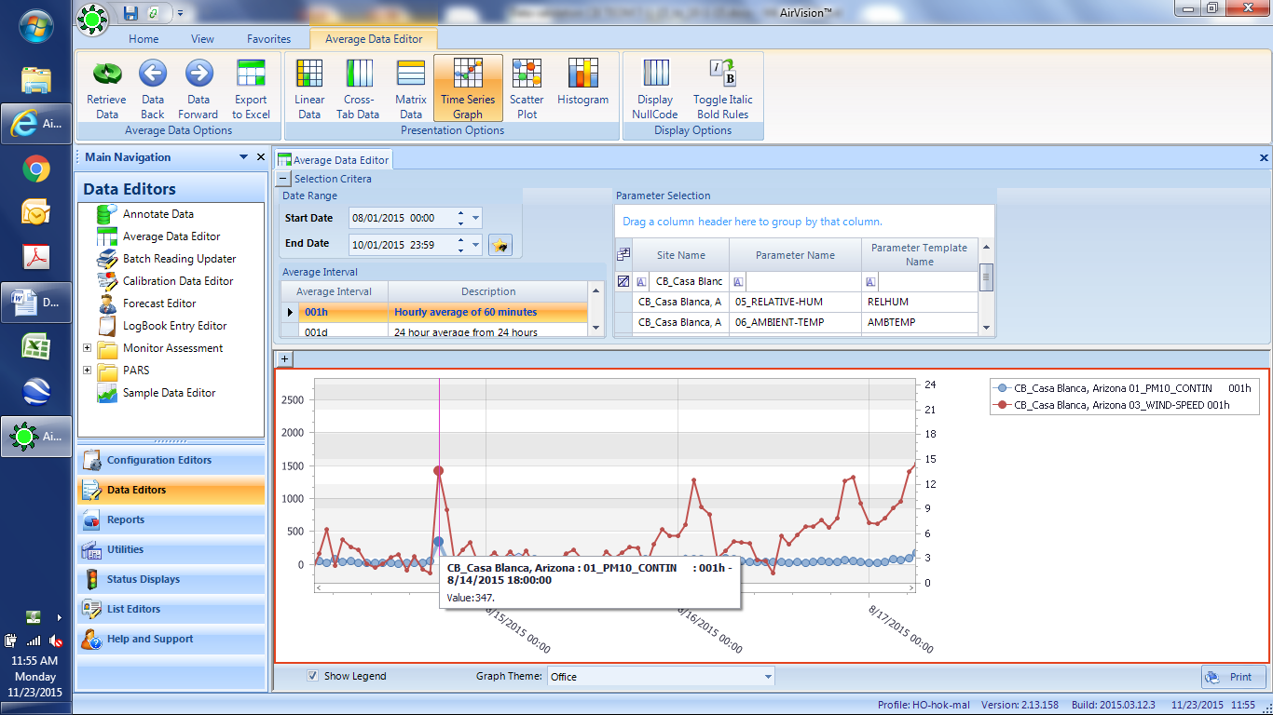

8/23/15: Data are valid and the log shows high winds at the same date/time:

CB_Casa Blanca, Arizona | 01_PM10_CONTIN | 001h | 8/23/2015 7:00 PM | 73
CB_Casa Blanca, Arizona | 01_PM10_CONTIN | 001h | 8/23/2015 8:00 PM | 566
CB_Casa Blanca, Arizona | 01_PM10_CONTIN | 001h | 8/23/2015 9:00 PM | 80

8/27 and 8/29/15: High PM10 occurred at same date/times as high wind speed.

9/3/15: High winds also occurred at the time of high PM10:

9/12/15:

9/24-25/15: As shown below, the spike in PM10 concentration was accompanied by an increase in wind speed and/or a change in wind direction, and the PM10 concentrations are valid.

