DOCUMENT TYPE: Standard Operating Procedure

TITLE: Comparing Data to ARB (Banning Airport)

NUMBER: TAP 11.2.2

PREPARED BY: 04/06/15
Environmental Administrative Assistant (Date)

REVISED BY: 05/27/16
Environmental Administrative Assistant (Date)

REVIEWED BY:
Environmental Technician (Date)

APPROVED BY:
Environmental Department Director/ Supervisor (Date)
- Purpose
Morongo’s Air Quality Data needs to be compared against a neighboring station to ensure our equipment is functioning correctly and to show accuracy of data.
- Supplies
  - A Computer with Internet Access
  - Access to the shared O drive
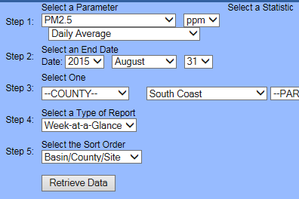
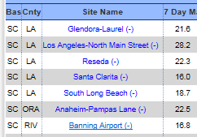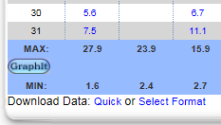
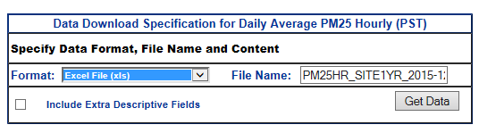
  - Air Quality Log
- Procedure to Retrieve ARB Data
  - Visit www.arb.ca.gov/aqmis2/aqdselect.php
    - Use the “Daily Data” tab.
  - Retrieve Particulate Mater 2.5 ARB Data
    - Step 1: Select a Parameter: PM 2.5 ug/m3
& Select a Statistic: Daily Max/Daily Average
    - Step 2: Change the dates to reflect the end date of the month & year you are seeking to retrieve information for.
    - Step 3: Air Basin: South Coast
      - Click Retrieve Data
    - Site Name: Banning Airport
    - Select Format: Excel File, get data, then open
    - Save file in folder: O:\Tribal Air Program\DATA\PM_Data\BAM_DATA\YEAR\ARB\PM25_ARB_XXMONYR_DM (daily max) (or DA daily average)
    - Copy column “D” (pm25_davg or pm25_dmax)
    - Use excel file: O:\Tribal Air Program\DATA\PM_Data\BAM_DATA\2015\Validated Data\ BAM1020_2011_Validated_XXMONYR (created in SOP 11.2.1a), and click on the “Banning graphs” tab. Paste the copied information into column “B” (Avg) or “C” (Max) next to the corresponding date.
  - Retrieve Ozone ARB Data
    - Step 1: Select a Parameter: Ozone ppm
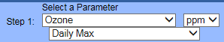
& Select a Statistic: Daily Max/Daily Average
    - Repeat steps b. ii-v. from above.
    - Save file in folder: O:\Tribal Air Program\DATA\O3_Data\YEAR\O3vsARB\Banning ARB\O3_ARB_XXMONYR_DM (daily max) (or DA daily average)
    - Copy column “C” (ozone_davg or ozone_dmax)
    - Use excel file: O:\Tribal Air Program\DATA\O3_DATA\YEAR\AMS_DATA\ AMS_O3_DATA _2011_XXMONYR (created in SOP 11.2.1a), and click on the “Banning graphs” tab. Paste the copied information into column “B” (Avg) or “C” (Max) next to the corresponding date.
  - Retrieve Nitrogen Dioxide ARB Data
    - Step 1: Select a Parameter: Nitrogen Dioxide ppb
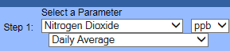
& Select a Statistic: Daily Max/Daily Average
    - Repeat steps b. ii-v. from above.
    - Save file in folder: O:\Tribal Air Program\DATA\NO2_Data\YEAR\NO2vsARB\Banning ARB\NO2_ARB_XXMONYR_DM (daily max) (or DA daily average)
    - Copy column “C” (no2_davg or no2_dmax)
    - Use excel file: O:\Tribal Air Program\DATA\NO2_DATA\YEAR\AMS_DATA\ AMS_NO2_DATA_2011_XXMONYR (created in SOP 11.2.1a), and click on the “Banning graphs” tab. Paste the copied information into column “B” (Avg) or “C” (Max) next to the corresponding dates.
- Procedure to add Morongo’s data to graph
  - In the “Banning Graphs” tab, select the cell with the date from last period. Click on the crosshair on the bottom right of the cell and drag down to fill in all dates for the next period.
  - Click on the first tab that contains all validated data & clear the filter from column “Y”
  - Select the drop down arrow above column “AA”, scroll down to “blanks” at the bottom and uncheck. This will display the average for each day.
  - Highlight columns “AA” and “AB” of new data and copy.
  - Click on the “Banning Graphs” tab at the bottom, click on the cell in the “D” column under the last row of previous information & Paste as a Value.
  - Click on the two graphs in columns “G”- “N” in the month above and copy. Paste in to column “G” in the row of the new dates. Click on the Title of each graph and update the month.
  - Click on the “Average” graph, then right click & “Select Data”. Highlight columns “A”, “B” & “D” for new dates, then click on “Series 1” & click “Edit”. Type in “Banning” under “series name”. Repeat step for “Series 2” with “Morongo”. (see Figure 4.g)
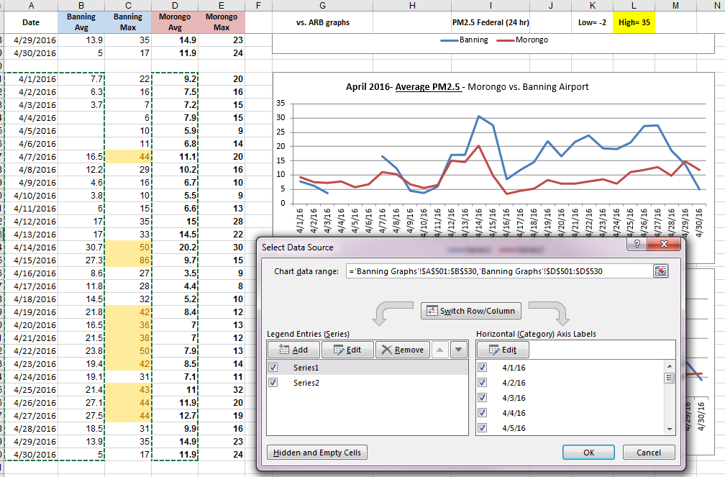
Figure 4.g
  - Repeat step “g” for the “Maximum” graph, highlighting columns “A”, “C” & “E”.
  - Columns “B”-“E” will automatically highlight any levels outside the parameters.
  - Click on graphs and copy. Click on “Suspect, Missing or Flagged” tab and paste into column “A” under the flagged data.
  - Take note of any Morongo parameters outside of the limits and compare to Banning’s parameters. If they are “trending” at the same time, make a note in the explanation column as “Trending with Banning ARB”.
  - Copy the flagged data and graph send as an email to the Tribal Air Specialist for review. Make sure to note any instances that are over/under the acceptable range, or Disqualified without explanation.
  - Repeat step 4 for each additional particulate.
  - Tribal Specialist will email back with explanations or advise to proceed with reporting to AQS as is without invalidation. If explanations are given, make sure to note in “explanation” column and enter “Null code”.
- Troubleshooting
  - Should you incur problems in confirming this data, speak to the Tribal Air Specialist.

