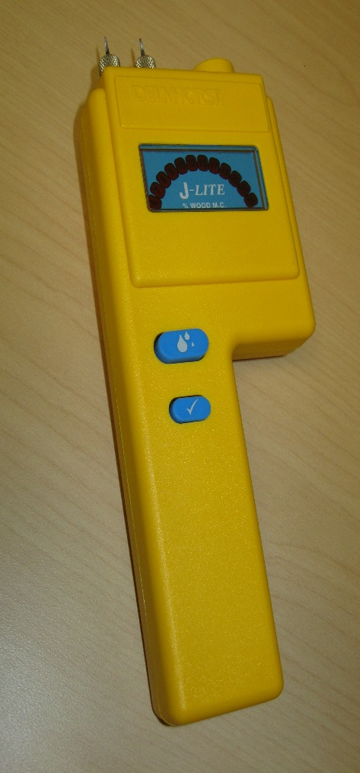
Contact Pins External Connector

Read Button
Calibration
Check
Button

1 Press the Calibration Check Button. The meter is in calibration when the “12” lights up. For any other reading other than “12”, it is likely the battery is low.
2 Remove the protective cover and check that the contact pins are firmly hand tightened.
3 Align the contact pins parallel to the wood grain, pushing them to their full penetration.
4 Press the Read button and read the moisture content on the LED display.

The J-Lite uses Douglas Fir as the basis for all calibrations. For other wood species, refer to the manufacturer guide for a species correction. There is also a temperature correction given in the manufacturer guide, but if the wood temperature, which is typically the ambient temperature, is between 50°F/10°C and 90°F/32°C, there is no need to apply a correction.
“Since the J-Lite displays %MC in a “range” between two values, corrections for pin, temperature, and species have less impact on the accuracy of the meter readings, especially below 12%. Therefore these corrections are not necessary.”
On the other side of this page is a guide to the Actual Meter Readings:

METER READINGS

If the LED displays: | The %MC is:
Blinking 6% | Below 5.5%
6% | Between 5.5 and 6.0
7% | Between 6.1 and 7.0
8% | Between 7.1 and 8.0
9% | Between 8.1 and 9.0
10% | Between 9.1 and 10.0
Blinking 10% and 12% | Between 10.1 and 11.0
12% | Between 11.1 and 12.0
Blinking 12% and 15% | Between 12.1 and 13.5
15% | Between 13.6 and 15.0
Blinking 15% and 17% | Between 15.1 and 16.0
17% | Between 16.1 and 17.0
Blinking 17% and 19% | Between 17.1 and 18.0
19% | Between 18.1 and 19.0
20% | Between 19.1 and 20.0
Blinking 20% and 25% | Between 20.1 and 22.5
25% | Between 22.6 and 25.0
Blinking 25% and 30% | Between 25.1 and 27.5
30% | Between 27.6 and 30.0
Blinking 30% | Above 30%
The J-Lite can be used to test many other building materials such as drywall, plywood, OSB, MDF. Call 877-DELMHORST (335-6467) or e-mail info@delmhorst.com for more information on using the meter on other materials.

