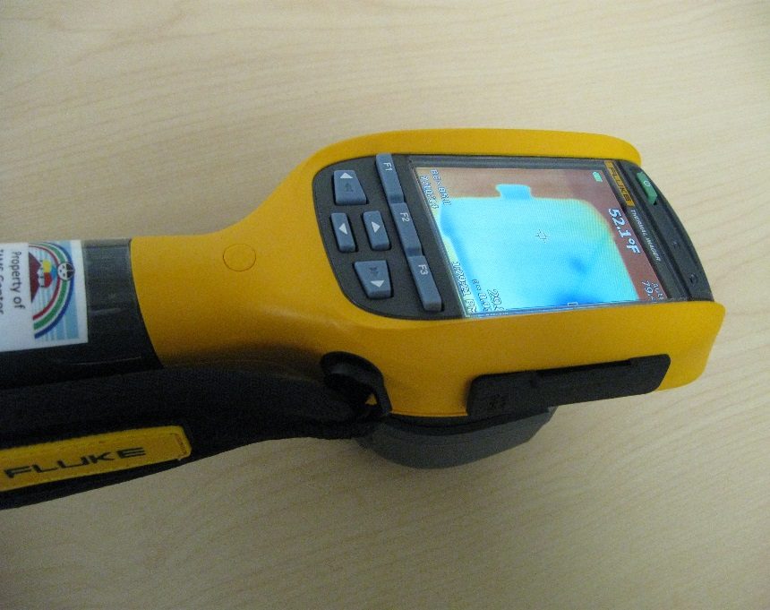
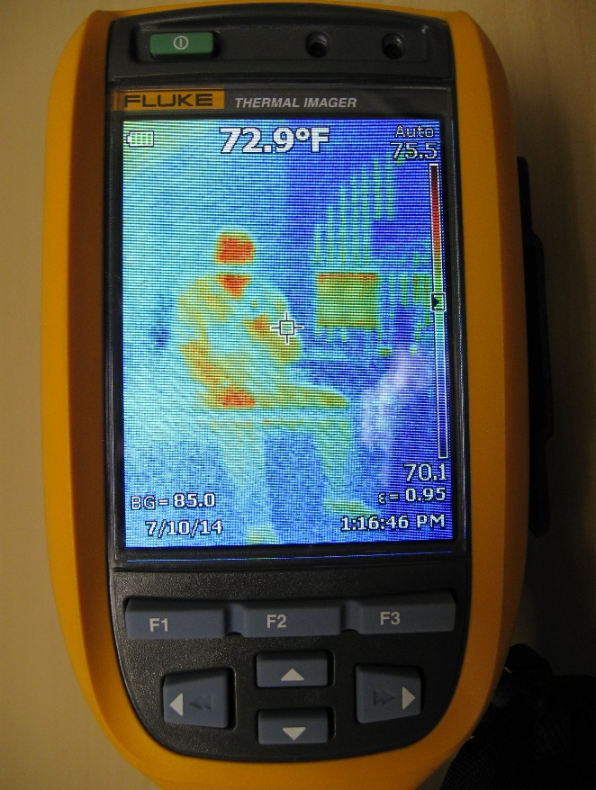

To turn the Imager on or off, push and hold for two seconds the green button above the LCD and on the left. Before using the Imager for the first time, charge the battery for a minimum of two and on-half hours. Allow the Imager a warm up time of at least 3-5 minutes. Fold back the Retractable Lens Cover before using the Imager.
At the top of the LCD is the battery indicator, surface temperature located by the crosshair, Auto/Manual range, the temperature range bar on the right. BG for the Reflected Background Temperature Compensation and below that is the date. The script E= the emissivity constant and below that, the current time.
There are two triggers: the larger green trigger will initiate a screen capture of the entire image, which then can be saved or discarded. The smaller black trigger will activate the laser pointer for temperature readings to be taken at the location of the laser dot.
For Image Capture, make sure the object is in focus. Pull and release the green trigger. This will capture and freeze the image. To cancel, pull the green trigger again, or press F3 to return to live view.
After a screen capture, there are three options: Save, Edit, or Cancel that appear on the LCD screen above the menu buttons F1, F2, or F3.
Pressing F2 or any of the arrow keys will bring up the menu choices: Measurement, Image, Camera, Memory, Settings. Up and down arrows will move between these selections, left and right arrows will move the menu selection either back one level or deeper one level respectively, and additionally, menu selections can be made with the F1, F2, and F3 keys.

Menu descriptions next page:

Measurement ->Range ->Auto Range, or Manual Range In manual mode, use the arrow keys to increase or decrease the temperature span.

->Emissivity ->Adjust Number, or Select table Emissivity of a surface determines what percentage of thermal energy is Emitted rather than absorbed. Selecting the correct value for the observed surface will
increase the accuracy of the surface temperature calculated by the imager.

->Background ->Adj Temp BG or Reflected Background Temperature Compensation. Increases
accuracy of calculated surface temperature by adjusting for background thermal energy reflected by the
observed surface.

Image ->Palette ->Greyscale, Blue-Red, Ironbow, Amber Palette selection from
Greyscale-no color to Blue-Red-full spectrum

->IR-Fusion ->Max IR (inset IR image), Max IR (fullscreen IR image), Visible (no IR image-fullscreen visible image)

->Display ->Display All, Details/Scale, Scale Only, Image Only Choose the amount of details and scale shown in display and saved images.

Camera ->Laser/Torch ->Trigger Laser, Trigger Torch, Laser/torch For the small black Trigger,
Laser directs a “Laser Dot” for Temperature Measurement, Torch shines a “Flashlight” to
Illuminate dark work areas.

->Backlight ->Low, Medium, High Illumination from the LCD itself, to increase readability in low light conditions.

Memory Allows review of saved images. Selected image is outlined in RED. F1 OK, puts the image
Fullscreen, F2 Delete, deletes the selected image, and F3 Cancel puts the imager back in
Live Image mode.

Settings ->Units ->Degrees F, Degrees C Choose temperature scale.

->File Format ->IS2, BMP, JPEG Choose the file format for saved images. .is2 files
have all data in a single file and are analyzed and modified by SmartView software.

->Auto Off ->On, Off When set to “On” imager goes to sleep in 5 minutes and turns
off after 20 minutes of inactivity.

->Date Choose between MM/DD/YY or DD/MM/YY formats.

->Time Set time and choose between 12hr or 24hr formats.

->Language Choose between 18 different languages.

->Imager Info Model, serial number and calibration date.

